Questions

- Label the parts of the nephron below and explain briefly what happens at each point
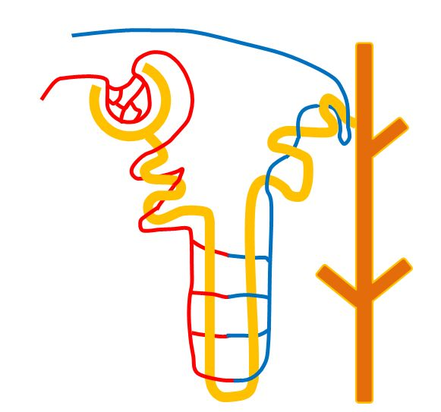

What happens here? ________________________________________________________________________

What happens
What happens here?
____________________________________________________________________________________________________________

What happens here? ___________________________________________________________________________________________

- Urea is one of the main waste products of your body. Describe in detail:
- How it is formed.
__________________________________________________________________________________________________________________________________________________________________________________________

- Why it has to be removed.
____________________________________________________________________________________________________________________________

- How it is removed from the body.
________________________________________________________________________________________________________________________________________________________________________________________________________________________________________________________

Questions continued…
Look at the graphs and answer the questions below:
---------------------------
---------------------------

- Using the graph describe what changes have occurred over the 150 minutes. Why are these changes important and why do they occur? ___________________________________________________________________________________________________________________________________________________________________________________________________

- What happened to the salt concentration over the same 150 minutes?
___________________________________________________________________________________________________________________________________________________________________________________________________

- Why do these changes in salt concentration occur?
____________________________________________________________________________________________________________________________________________________________________________________________________________________________________________________________________

