ITC TASK to produce 4 interesting stamp designs.

For this task, I want you to choose a sketch, a picture or an image that you have created in connection to your subject.

Use any ITC medium to develop the sketch, picture or image using the style of your chosen artist.

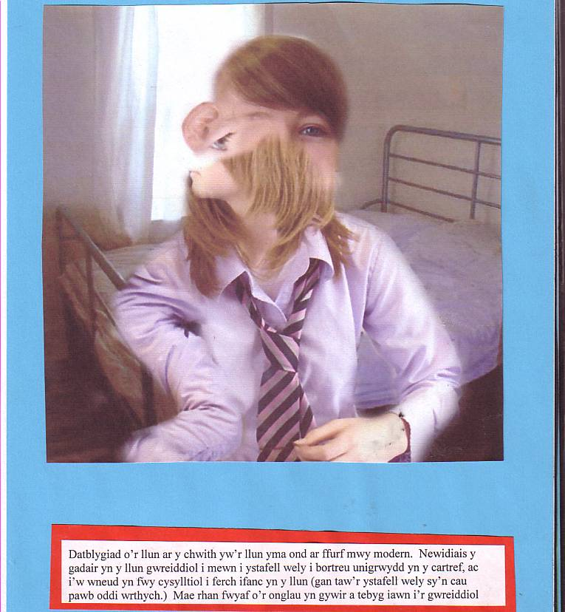
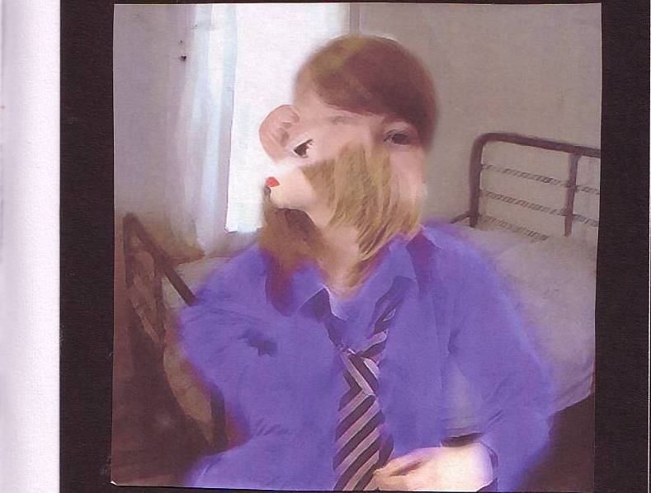
Below is an example of work on the subject of ‘Loneliness’ that developed and used the style of Picasso. A camera was used to capture the initial photo, before the image was adapted using photo-paint software.

This picture is a development of the picture on the left, but in a more modern form. I changed the chair in the original image into a bedroom to represent loneliness at home, and to make a connection with the young girl in the image (as you can lock yourself away from everyone in your bedroom). Most of the angles are accurate and very similar to the original.

