Iwan Bala, Cardiff

The artist and author Iwan Bala was born in North Wales in 1956. He studied Politics and Social Sciences in the University of Wales, Aberystwyth (1973-74) and Fine Art in Cardiff Art College, (1975-78), returning there to gain an MA in Fine Art.
He has collaborated with dramatists, poets and film makers, and his work is in several private and public collections including The National Museum and Gallery of Wales and Museum of Modern Art, Wales.

Iwan Bala works with a variety of media, creating paintings, installations, assemblages and prints. The focus of his themes is identity in minority cultures. He is influenced by culture, politics, poetry, legends and globalisation. Very frequently, it is said that his work is iconographic.

According to the artist: 'I cannot escape from Wales. I have always lived here apart for a few trips beyond its borders to promote the way I feel about cultural and political issues at home. My art reflects these issues, and in that respect it is political; post colonial art, art that suggests the complexities, ambiguities, contrasts, incomplete signs and uncertain cadences of this period, but also the hope of roots and continuation. Art (and politics) where optimism is managed and nihilism is kept away.’

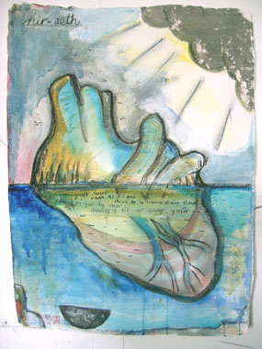

Hiraeth, Iwan Bala
Images with kind permission of Iwan Bala

