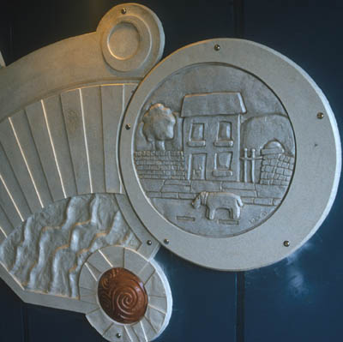

Part of a mural on a subway in Aberystwyth, created by the artist Rubin Eynon.

Rubin Eynon, Neath, South Wales

Rubin Eynon is an artist who concentrates on making sculptures for public or community places. He works with materials such as metals, stone, hard wood, resin, mosaic and so on. These sculptures are usually created in clay, plaster or MDF to begin with, in order to make mould and cast them in resin or bronze. He experiments with materials and very often he chooses unconventional items to inspire him. He started to work with sculptures by painting, and working with acrylic paint. In 2003, he was commissioned to make a mural in a subway in Aberystwyth. Rather than working with paint and creating a mural that would be at the mercy of the weather, he decided to create a series of three-dimensional panels in jesmonite resin, incorporating drawings in stainless steel, copper, slate and ceramic mosaic.
The piece has a very modern style, and it reflects the nearby coast. The result is a dynamic pattern of repetitive forms, that lead you through the subway.
According to the artist: ‘I'm inspired by lots of things visual and emotional. Everything from a rusted cog on an old machine to the trickle of water in a stream or the latest concept car design. I'm as inspired by the lush Welsh valleys as I am by concrete bridges and old fence posts. I get inspired by current science but also ancient technologies and historical industries. I also love listening to music and find inspiration in lots of different tunes. Everything around is inspiring and being an artist is about collecting these snippets of information and hopefully be able to condense them into visual, tangible pieces of art’.

www.cywaithcymru.org

