Terry Setch

Terry Setch was born in 1936 in London, but has lived in Penarth/Cardiff since the 1970s. From 1950 to 1954 he studied Fine Art at the Sutton & Cheam School of Art, and from 1956 to 1960 at the Slade School of Art, London.
Artist's Statement:"My art addresses what I am interested in. I get very excited when looking at paintings, sculpture, architecture and design which are out of the ordinary. I have an inclusive taste and can enjoy art from cave painting to old and modern masters, but I also enjoy amateur art and mad art. When I see visually exciting colour and form in a mess or in a gutter, the absurdity of the excitement that it can cause, is interesting. Maybe I see things in a 'heightened' way, visually powerful objects or experiences can upset my balance. My beach paintings are about my observations within a chosen subject matter which is on my doorstep. That is important to me, it is where I live, about the place I live; romantic, geographically, historically interesting. If one were to analyse the psychological elements of a painting, almost certainly aspects of the artist's personal life and history would be there" (quoted from Tony Curtis: 'Welsh Artists Talking' p.70)
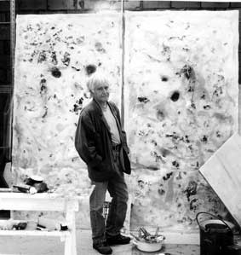
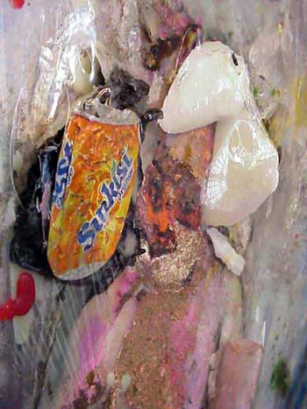

Detail from‘Nice Beach’

Penarth Beach, 2007

Terry Setch
Images with kind permission of Terry Setch

Once upon a Time there was Oil III, Panel I (1981-2)
Oil, wax, scrim and paper on canvas
support: 2600 x 4360 mm
on paper, unique
Purchased by the Tate Collection 1983
The figure at the centre of this work is the artist carrying the carcass of a sheep washed down the Severn and deposited on the beach at Penarth, just south of Cardiff docks and across the Severn estuary from Hinkley Point nuclear power station.

In the late 1890s, the English Impressionist Alfred Sisley painted bright views of the Bristol Channel from the cliff above Penarth beach. Terry Setch takes a different approach, treating the beach less as a scenic resource than as a perpetually evolving collision between nature and human industry. For thirty years now, he has been dragging his canvasses right out onto the beach, and including materials found there into the texture of his works. The memory of Sisley's unspoiled world persists in Setch’s paintings, but it is now mixed up with old cars, rubbish and other industrial debris. Once Upon a Time there was Oil III incorporates oil spilled from the tanker Amoco Cadiz, which ran aground off the shore of Brittany in 1978.
(From the display caption September 2004)

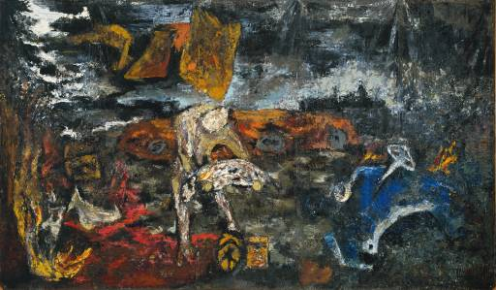
Once upon a Time there was Oil III, Panel I (1981-2)
Oil, wax, scrim and paper on canvas
support: 2600 x 4360 mm
on paper, unique
Images with kind permission of Terry Setch

