Learning Objectives:

At the end of this topic you will be able to;

- analyse and draw graphs to illustrate the following pulse carrier modulation techniques:
  - Pulse width modulation
  - Pulse position modulation
  - Pulse amplitude modulation
- analyse and draw graphs to illustrate the use of FSK to transmit digital data on an analogue carrier;
- analyse and draw graphs to illustrate phase shift keying.
Further Modulation Techniques
In the previous section we described some of the more familiar modulation techniques that are used in communications systems.

In this section we will introduce three further methods of modulation.

1. Pulse Carrier Modulation
2. Frequency Shift Keying
3. Phase Shift Keying

We will consider each if these in turn.

Pulse Carrier Modulation

In the first example we will discuss three ways of modifying a sequence of digital pulses, a digital carrier if you like, in sympathy with an analogue input signal. We are familiar now with the difference between analogue and digital signals, so you should easily recognise the following as a digital carrier signal.

Amplitude
time
If we look at this signal carefully there are three ways in which we can alter the above signal, (i) change the width of the pulse, (ii) change the position of the pulse, and (iii) change the amplitude of the pulse. These alterations lead directly to the three methods of modulating the digital carrier signal.

i) Pulse Width Modulation (PWM)

As its name suggests this method of modulating the carrier signal alters the width of the digital pulses in accordance with the modulating signal. The width of the pulse is proportional to the instantaneous amplitude of the modulating signal. For a positive modulating signal the width of the pulse increases proportionally, and for a negative modulating signal the width of the pulse decreases proportionally. This is best illustrated by looking at an example.
Amplitude
time
Amplitude
time
Amplitude
time
Un-modulated Carrier
Modulating Signal
PWM Modulated Signal

Examination of the PWM signal (shown in green) should illustrate how the original carrier (blue) has been altered by the modulating signal. In this case when the modulating signal is positive, the width of the un-modulated carrier increases in proportion, and when the modulating signal is negative, the width of the un-modulated carrier decreases in proportion.

The construction of PWM systems can be complex and are beyond the scope of this introductory unit. In this specification you will be expected to apply a consistent approach to the construction of a PWM signal based upon the properties of the modulating signal.

This convention is one of several possible conventions that could be applied to PWM systems. It is possible that if you research widely into different PWM systems that you will come across a different convention, and this is only to be expected as this technology is new and developing all the time. For the purposes of answering examination questions any consistent convention would be accepted, if it was clear from the answer that there is a consistent approach to the answer given, otherwise stick to the convention given here.

Now for a couple of examples.
Example 1. In the following example 3 possible answers are provided, A, B and C. Which one is the correct answer?
Amplitude
time
Amplitude
time
Un-modulated Carrier
Modulating Signal
Amplitude
time
PWM Modulated Output A
Amplitude
time
PWM Modulated Output B
Amplitude
time
PWM Modulated Output C
In the previous example, you will have hopefully decided that Output signal B is consistent with the input signal as the pulse width continuously increases in width as the signal increases.

Example 2: In the following example 3 possible answers are provided, A, B and C. Which one is the correct answer?
Amplitude
time
Un-modulated Carrier
Amplitude
time
PWM Modulated Output
Amplitude
time
Modulating Signal A
Amplitude
time
Modulating Signal B
Amplitude
time
Modulating Signal C
In this example Modulating Signal C is the correct answer.

Note: If you are asked to draw the modulating signal, you are only required to give an indication of what the modulating signal is doing. We will not be performing detailed calculations on the pulses and so indicative graphs are all that is required. i.e. in example 2, the following modulating signal would have been acceptable as a possible answer.
Modulating Signal
Amplitude
time

Issues with Pulse Width Modulation

During the last section we have looked at a very simplistic view of Pulse Width Modulation. This has been a deliberate approach since what we are concerned with in this introductory section on more advanced modulation techniques is passing on the principle of each method.

From an examination perspective, you will have to know what pulse width modulation does to a series of carrier pulses, and apply the rules given here consistently in order to obtain a correct representation of the output graph. For example: one way of being consistent is if the modulating signal is positive, then the pulse width should be wider than the original pulse, and the greater the positive voltage the wider the pulse should be. When the pulse is negative the pulse should be narrower than the original and the more negative the modulating signal becomes the narrower the output pulse should be.

However it is important to realise that in practical applications there are some issues we need to consider.

i. When we have drawn our graph, we have drawn the output directly underneath the modulating signal. This has sometimes meant that the pulse width has to increase, and start before the sample of the modulating signal was taken. Clearly this is impossible to achieve in reality.
ii. In practical circuits an offset, typically half a cycle, is introduced between the sampling of the modulating signal and the production of the output signal.
iii. For examination purposes this leads to confusion about whether an offset should be applied and where to place this offset. Therefore to clear up any confusion for examination questions the graphs will always be drawn in the same manner as the examples within these notes, and these will then be consistent with past examination paper questions.

Student Exercise 1:

1. Complete the following diagram to show the PWM modulated output for the given modulating signal. The original carrier pulses are shown dotted in bottom graph to help you complete the output.
Amplitude
time
Amplitude
time
Un-modulated Carrier
Modulating Signal
Amplitude
time
PWM Modulated Output
2. Complete the following diagram to show the PWM modulated output for the given modulating signal. The original carrier pulses are shown dotted in bottom graph to help you complete the output.
Amplitude
time
Amplitude
time
Un-modulated Carrier
Modulating Signal
Amplitude
time
PWM Modulated Output

3. The following diagram shows an un-modulated carrier, and the modulated PWM Output. Complete the lower graph to show the modulating signal.

Amplitude
time
Un-modulated Carrier
Amplitude
time
PWM Modulated Output
Amplitude
time
Modulating Signal
ii) Pulse Position Modulation (PPM)

In this variation of the modulation process the modulating signal alters the position of the pulse from its normal centre position. The position of the pulse is proportional to the instantaneous amplitude of the modulating signal. For a positive modulating signal the position of the pulse moves ahead (to the right) proportionally, and for a negative modulating signal the position of the pulse moves earlier (to the left) proportionally. The width of the pulse however remains unaltered. This is best illustrated by looking at an example.
Amplitude
time
Amplitude
time
Amplitude
time
Un-modulated Carrier
Modulating Signal
PPM Modulated Signal

Examination of the PPM signal (shown in green) should illustrate how the original carrier (blue) has been altered by the modulating signal. In this case when the modulating signal is positive, the un-modulated carrier pulse occurs before its normal position, and when the modulating signal is negative, the un-modulated carrier pulse occurs later than it would normally.

The construction of PPM systems can be complex and it is beyond the scope of this introductory unit. In this specification you will be expected to apply a consistent approach to the construction of a PPM signal based upon the properties of the modulating signal.

As was the case with PWM systems this is only one convention of a number that are available depending on the system being used to gererate the modulated signal. All we are looking for here again is a consistent approach to demonstrating your understanding of what a PPM system does to a digital carrier.

For the purposes of answering examination questions any consistent convention would be accepted, if it was clear from the answer that there is a consistent approach to the answer given, otherwise stick to the convention given here.

Now for a couple of examples.

Example 1: In the following example 3 possible answers are provided, A, B and C. Which one is the correct answer?
Amplitude
time
Amplitude
time
Un-modulated Carrier
Modulating Signal
Amplitude
time
PWM Modulated Output A
time
Amplitude
PWM Modulated Output B
Amplitude
time
PWM Modulated Output C
In the previous example, you will have hopefully decided that Output signal C is consistent with the input signal.

Example 2: In the following example 3 possible answers are provided, A, B and C. Which one is the correct answer?
Amplitude
time
Un-modulated Carrier
Amplitude
time
Modulating Signal A
time
Amplitude
PWM Modulated Output B
Amplitude
time
Modulating Signal B
Amplitude
time
Modulating Signal C
The correct answer for Example 2 is Modulation Signal B.

As was the case with PWM, if you are asked to draw the modulating signal without any indication of the exact shape of the graph, there are a number of possibilities that can be accepted as being correct. Once again a consistent approach is all that is required, so an alternative, but equally correct answer to the previous example is as follows:

Amplitude
time
Modulating Signal

Issues with Pulse Position Modulation

During the last section we have looked at a very simplistic view of Pulse Position Modulation. This has been a deliberate approach since what we are concerned with in this introductory section on more advanced modulation techniques is passing on the principle of each method.

From an examination perspective, you will have to know what pulse position modulation does to a series of carrier pulses, and apply the rules given here consistently in order to obtain a correct representation of the output graph. For example: one way of being consistent is if the modulating signal is positive, then the pulse position should be after the original pulse, and the greater the positive voltage the further the pulse should be from its origin. When the pulse is negative the pulse should be before the original and the more negative the modulating signal becomes the earlier the output pulse should be.

However it is important to realise that in practical applications there are some issues we need to consider.

i. As before when we have drawn our graph, we have drawn the output directly underneath the modulating signal. This has sometimes meant that the pulse position has to move before the original pulse took place, and start before the sample of the modulating signal was taken. Clearly this is impossible to achieve in reality.
ii. In practical circuits an offset, typically half a cycle, is introduced between the sampling of the modulating signal and the production of the output signal.
iii. For examination purposes this leads to confusion about whether an offset should be applied and where to place this offset. Therefore to clear up any confusion for examination questions the graphs will always be drawn in the same manner as the examples within these notes, and these will then be consistent with past examination paper questions.
Student Exercise 2:

1. Complete the following diagram to show the PPM modulated output for the given modulating signal. The original carrier pulses are shown dotted in bottom graph to help you complete the output.
Amplitude
time
Amplitude
time
Un-modulated Carrier
Modulating Signal
Amplitude
time
PPM Modulated Output
2. Complete the following diagram to show the PPM modulated output for the given modulating signal. The original carrier pulses are shown dotted in bottom graph to help you complete the output.
Amplitude
time
Amplitude
time
Un-modulated Carrier
Modulating Signal
Amplitude
time
PPM Modulated Output

3. The following diagram shows an un-modulated carrier, and the modulated PPM Output. Complete the lower graph to show the modulating signal.
Amplitude
time
Un-modulated Carrier
Amplitude
time
PPM Modulated Output
Amplitude
time
Modulating Signal

iii) Pulse Amplitude Modulation (PAM)

In this variation of the modulation process the modulating signal alters the amplitude of the pulse from its normal amplitude. The amplitude of the pulse is proportional to the instantaneous amplitude of the modulating signal. For a positive modulating signal the amplitude of the pulse matches the instantaneous amplitude of the information signal, and for a negative modulating signal the modulated pulse also becomes negative, with an amplitude matching that of the information signal. The width of the pulse however remains unaltered. This is best illustrated by looking at an example.
Amplitude
time
Amplitude
time
Amplitude
time
Un-modulated Carrier
Modulating Signal
PAM Modulated Signal
Examination of the PAM signal (shown in green) should illustrate how the original carrier (blue) has been altered by the modulating signal. In this case when the modulating signal is positive, the un-modulated carrier pulse takes the amplitude of the modulating signal, and when the modulating signal is negative, the un-modulated carrier pulse takes a negative value, again equal to the value of the modulating signal.
Pulse Amplitude Modulation is by far the easier of the three modulation techniques since the only thing that changes is the amplitude of the carrier pulse train to match that of the modulating signal. This will be very important when we look at Pulse Code Modulation (PCM) in more detail in topic 4.5.4.

Further examples for PAM should not be required, as the process is quite straightforward so we will move straight into the student exercise for this section.

Student Exercise 3:

1. Complete the following diagram to show the PAM modulated output for the given modulating signal. The original carrier pulses are shown dotted in bottom graph to help you complete the output.
Amplitude
time
Amplitude
time
Un-modulated Carrier
Modulating Signal
Amplitude
time
PAM Modulated Output

2. Complete the following diagram to show the PAM modulated output for the given modulating signal. The original carrier pulses are shown dotted in bottom graph to help you complete the output.
Amplitude
time
Amplitude
time
Un-modulated Carrier
Modulating Signal
Amplitude
time
PAM Modulated Output

3. The following diagram shows an un-modulated carrier, and the modulated PAM Output. Complete the lower graph to show the modulating signal.
Amplitude
time
Un-modulated Carrier
Amplitude
time
PAM Modulated Output
Amplitude
time
Modulating Signal
Carrier Modulation by Digital Signals

It is sometimes possible to transmit a digital signal directly, without a carrier, and this would be termed baseband transmission. This can happen in a short length of electrical cable, where the digital logic 1’s and 0’s are essentially pulses of current or voltage. Usually however a carrier is required to transport the bits through the wire pairs of the telephone (in which case the carrier is a.c. current) or the atmosphere (in which case the carrier is radio waves or microwaves) or an optic fibre (in which case the carrier is a beam of infra red light).

The modulation by a digital signal must make some property of the carrier switch between one state and the other (according to whether the digital information is logic 1 or logic 0); this process is known as keying.

This is a process that was used primarily to send digital data over an analogue communications channel. Digital data has only one of two values 0 and 1, whereas analogue signals can have any value between the limits of the power supply.

In early communication systems that carried only analogue signals, there were many capacitors and inductors used to allow a.c. signals to pass from one stage of the system to another but to block off any d.c. components which may have caused the average voltage in the system to drift away from a zero average.

Trying to send digital data over early communications channels was not easy because the digital signal may have contained several ‘1’s in a row, which had the effect of charging up the capacitors in the circuits, and raising the average value away from zero. This was especially the case when the carrier signal was just switched off when the digital data was a logic 0 and switched on when it was a logic 1, as shown by the following diagram.

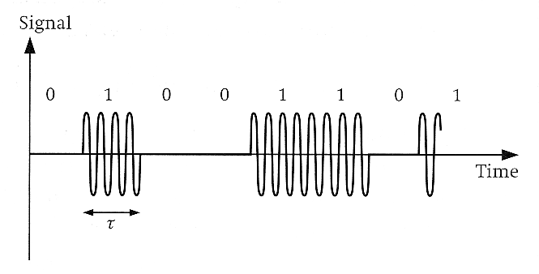

This form of transmission was called amplitude shift keying. However it was not particularly successful because of the fact that this signal caused capacitors in the network to charge up, but more importantly the receiver did not know whether he was receiving a string of logic 0’s or whether the connection had been lost since no signal meant logic 0.

An improvement to the communication of digital signals came about by using two sine waves of different frequency to represent the digital logic 0, and 1. This gave several advantages over the amplitude shift keying process described earlier.

i. The signals transmitted were analogue signals, with a zero average, so no charging of capacitors along the transmission line took place.
ii. There was always a signal present, so there was no doubt if the signal had been lost or not.

The following diagram shows a typical Frequency Shift Keying signal.

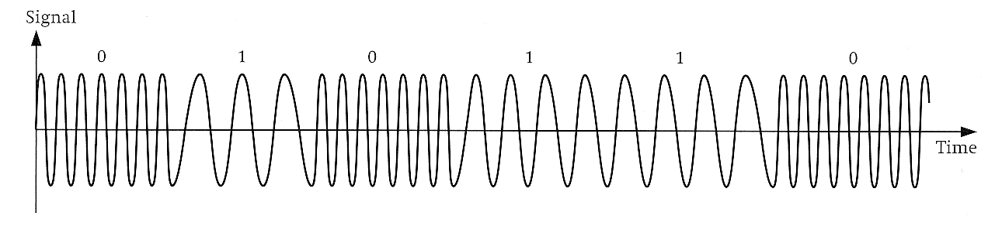

Notice that a high frequency sine wave is used for the logic 0 and a lower frequency for the logic 1. The signal is continuous so there was no doubt if the signal was lost.
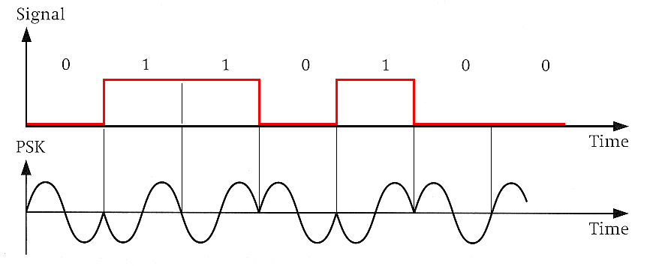
An alternative system to the frequency shift method employed above, which still resulted in a continuous signal is to change the phase of a signal. In the example shown below, each bit is represented by one cycle of a sine wave, and the phase of the output is changed by 180° every time there is a change between logic 1 and logic 0.
Change in Logic Level

So change
in phase
No Change in Logic Level

So no change
in phase
Change in Logic Level

So change
in phase

You will notice from the graph that a logic 0 is represented by a sine wave which starts with a positive half cycle, and a logic 1 represented by a sine wave which starts with a negative half cycle, i.e. 180° out of phase.

Once again we are not going to investigate the necessary circuits that are responsible for the production of these signals, as there is insufficient time in this introductory course to go into that much detail, however you should now be able to sketch graphs to illustrate the effect of amplitude shift keying (ASK), frequency shift keying (FSK) and phase shit keying (PSK) for a given digital signal, or given a suitable ASK,FSK or PSK graph extract the digital data that created it.

Here are a couple of examples to get you started.
Student Exercise 4.

1. The following graph shows a digital signal that is to be transmitted using the process of (i) amplitude shift keying, (ii) frequency shift keying, and (iii) phase shift keying. Sketch on the grid provided the corresponding output signals for each of these transmission methods.
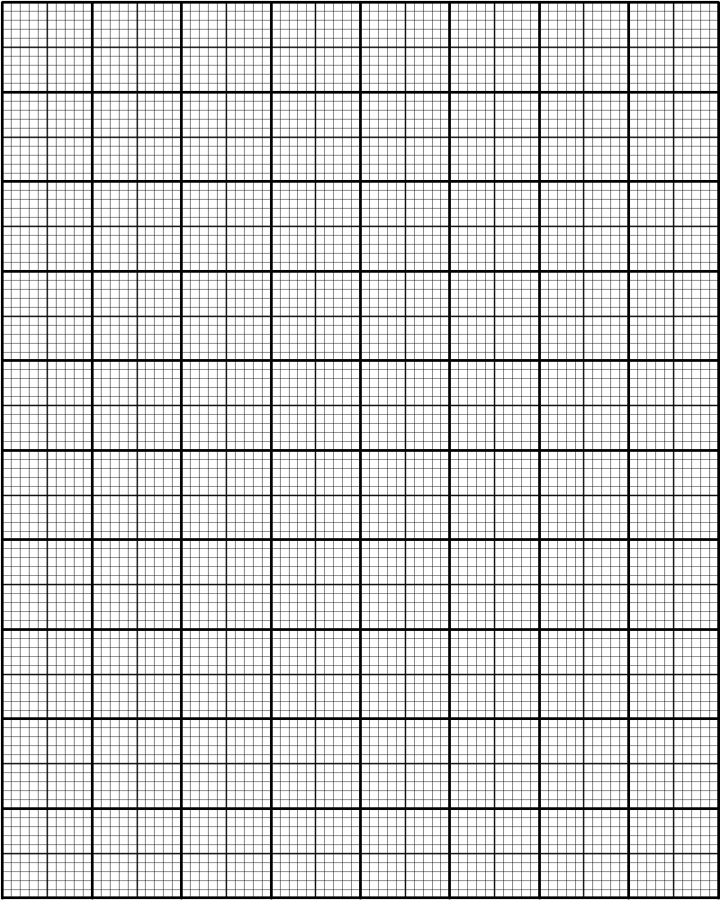
Digital signal
(i) ASK
(ii) FSK
(iii) PSK
time
time
time
time
2. The following graph shows a digital signal being transmitted by frequency shift keying. Draw the digital signal that is contained in the FSK signal.
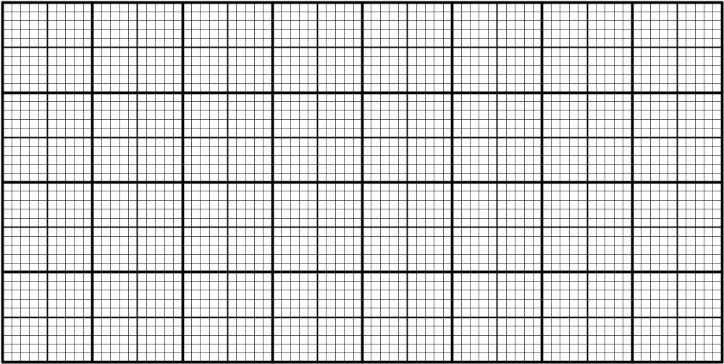
FSK Signal
time
time
Digital Signal
3. The following graph shows a digital signal being transmitted by phase shift keying. Draw the digital signal that is contained in the PSK signal.
PSK Signal
time
time
Digital Signal

Solutions to Student Exercises.

Student Exercise 1

1.
Amplitude
time
Amplitude
time
Un-modulated Carrier
Modulating Signal
Amplitude
time
PWM Modulated Output
2.
Amplitude
time
Amplitude
time
Un-modulated Carrier
Modulating Signal
Amplitude
time
PWM Modulated Output

3. The following diagram shows an un-modulated carrier, and the modulated PWM Output. Complete the lower graph to show the modulating signal.

Amplitude
time
Un-modulated Carrier
Amplitude
time
PWM Modulated Output
Amplitude
time
Modulating Signal
Student Exercise 2:
Amplitude
time
Amplitude
time
Un-modulated Carrier
Modulating Signal
Amplitude
time
PPM Modulated Output
1.

2.
Amplitude
time
Amplitude
time
Un-modulated Carrier
Modulating Signal
Amplitude
time
PPM Modulated Output

3.
Amplitude
time
Un-modulated Carrier
Amplitude
time
PPM Modulated Output
Amplitude
time
Modulating Signal

Student Exercise 3:

1.
Amplitude
time
Amplitude
time
Un-modulated Carrier
Modulating Signal
Amplitude
time
PAM Modulated Output
2. Complete the following diagram to show the PAM modulated output for the given modulating signal. The original carrier pulses are shown dotted in bottom graph to help you complete the output.
Amplitude
time
Amplitude
time
Un-modulated Carrier
Modulating Signal
Amplitude
time
PAM Modulated Output

3. The following diagram shows an un-modulated carrier, and the modulated PAM Output. Complete the lower graph to show the modulating signal.
Amplitude
time
Un-modulated Carrier
Amplitude
time
PAM Modulated Output
Amplitude
time
Modulating Signal

Student Exercise 4.

1.
Digital signal
(i) ASK
(ii) FSK
(iii) PSK
time
time
time
time

2.
FSK Signal
time
time
Digital Signal

3.
PSK Signal
time
time
Digital Signal
Now for some examination style questions.
Examination Style Questions.

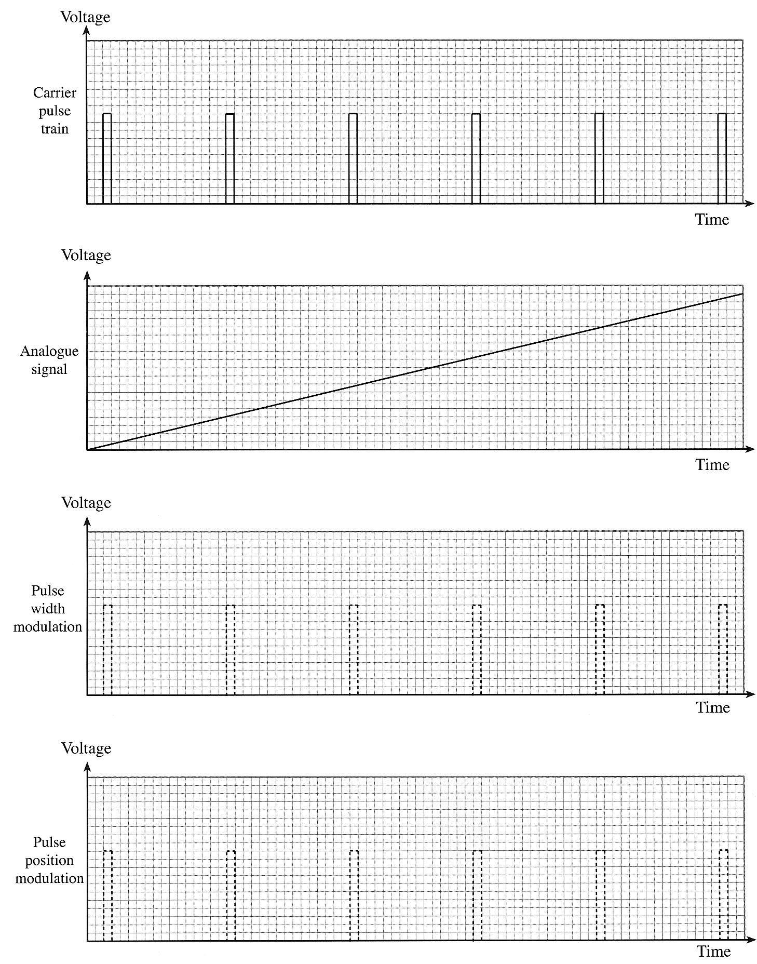
1. An analogue signal can be modulated onto a stream of pulses using techniques such as pulse width modulation or pulse position modulation. Use the axes provided to show the effect of modulating the carrier pulse train with the analogue signal shown. The original pulse train is shown to assist you. [4]
2. Pulse Amplitude Modulation, Pulse Position Modulation and Pulse Width Modulation are three methods of transmitting information.

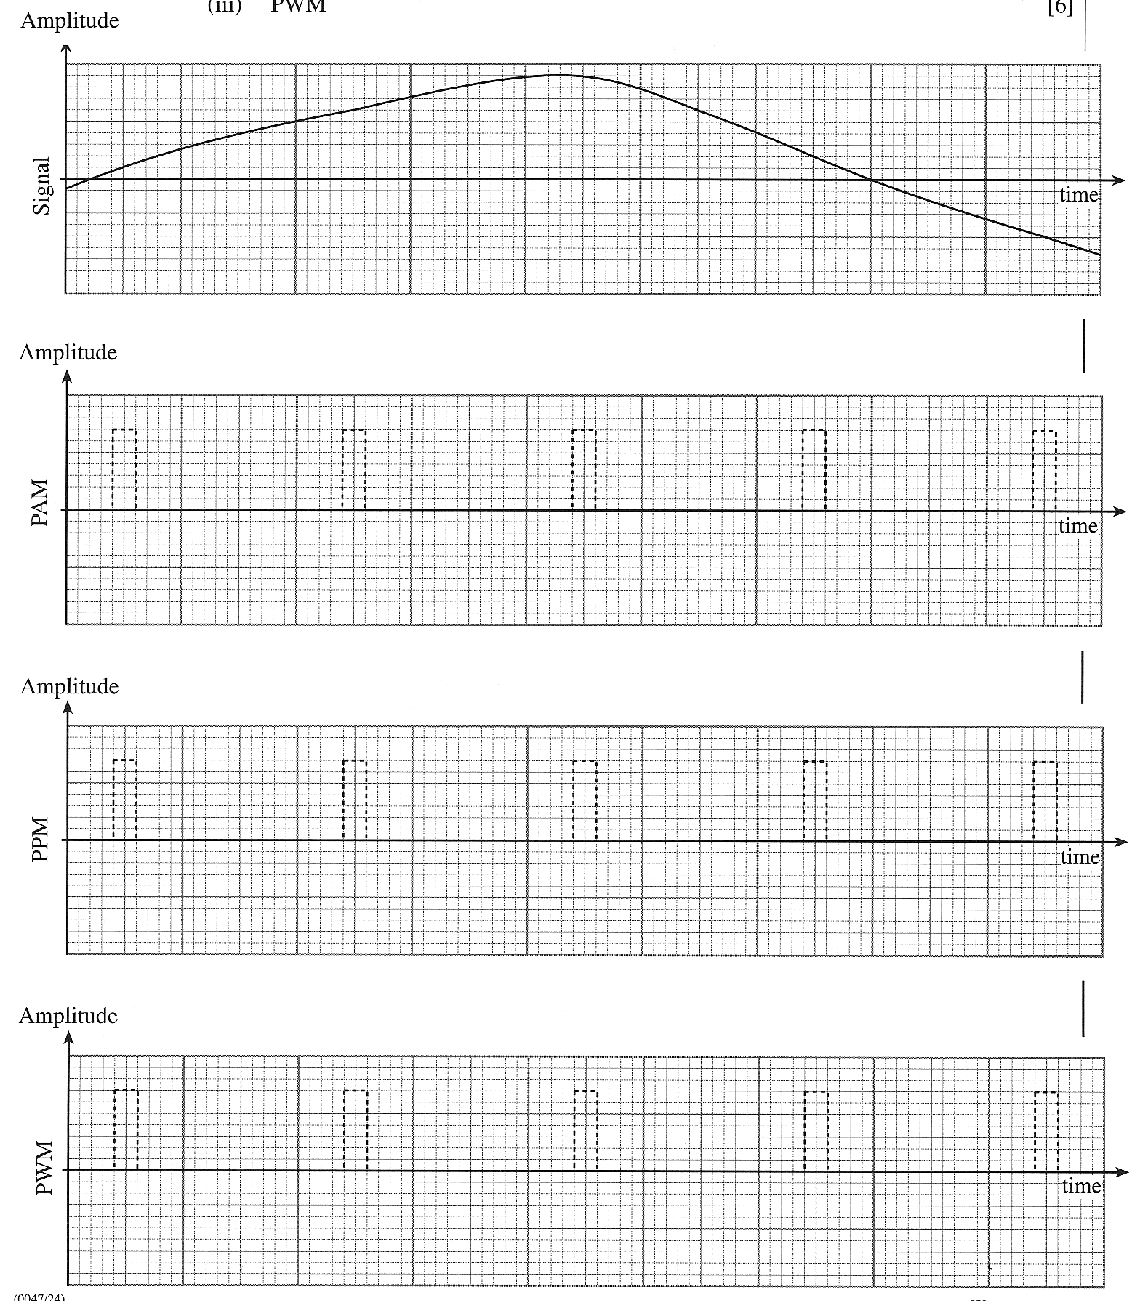
On each of the following graphs illustrate what would happen to the unmodulated pulse train (shown dotted) if the signal below were transmitted using (i) PAM, (ii) PPM and (iii) PWM. [6]

3. The following graph shows a digital signal being transmitted by frequency shift keying. Draw the digital signal that is contained in the FSK signal.
[2]
FSK Signal
time
time
Digital Signal
4. (a) The first graph shows a pulse position modulated (PPM) signal. The unmodulated pulse carrier is shown as a dotted trace.

Use the axes provided to sketch the output produced when the PPM signal is demodulated.
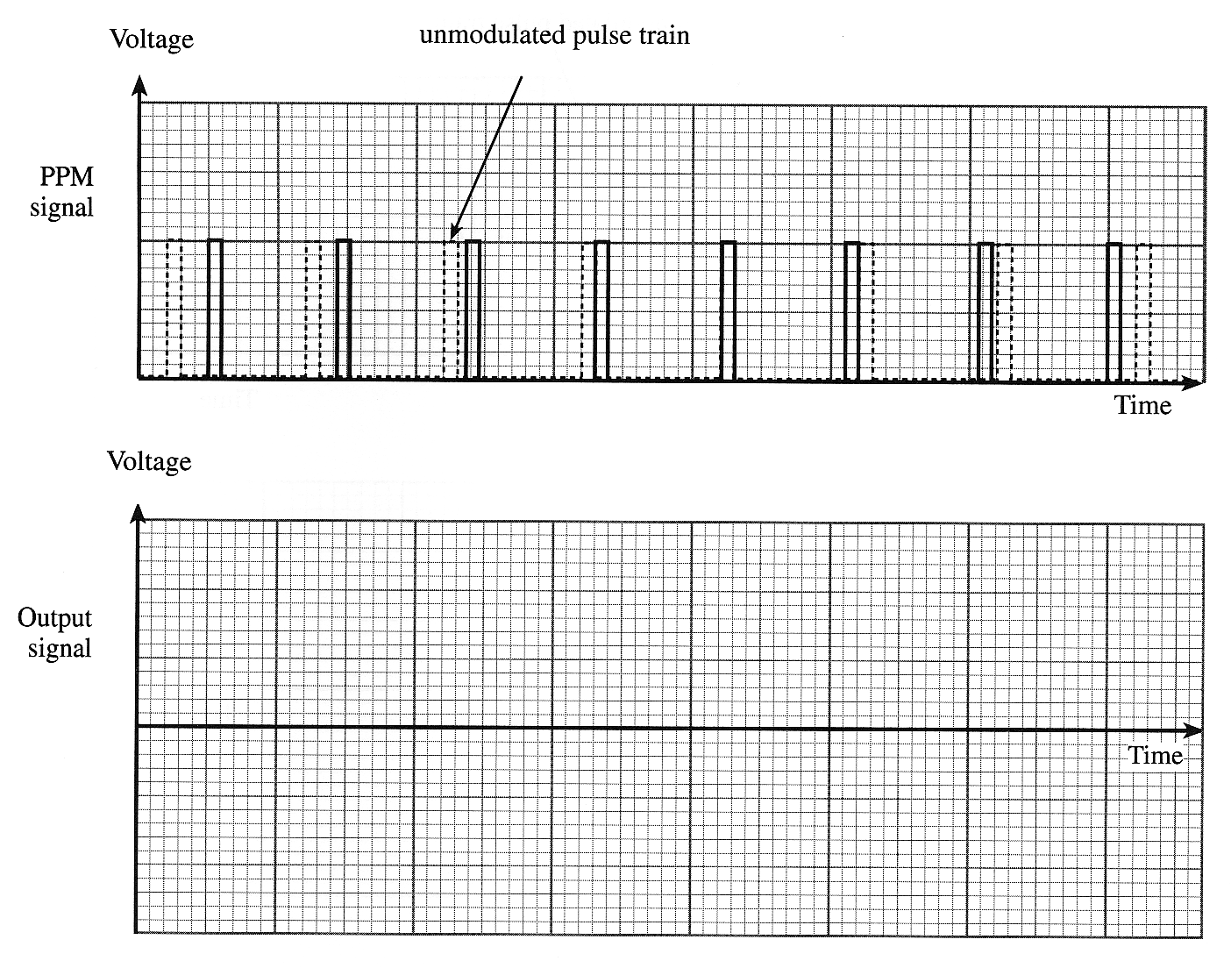

(b) The next graph shows a pulse width modulated (PWM) signal. Again, the unmodulated pulse carrier is shown as a dotted trace.

Use the axes provided to sketch the output produced when the PWM signal is demodulated.
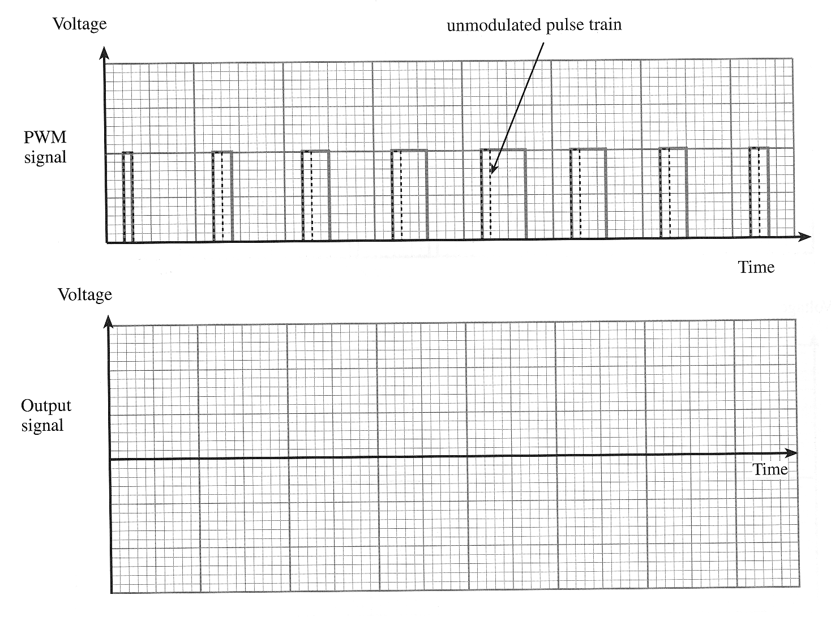

5. The following graph shows a digital signal being transmitted by phase shift keying. Draw the digital signal that is contained in the PSK signal.
[2]
PSK Signal
time
time
Digital Signal
6. The following graph shows a digital signal that is to be transmitted using the process of (i) amplitude shift keying, (ii) frequency shift keying, and (iii) phase shift keying. Sketch on the grid provided the corresponding output signals for each of these transmission methods.
[6]

Digital signal
(i) ASK
(ii) FSK
(iii) PSK
time
time
time
time
7. Pulse Amplitude Modulation, Pulse Position Modulation and Pulse Width Modulation are three methods of transmitting information.

On each of the following graphs illustrate what would happen to the un-modulated pulse train (shown dotted) if the signal below were transmitted using (i) PAM, (ii) PPM and (iii) PWM. [6]

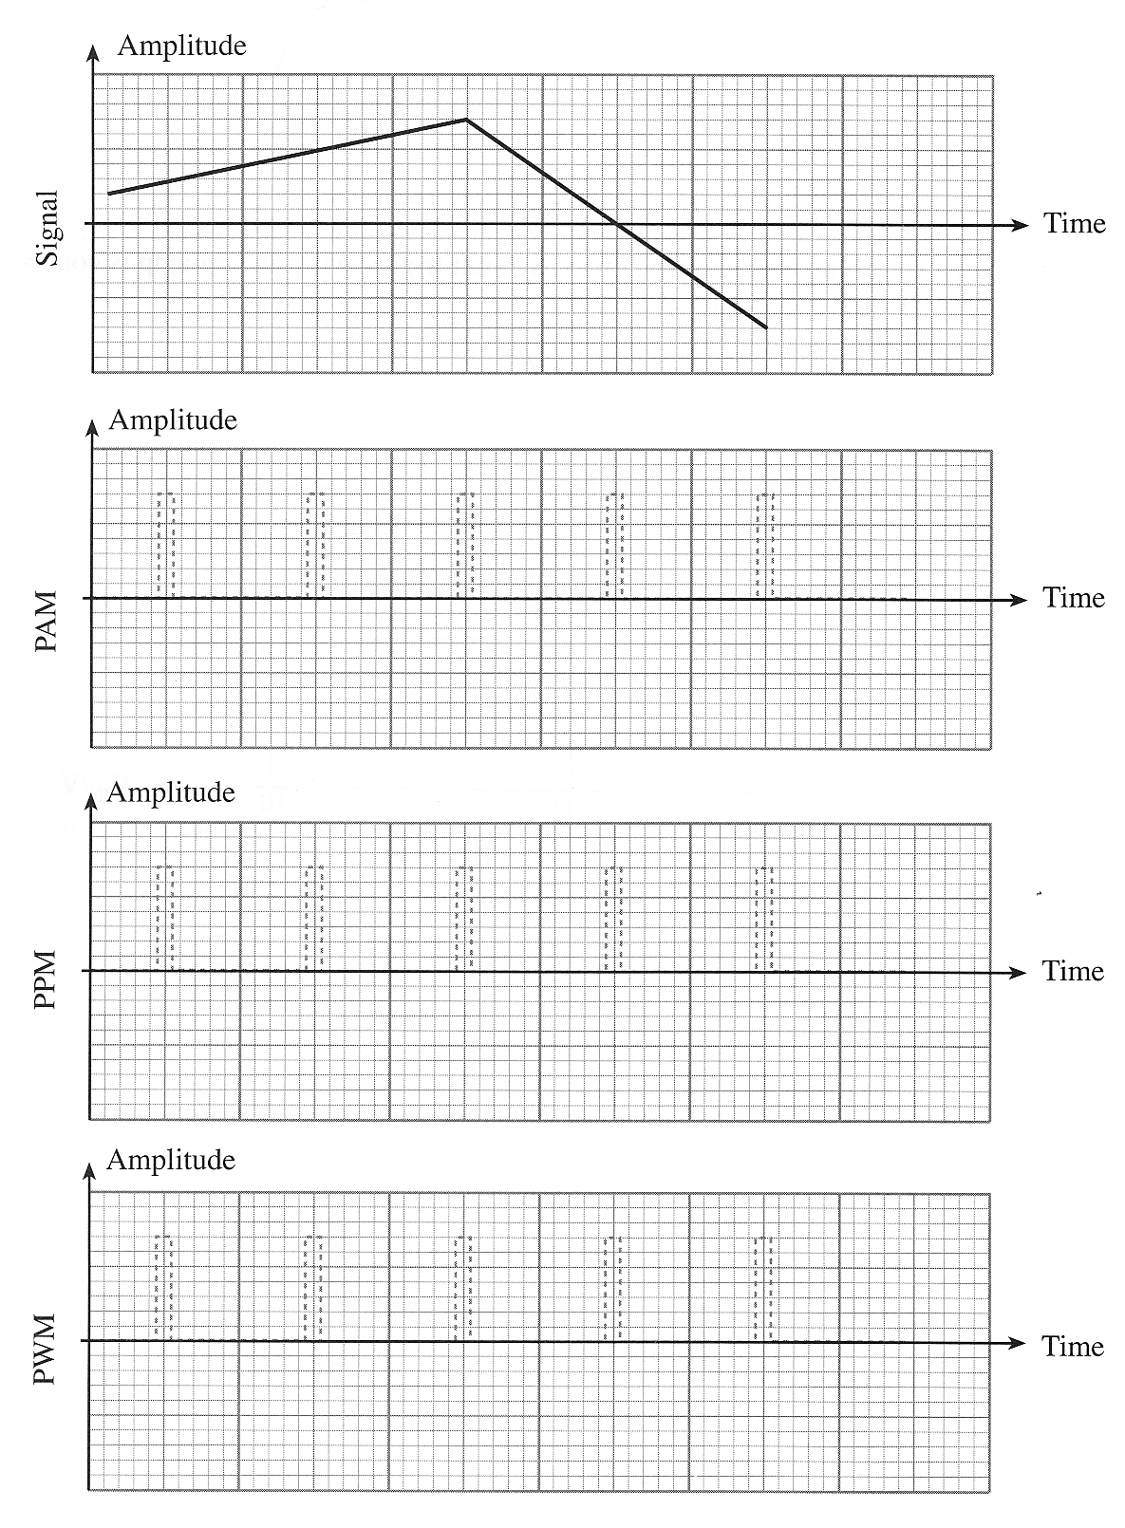
8. The following graph shows a digital signal that is to be transmitted using the process of (i) amplitude shift keying, (ii) frequency shift keying, and (iii) phase shift keying. Sketch on the grid provided the corresponding output signals for each of these transmission methods.
Digital signal
(i) ASK
(ii) FSK
(iii) PSK
time
time
time
time

9. Pulse Amplitude Modulation, Pulse Position Modulation and Pulse Width Modulation are three methods of transmitting information.

On each of the following graphs illustrate what would happen to the un-modulated pulse train (shown dotted) if the signal below were transmitted using (i) PAM, (ii) PPM and (iii) PWM. [6]

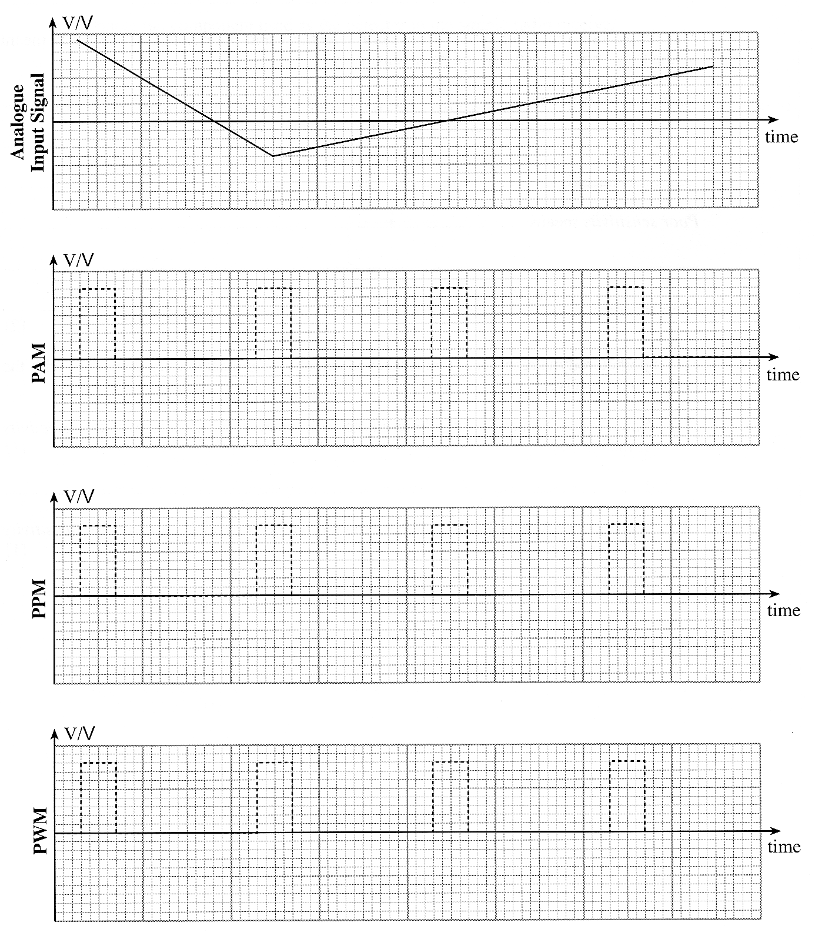
10. (a) The following graph shows a digital signal being transmitted by frequency shift keying. Draw the digital signal that is contained in the FSK signal.
FSK Signal
time
time
Digital Signal

(b) The following graph shows a digital signal being transmitted by phase shift keying. Draw the digital signal that is contained in the PSK signal.

PSK Signal
time
time
Digital Signal
Self Evaluation Review

Learning Objectives | My personal review of these objectives:
Learning Objectives | ☺ | 😐 | ☹
analyse and draw graphs to illustrate the following pulse carrier modulation techniques:
Pulse width modulation
Pulse position modulation
Pulse amplitude modulation
analyse and draw graphs to illustrate the use of FSK to transmit digital data on an analogue carrier;
analyse and draw graphs to illustrate phase shift keying.

Targets: 1. ………………………………………………………………………………………………………………

………………………………………………………………………………………………………………

- ………………………………………………………………………………………………………………

………………………………………………………………………………………………………………

