Learning Objectives:

At the end of this topic you will be able to;

- describe the use of the following analogue sensors:
thermistors and strain gauges;
- describe the use of the following digital sensors:
slotted discs (for sensing rotational speed),
encoded discs (for sensing angular position);
- recall the Gray code (3 bit) and explain its use in encoded discs;
- design and analyse sensor sub-systems which incorporate thermistors and strain gauges in bridge circuits;
- recall the advantages of a bridge circuit compared to a simple voltage divider circuit;
- recall, and explain the significance of, the ideal properties of an instrumentation amplifier – high input impedance and high common-mode rejection ratio;
- analyse and design instrumentation amplifiers based on the op-amp difference amplifier circuit;
- select and use the formula:
V_{OUT} = V_{DIFF} (R_{F} / R₁);
- design a logic system to process the output of slotted and encoded discs to meet a given specification.

Analogue sensing units:

An analogue signal can have any voltage value, limited only, usually, by the voltages of the power rails.

Some devices have a resistance which responds to changes in their surroundings. For example, a LDR (Light Dependent Resistor) has a resistance which decreases when more light falls on it. There are two kinds of thermistor (temperature dependent resistor). The ptc (positive temperature coefficient) thermistor has a resistance that increases as its temperature rises. The ntc (negative temperature coefficient) thermistor has a resistance that decreases as its temperature rises. This course considers only ntc thermistors.
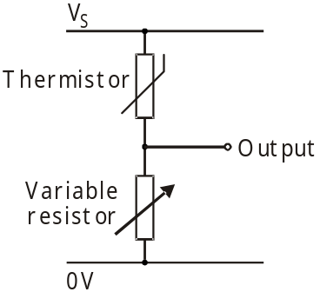
The simplest form of sensing unit is made by connecting
one of these devices in series with a resistor.
The output signal is taken from the point where the
resistor is connected to the device.
The diagram shows this arrangement used in a
temperature sensing unit. The analogue output signal
changes as the temperature changes.

For example, suppose that:
- the thermistor has a resistance of 1kΩ. at a temperature of 20⁰C;
- the variable resistor is set to a resistance of 2kΩ;
- the supply voltage V_{S} = 12V.

The output voltage is obtained from the voltage divider formula:
V_{OUT} = V_{S} (R₁ / R₁ + R₂)
In this case, at 20⁰C,
V_{OUT} = 12 x (2 / 2 + 1) = 8V.

Exercise 1 (The solutions are given at the end of the topic.)

At 100⁰C, a thermistor has a resistance of 0.5kΩ. The variable resistor is unchanged. Calculate the output voltage of this temperature sensing unit at 80⁰C.
A strain gauge

When trucks drive over a bridge, or someone stands on bathroom scales, the structure is squashed slightly. Strain is defined as this change in length divided by the original length, and strain gauges are used to measure it.

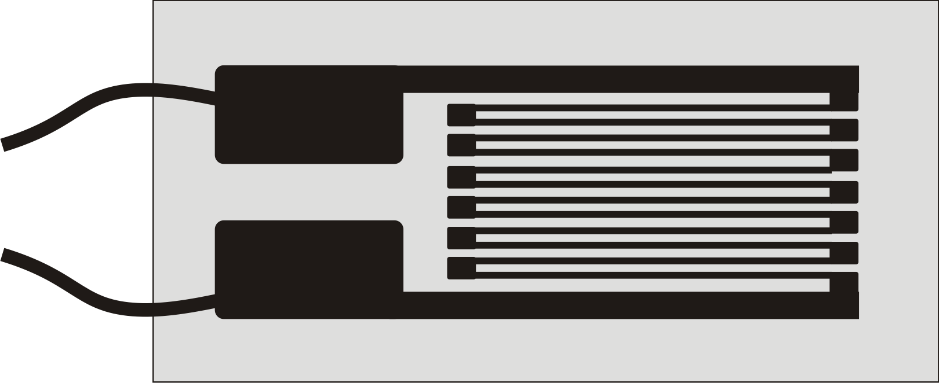
The layout of a typical strain gauge is shown in the
picture. It is often glued to the structure, and so
is distorted when the structure is distorted.
This changes the resistance of the strain gauge.

For example, when a straight wire is stretched, it gets longer and thinner. As a result, its resistance increases.
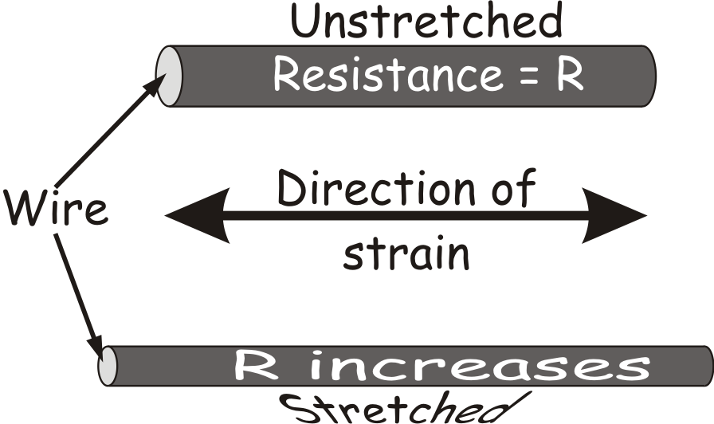

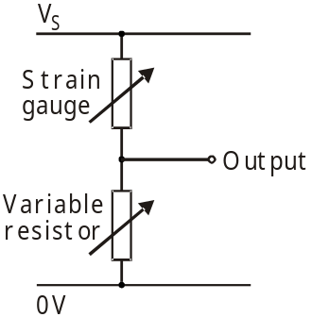By measuring the change in resistance, we can monitor the strain that produced it.

The strain gauge could be incorporated into a voltage
divider circuit, shown opposite, which behaves like the
one just considered for a temperature sensor.

However, there are problems with this kind of sensor:

- The resistance of the sensor may change because of some factor other than the one you are trying to measure. For example, the resistance of a strain gauge changes if the strain gauge gets hot. This has nothing to do with any forces applied to it.
- Look at the voltage divider formula again:
V_{OUT} = V_{S} (R₁ / R₁ + R₂)
As this shows, the output voltage depends on the supply voltage.
In many situations, the supply voltage will fluctuate.
  - The system may be battery-powered and using batteries that are going flat.
  - The system may be using a mains power supply, which does not have good line regulation.
  - The power supply cables might be subject to electrical noise, which changes the instantaneous value of the supply voltage.

In other words, you cannot know whether a change in the output indicates a change in the factor you are trying to monitor, or is the result of a change in some other factor in its surroundings.

A better sensing circuit:

Both of the problems outlined above can be overcome or reduced by using a bridge circuit, (though this title does not refer to the bridges that trucks drive over!)
This can be drawn in two ways, but the circuit is the same.

The following diagrams show a bridge circuit for a temperature sensing unit:
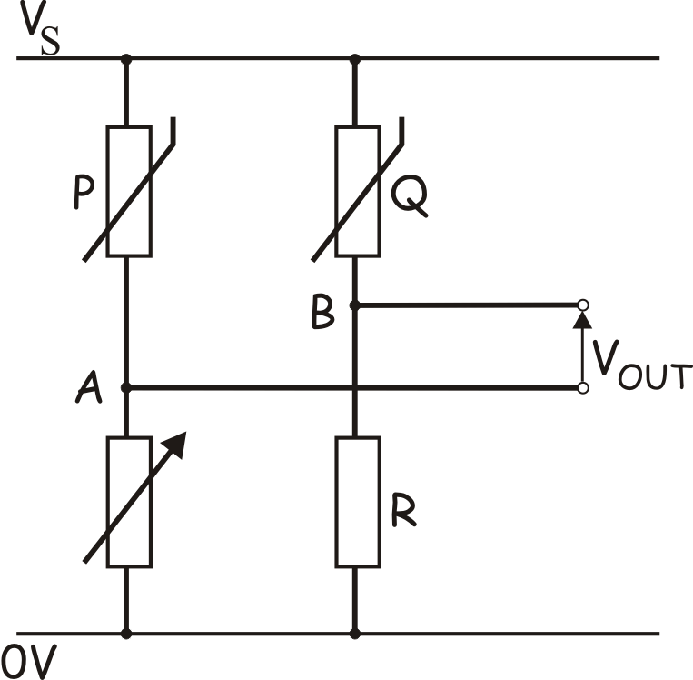
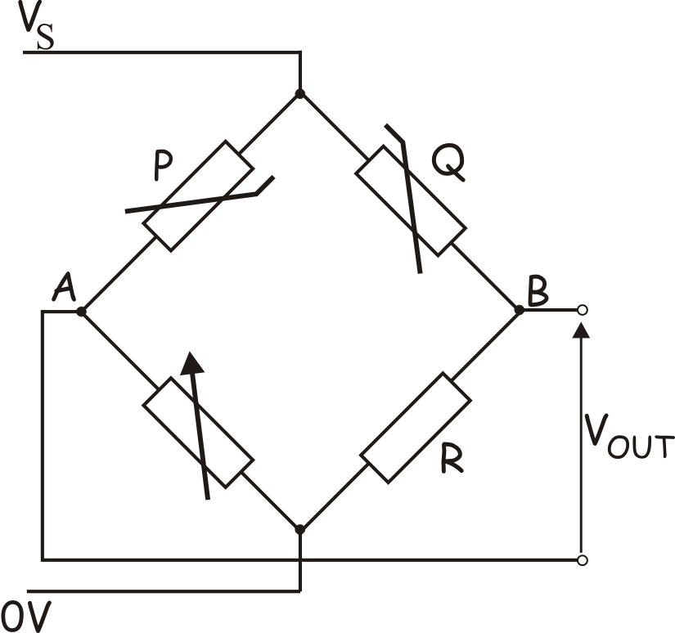

In a bridge circuit, there are two sensing devices, each connected in its own voltage divider. The output is the voltage difference between the outputs (B and A) of the two voltage dividers.

In the case above, there are two thermistors, P and Q. One is subjected to the temperature changes under investigation. The other is not. That is the only difference. Otherwise, both thermistors are exposed to the same conditions.
Null measurement technique:

Usually, the bridge is ‘balanced’ initially. In other words, the variable resistor is adjusted until V_{OUT} is zero.
In this condition:
Resistance of P = Resistance of Q
Resistance of variable resistor Resistance of R

Exercise 2 will show that in this condition, the power supply voltage makes no difference at all. Any value can be used, but two conflicting issues need to be considered:
- the higher the supply voltage, the more sensitive the output voltage is to changes in temperature (for the temperature sensing bridge circuit.)
- the higher the supply voltage, the greater the self-heating effect of all the resistors in the circuit.

Any changes in the condition being monitored, e.g. temperature, makes the bridge unbalanced, meaning that V_{OUT} is no longer zero. Using this null measurement makes it possible to detect very small changes in conditions, by connecting the bridge circuit to a high gain voltage amplifier, as outlined below.

A strain gauge bridge circuit:

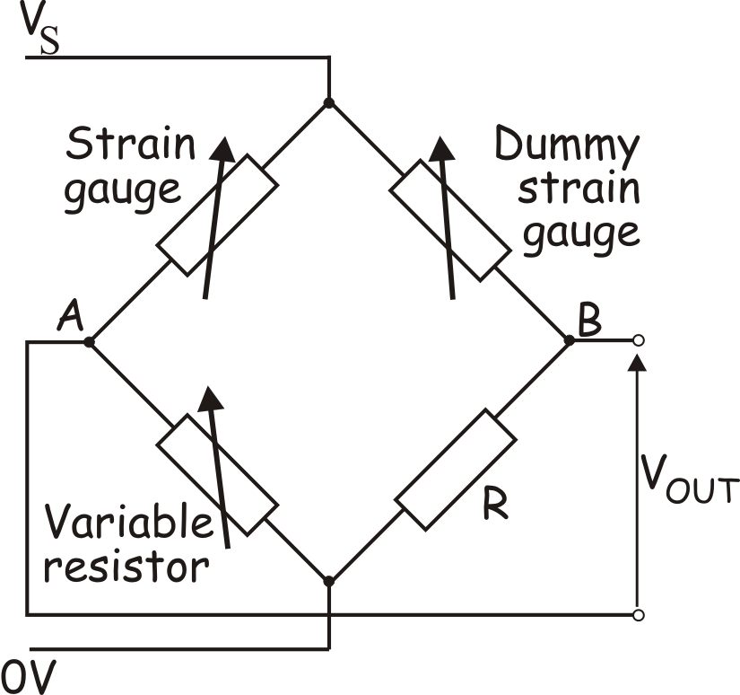

As in the temperature sensing bridge circuit, there are two sensing devices. In this case, they are labelled ‘Strain gauge’ and ‘Dummy strain gauge’, though their positions in the bridge can be reversed.

The ‘Strain gauge’ is glued to the structure in such a way that it is distorted by movement of the structure. The ‘Dummy strain gauge’ is glued nearby so that it is exposed to the same conditions, except for the distortion.
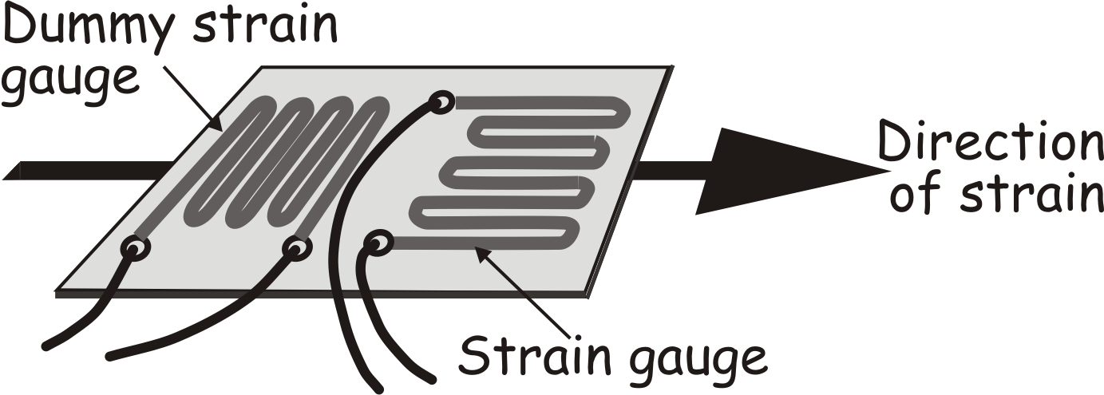
Often, the two strain gauges are
formed on the same substrate,
as shown in the diagram.

Exercise 2 (The solutions are given at the end of the topic.)
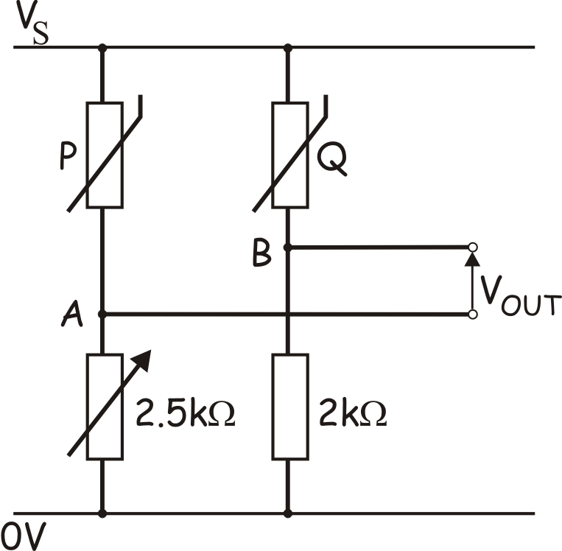
A thermistor bridge circuit is shown opposite.
The power supply voltage V_{S} = 12V
The variable resistor is adjusted until the bridge
is balanced, i.e. the output V_{OUT} = 0V. It then has
a resistance of exactly 2.5kΩ.
Thermistor Q is found to have a resistance
of 1.2kΩ.

(a) Calculate the resistance of thermistor P.

(b) The power supply voltage is changed to 10V.
Calculate the new output voltage V_{OUT}.

Exercise 3 (The solutions are given at the end of the topic.)
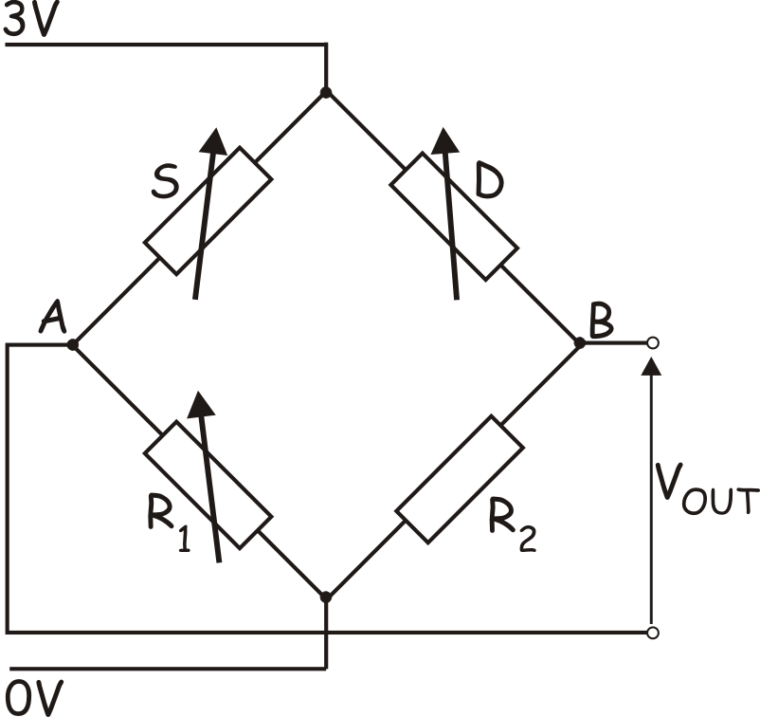
Initially, the strain gauge bridge circuit is
balanced by adjusting the variable resistor,
which then has a resistance R₁ = 710Ω.
Later, a force is applied to strain gauge S,
and its resistance becomes 366Ω.
The dummy strain gauge, D, is unaffected,
and still has a resistance of 350Ω.
R₂ is a fixed resistor, with resistance 700Ω.

Use the voltage divider rule twice to calculate
the voltages at A and B when the force is applied, and hence calculate the output voltage V_{OUT}.
(All your calculations should be quoted to two decimal places.)
Instrumentation amplifiers:

The output from a bridge circuit is usually only a few millivolts. It is usually amplified by a high gain voltage amplifier known as an instrumentation amplifier.

Ideal characteristics:

- High input impedance – This ensures that as much as possible of the voltage signal from the bridge circuit is transferred to the instrumentation amplifier. The current flowing in the wires connecting the two sub-systems is very small, and so the voltage dropped across the output impedance of the bridge circuit, (and so not transferred to the amplifier) is kept to a minimum.

- High common-mode rejection ratio –on both inputs. There will be steady DC voltages on the outputs of the two voltage dividers that make up the bridge circuit. (You calculated these earlier.) Part of this DC voltage will appear on, ( be common to) both outputs. A high CMRR ensures that the instrumentation amplifier ignores (rejects) these, and amplifies only the difference between these voltages signals.

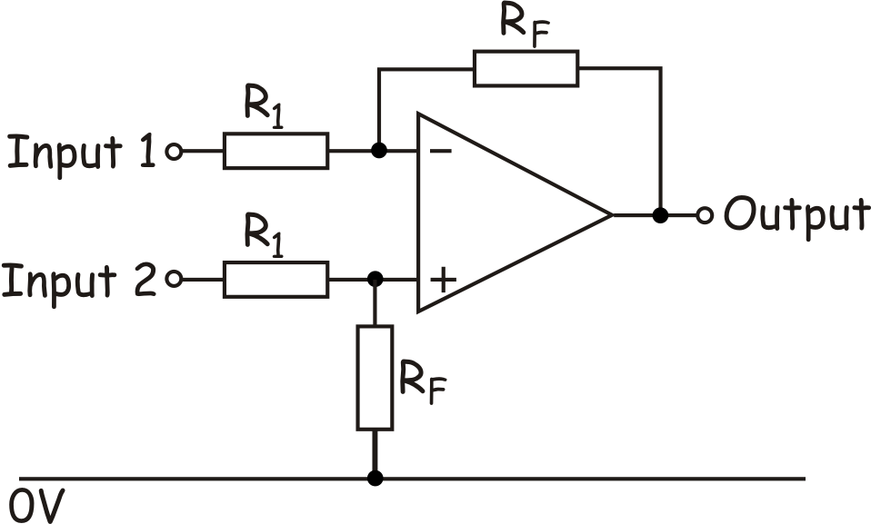
The diagram shows the circuit for an
instrumentation amplifier, used in the
WJEC specification. It is based on an
op-amp difference amplifier. With
careful design, it can match the ideal
characteristics very well. It consists of
two pairs of resistors, labelled R₁ and R_{F}
and an op-amp. In practice, the circuits
for instrumentation amplifiers are more complex.

When used to amplify the output of a bridge circuit, input 1 is connected to output A, and input 2 to output B of the two voltage dividers that make up the bridge circuit.

The next section is NOT examinable! It shows you how to analyse the difference amplifier circuit, using the rules for op-amps developed in earlier modules. If you can follow this, it will help you to understand the way the circuit works.

‘Rules’ for op-amp behaviour:
- If the output is not saturated, the two inputs sit at the same voltage;
- The input impedance of the inputs is so big, they draw negligible current;
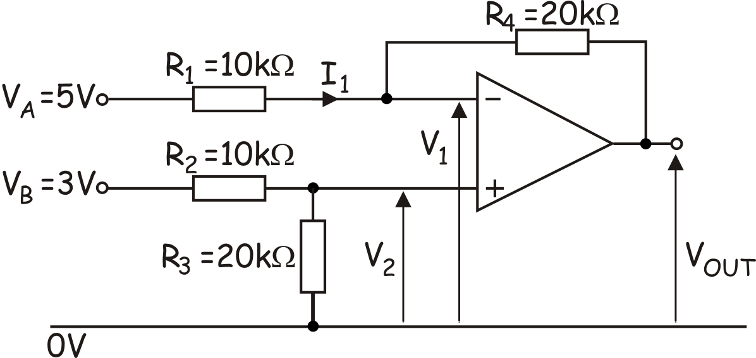
The circuit shown will be used for
this analysis. The sizes of the
input voltages are much greater
than we would expect from a
bridge circuit, but will make the
arithmetic easier!

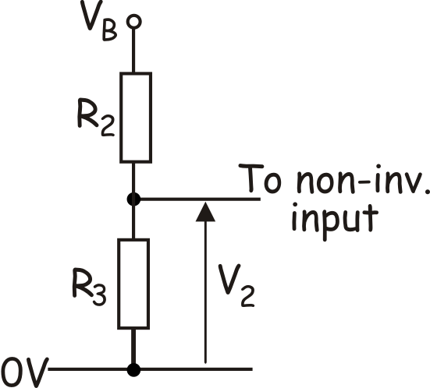
Step 1 – Calculate voltage V₂ at the non-inverting input.
Since the op-amp input draws negligible current,
we have, in effect, a voltage divider, sharing the
voltage V_{B} between the two resistors R₂ and R₃.
Using the voltage divider rule:
V₂ = V_{B} x R₃ / (R₃ + R₂) = 3 x 20/30 = 2V

Step 2 – Deduce the voltage at the inverting input.
Assuming that the output is not saturated, the voltages V₁ and V₂, at the inputs of the op-amp, are equal, so V₁ = 2V

Step 3 – Calculate current I₁.
Looking at resistor R₁, the voltage at the left-hand end of R₁ = V_{A} = 5V.
The voltage at the right-hand end of R₁ = V₁ = 2V.
The voltage drop across this input resistor = V_{A} – V₁ = 3V.
Using Ohm’s law, the current I₁ through this resistor is given by:
I₁ = V/R₁ = 3/10 = 0.3mA

Step 4 – Calculate the voltage drop across the feedback resistor.
As no current flows into the inverting input, all of I₁ flows through the feedback resistor, R₄.
Using Ohm’s law, the voltage drop across R₄ = I x R = 0.3 x 20 = 6V

Step 5 – Calculate the output voltage.
Looking at resistor R₄, the voltage at the left-hand end = V₁ = 2V.
The voltage at the right-hand end = V_{OUT}.
We have calculated that there is a 6V drop across the resistor, with current I₁ flowing from left to right through it. Hence the right-hand end must be 6V lower then the left-hand end.
In other words, V_{OUT} = 2 – 6 = -4V.

You are expected to calculate the output voltage using the formula:
V_{OUT} = V_{DIFF} (R_{F} / R₁);
In the circuit explored above,
V_{DIFF} = V_{B} – V_{A} = 3 – 5 = -2V
(Take care to subtract these in the right order:
V_{DIFF} = non-inverting input voltage – inverting input voltage)
Hence:
V_{OUT} = -2 x (20 / 10)
= -4V.

Exercise 4 (The solutions are given at the end of the topic.)

Calculate the output voltage for the circuit shown below.
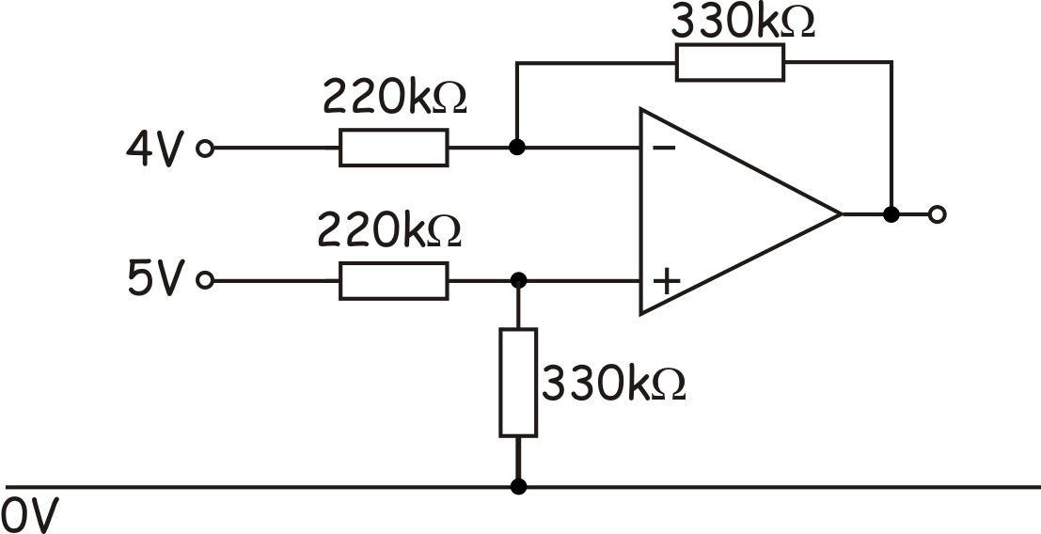

Digital sensing units:

A digital signal has one of only two possible voltage values. Digital signals are usually identified as either ‘logic 1’ or ‘logic 0’. The corresponding voltages are set by the designer of the system, but are usually values close to the positive supply voltage and the negative supply voltage.

The simplest digital sensor is the switch, which has two positions – ‘on’ and ‘off’. Combined into a voltage divider, it becomes a digital sensing unit outputting either logic 1 (which we will define as a voltage equal to the positive supply,) or logic 0 (which we will define as a voltage equal to 0V.)
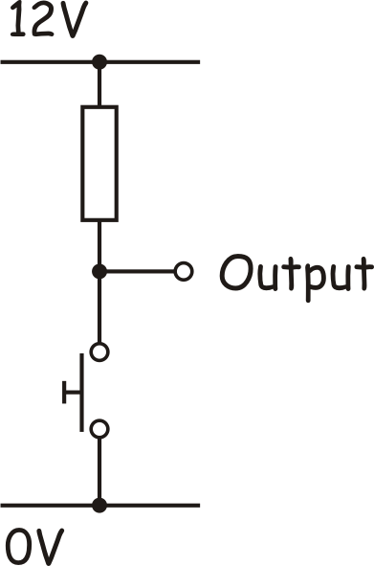
The diagram shows one form of this arrangement.
The sensing unit outputs logic 0 when the switch
is pressed.
To output logic 1 when the switch is pressed, swap
the positions of the switch and the resistor.

This unit looks at two more complicate digital sensors,
used to monitor rotation. One, the slotted disc, is used
to measure the number of rotations made by a shaft, or to measure the speed of rotation. The other, the encoded disc, is used to indicate angular position of a rotating shaft.

The slotted disc:

This can take a number of forms, but a common one is shown in the diagram.
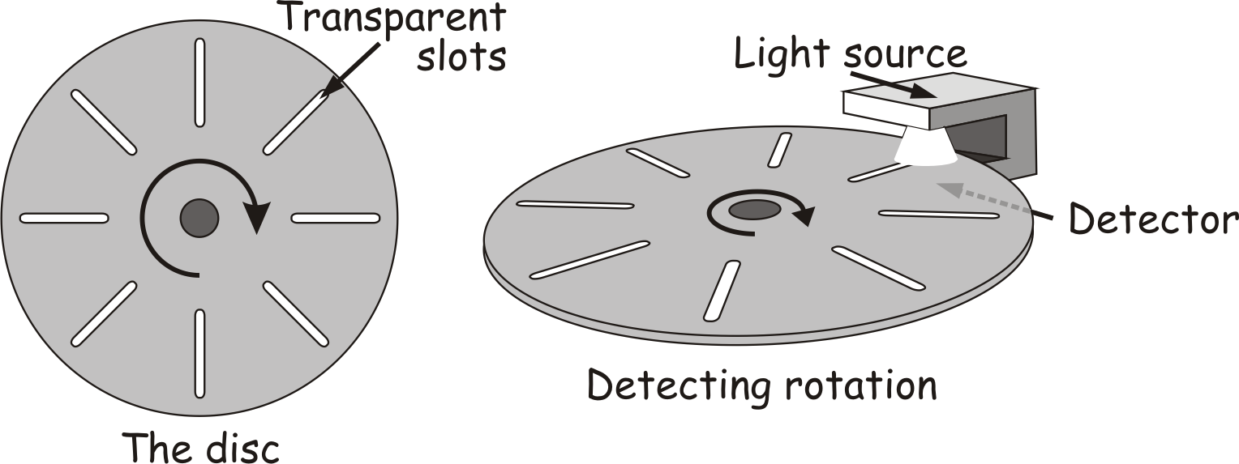

The greater the number of transparent slots in the disc the greater the angular resolution, (meaning that it will sense smaller angles of rotation.) Often infra-red radiation is used instead of visible light.
The encoded disc (also called absolute encoders):

The slotted disc shown above can measure the angle a shaft has rotated through, and by combining that information with the time it took to do so, can measure rotational speed (angular velocity.)

However it has two limitations:
- although it can measure the angle the shaft has rotated through, it cannot pinpoint its current (angular) position;
- it cannot distinguish between clockwise rotation and anticlockwise rotation.

One way to overcome both of these limitations is to use an optically read, encoded disc. We need to consider two versions, the binary encoded disc and the Gray code encoded disc. The only difference between these is the pattern placed on the disc. The following diagrams show these.
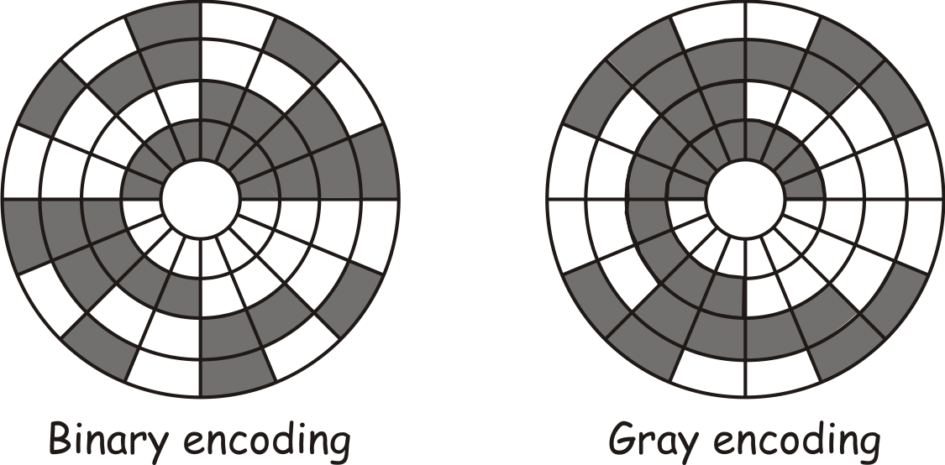

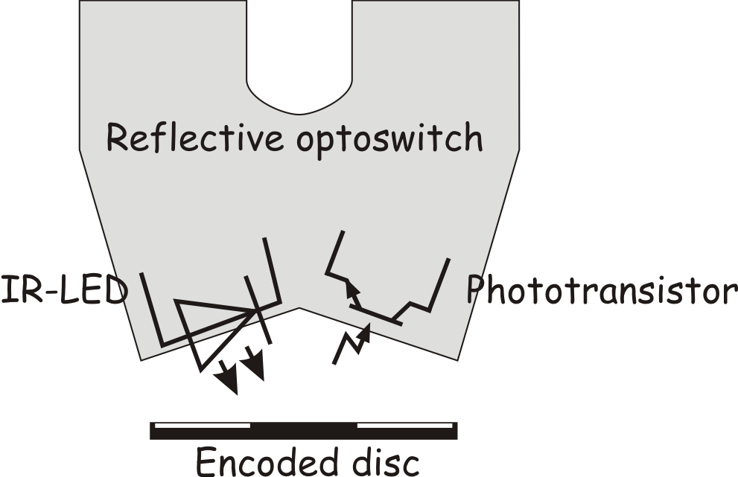
The discs are ‘read’ by a series of reflective optoswitches. An optoswitch consists of an infrared LED and a phototransistor combined in a single package. The phototransistor is arranged so that it can detect the infrared from the LED.
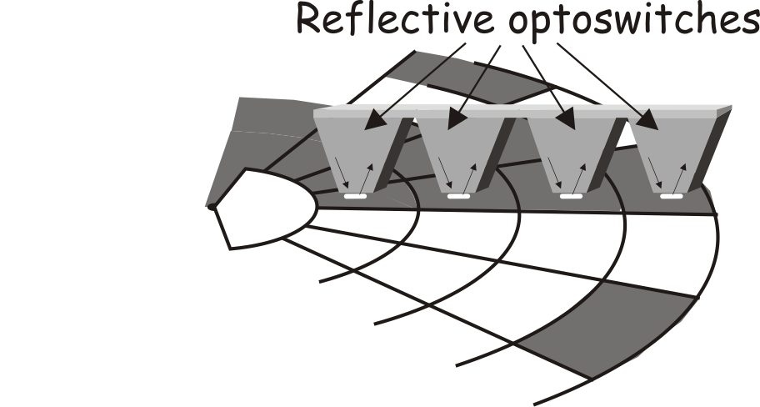

With a reflective optoswitch the infrared beam is only detected by the phototransistor if it is reflected by a white surface close to the switch.
Binary encoded discs can cause problems.
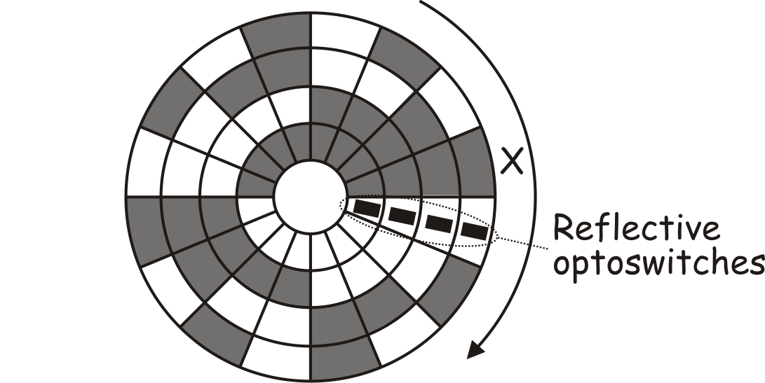
The extreme case is illustrated in the
diagram. The disc is rotating clockwise.

Currently, all four optoswitches are on
white. Suppose that this causes an output
of ‘0000’.

Shortly, segment X will be under the optoswitches, causing a reading of ‘1111’.
It is the changeover that causes the problem. The optoswitches cannot be in a perfect line. The pattern on the disc cannot have an absolutely straight boundary between the segments. One of the optoswitches must move off the white onto the dark area before the others. This will cause a false reading.

The following table shows a possible sequence of false readings that may occur while segment X is moving under the sensors.

Reflective optoswitch
D | C | B | A
0 | 0 | 0 | 0
0 | 1 | 0 | 0 | False
0 | 1 | 0 | 1 | False
0 | 1 | 1 | 1 | False
1 | 1 | 1 | 1

Of course, there are other sequences that may take place instead. Problems can arise whenever moving from one segment of the disc to the next involves changing the output of more than one optoswitch.
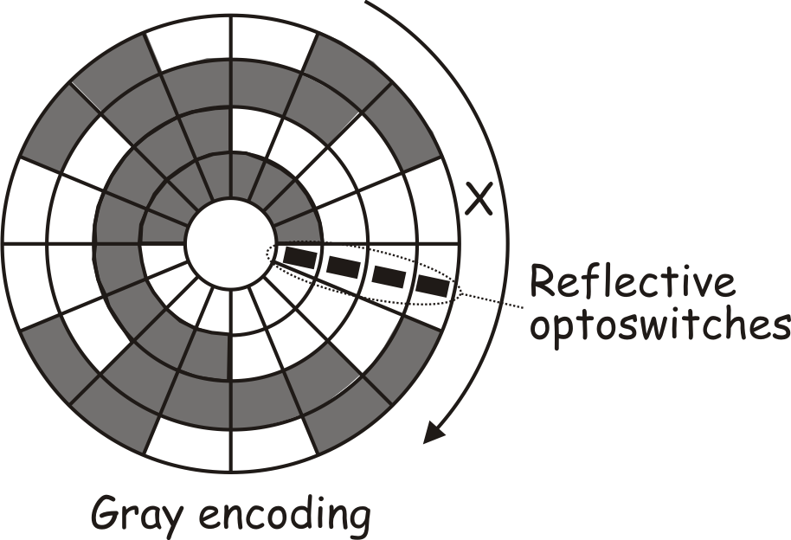
The solution is to use Gray code to encode
the disc. This is designed so that only one
change takes place moving from one
segment to the next. This is illustrated
in the diagram opposite. You should study
this carefully to convince yourself that, as
the disc rotates, only one bit of the output
changes in going from one segment to the next.
As the Gray encoded disc rotates anticlockwise, the outputs of the optoswitches will follow the sequence shown below:

Reflective Optoswitch
D | C | B | A
0 | 0 | 0 | 0
0 | 0 | 0 | 1
0 | 0 | 1 | 1
0 | 0 | 1 | 0
0 | 1 | 1 | 0
0 | 1 | 1 | 1
0 | 1 | 0 | 1
0 | 1 | 0 | 0
1 | 1 | 0 | 0
1 | 1 | 0 | 1
1 | 1 | 1 | 1
1 | 1 | 1 | 0
1 | 0 | 1 | 0
1 | 0 | 1 | 1
1 | 0 | 0 | 1
1 | 0 | 0 | 0

The ‘rule’ is – change the least significant bit (A in this case,) if the result has not occurred before. If it has, then change the next least significant bit (B,) unless that result has occurred. In that case change the next bit, and so on.


The resolution of these discs (i.e. the smallest angle of rotation that they can detect,) depends on how many segments, or rings, that there are.
The ones shown above have a four bit output (four rings, or sixteen segments.) The resolution is 360 / 16 = 22.5⁰.
To measure smaller angles, the number of bits
in the output must increase, making processing
it more complex. The diagram shows an 8-bit encoded
disc.

Practice Exam Questions:

1. (a) A difference amplifier is used to control a fan to keep the temperature constant throughout a pottery kiln. Two temperature sensors provide information about the temperature at the top and the bottom of the kiln.
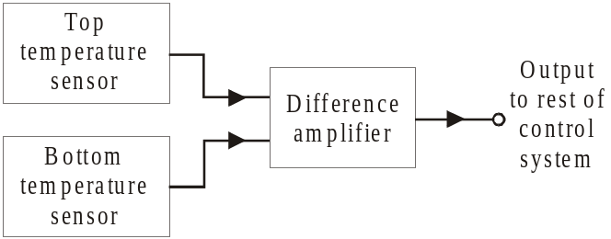

(i) Each temperature sensor consists of a voltage divider, using a ntc thermistor and variable resistor.
Draw the circuit diagram for a temperature sensor, designed to give an output voltage that increases as the temperature increases. [1]

(ii) The circuit diagram for the difference amplifier is given below.

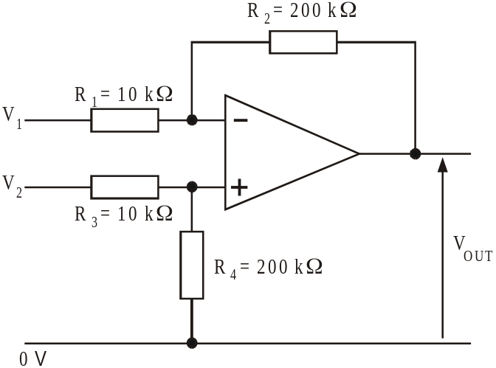

The Top temperature sensor output voltage, V₁ = 2.4V.
The Bottom temperature sensor output voltage, V₁ = 2.1V.
Calculate the output voltage V_{OUT} of the difference amplifier. [1]

………………………………………………………………………………………….………….

………………………………………………………………………………………….….

(b) The difference amplifier is used to amplify the output of a bridge circuit containing a strain gauge S, two equal resistors, R, and a variable resistor VR.
(i) Complete the following circuit diagram, to show how this is done. [3]

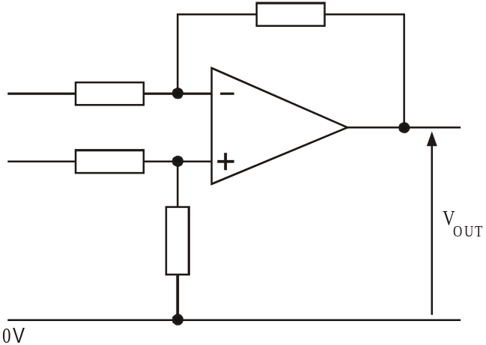

(ii) What is the advantage of this arrangement over a simple voltage divider and amplifier. [2]

……………………………………………………………………………………………………

……………………………………………………………………………………………………

……………………………………………………………………………………………………

(iii) It is important that the op-amp in this circuit has a very high input impedance and common mode rejection ratio.
Explain why a high value is important for these two quantities. [2]
……………………………………………………………………………………………………

……………………………………………………………………………………………………

……………………………………………………………………………………………………

……………………………………………………………………………………………………

……………………………………………………………………………………………………

……………………………………………………………………………………………………

……………………………………………………………………………………………………

……………………………………………………………………………………………………

2. The circuit diagram shows two identical strain gauges connected to precision 100Ω resistors in a bridge circuit.
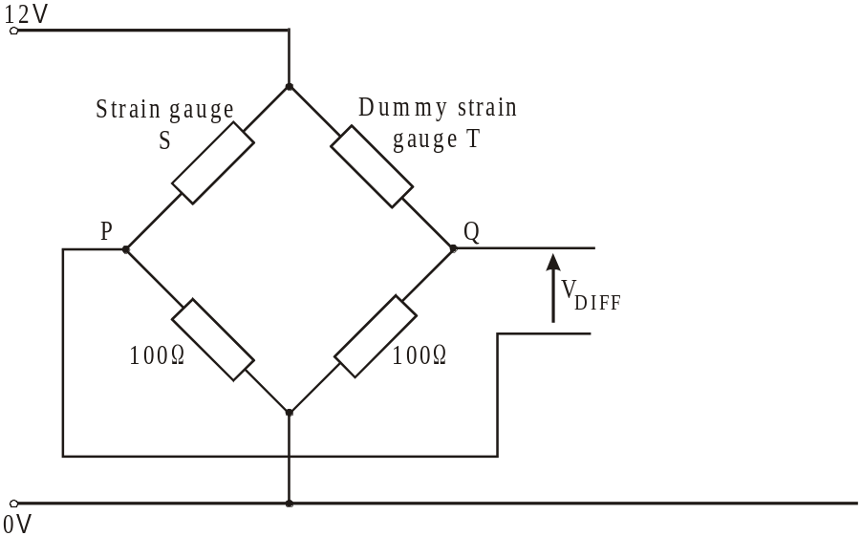
Under test conditions, the strain gauge, S, is found to have a resistance of exactly 100.5Ω, while the dummy strain gauge, T, has a resistance of exactly 100Ω.
(a) Calculate the voltages at points P and Q, and hence work out the voltage V_{DIFF}.
Give your answer correct to three decimal places. [2]
……………………………………………………………………………………………………..

……………………………………………………………………………………………………..

……………………………………………………………………………………………………..

(b) Modify the circuit diagram by adding a difference amplifier based on an op-amp, arranged to amplify the voltage V_{DIFF}. [3]
(c) Choose suitable values of resistors to give a voltage gain of 100. Label the resistors with these values. [3]
……………………………………………………………………………………………………..

……………………………………………………………………………………………………..

……………………………………………………………………………………………………..

(d) Calculate the output voltage of the system under these test conditions. [1]
……………………………………………………………………………………………………..

……………………………………………………………………………………………………..

(e) What is the purpose of the dummy strain gauge, in this circuit? [1]
……………………………………………………………………………………………………..

……………………………………………………………………………………………………..

4. The power supply circuit shown below uses a zener diode to provide good line regulation.

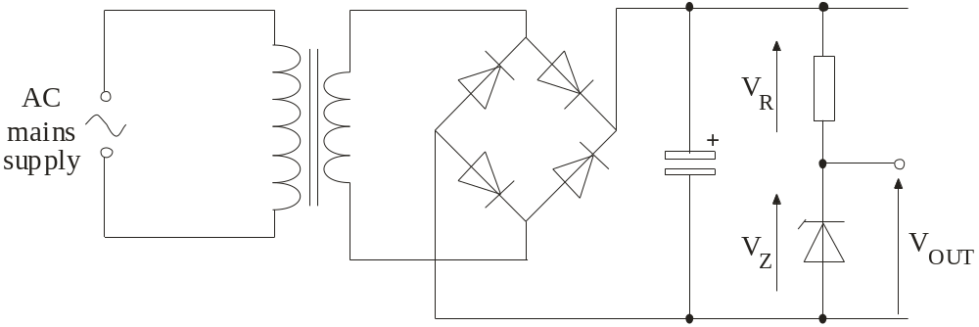

(a) Explain how the circuit provides line regulation. Your explanation should describe what happens to voltages V_{R} and V_{Z} when the AC mains supply voltage increases. [1]

………………………………………………………………………………..................................

………………………………………………………………………………………….………….

(b) A stabilised power supply circuit is shown below.

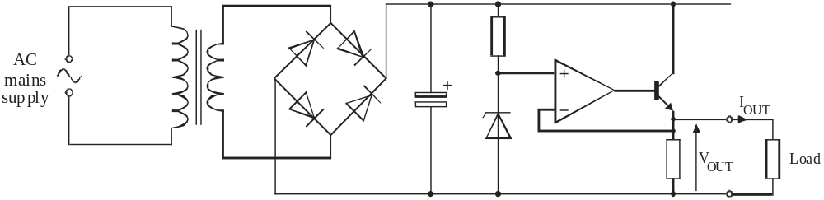
Explain how this circuit keeps V_{OUT} constant as the load current I_{OUT} increases. [2]

………………………………………………………………………………..................................

………………………………………………………………………………………….………….

………………………………………………………………………………………….………….

………………………………………………………………………………..................................

………………………………………………………………………………………….………….

………………………………………………………………………………………….………….
Solutions to Exercises:

Exercise 1:

Using the voltage divider formula:
V_{OUT} = 12 x (2 / 2 + 0.5) = 9.6V.

Exercise 2:

(a) The bridge is balanced, so:
Resistance of P = Resistance of Q
Resistance of variable resistor Resistance of R
or:
Resistance of P = 1.2kΩ
2.5kΩ 2kΩ
so that: Resistance of P = 1.2 x 2.5 = 1.5kΩ
2

(b) Using the voltage divider formula:
new voltage at A = 10 x (2.5 / (2.5 + 1.5) = 6.25V
new voltage at B = 10 x ( 2 / (2 + 1.2) = 6.25V

V_{OUT} = voltage at B - voltage at A = 0V.
The bridge is still balanced even though the supply voltage has changed.

Exercise 3:

Using the voltage divider formula:
V_{B} = 3 x (700 / 350 + 700) = 2.00V
and: V_{A} = 3 x (710 / 366 + 710) = 1.98V
Output voltage V_{OUT} = V_{B} – V_{A} = 0.02V

Exercise 4:

Using the formula:
V_{OUT} = V_{DIFF} (R_{F} / R₁)
V_{OUT} = (5 – 4) x (330 / 220)
= 1.5V
(Take care to subtract the input voltages in the right order –
non-inverting input voltage minus inverting input voltage.)

