Learning Objectives:

At the end of this topic you will be able to;

- draw a timing diagram to illustrate the significance of edge triggering;
- draw a timing diagram to illustrate how a transition gate can be used to produce edge triggering;
- distinguish between the operation of the clocked data input and the set / reset inputs on a D-type flip-flop;
- design a transition gate to a given specification.

D-type flip-flops.

In the previous section, we looked at the simple 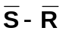 flip-flop which had three significant drawbacks or issues.

- both Q and  outputs would be at Logic 1 if both inputs were held at Logic 0.
- The inputs were active low, i.e. changes occurred on the transition between a Logic 1 and a Logic 0.
- Changes to the output occurred immediately when a change to the inputs occurred.

In many applications these issues would be significant, particularly item (iii) as in modern computers, you only want data to change when you are ready for it, and not immediately. This is particularly true if you are reading information from a memory i.c. where 16-bits of information have to be taken at the same time, each data line from the memory will take fractionally different lengths of time to settle at logic 0 or 1, so it important that time is allowed for the data to settle before it is ‘read’ and decisions made based on its content.

This is achieved by the introduction of a clock line, a single digital input which when it is at Logic 1, causes a change in the output, if such a change is required due to the logic state of the inputs. However if the clock is at Logic 0, no change at the output will occur even if the inputs demand it.

This type of flip-flop is called the clocked S - R flip-flop and it looks like this:


S
Clock
R
Q
You should recognise the right hand side of this circuit as being the simple latch discussed in the previous topic. The addition of the two extra NAND gates and a clock line has provided two advantages.

- changes at the output can only occur when the clock input is at Logic 1.
- The inputs are now active high, i.e. the output changes when the input signal on S or R are Logic 1.

A more detailed explanation of how this circuit works is contained in the Supplementary notes at end of this topic. {However no examination questions will be based on the Clocked S- R flip-flop, it is only included to show the development of the 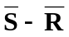flip flop into the D-type.}

Removal of the third problem came about with the development of a new type of flip flop called the D-type flip flop. It’s circuit is shown below:

D
Clock
Q

This flip flop has only one input labelled D, and a clock. The addition of the NOT gate ensures that the inputs to the clocked S-R flip flop can now never be the same.

The operation of the circuit is essentially the same as the clocked S-R flip flop, with the exception that the outputs Q and will now always be the opposite of each other, thanks to the inclusion of the NOT gate.

To SET the D-type flip-flop it is simply a case of setting the D input to Logic 1, and then setting the clock to Logic 1. The output Q will then become a Logic 1, and will be a Logic 0.

To RESET the D-type flip-flop it is simply a case of setting the D input to Logic 0, and then setting the clock to Logic 1. The output Q will then become a Logic 0, and will be a Logic 1.

A simple way of remembering this is that the Logic state of the D input is transferred to the Q output when the clock is high.

Further information about the operation of this circuit will be found in the supplementary notes section at the end of this topic.

In the clocked S-R flip-flop we have considered so far, the outputs Q and can change at any time during the period when the clock pulse is at a logic 1. This type of D-type is called a level-triggered D-type, as changes occur anywhere during the ‘on’ clock pulse.

Edge-triggered D-types:

Having a device where the outputs can change anywhere during the time when the clock pulse is high can be a disadvantage, because we lose some of the control we wanted over when data can be ‘read’ from a memory chip for example.

With the addition of some extra control circuitry we are able to convert a level-triggered D-type into an edge-triggered D-type, where changes to the output Q can only occur, when the clock input is changing from Logic 0 to Logic 1 is required. One way of achieving this is to use a transition gate.

The following circuit shows the full circuit diagram of an edge-triggered D-type made from logic gates
You will notice the clock input to the D type has been modified slightly by the addition of some extra logic gates to ensure that the time available for the D input to be transferred to the Q output is very short indeed. So short that it occurs only during the transition of the clock input from Logic 0 to Logic 1.
Q
D
Clock

We will now concentrate on the transition gate circuitry, and examine how this works. It is made from a simple combination of a NOT gate and an AND gate.

In all our logic circuits to date we have assumed that changes occur at the output of the logic gates at the same instant that the input changes. However this does not happen in reality. There is a very small delay between a change at the input and the output responding to that change which is called the propagation delay and this occurs for all logic gates. Typical delays are between 5 ns and 10 ns (1ns = 10⁻⁹s). You might think that this is so small a time that it can be ignored and for the majority of simple combinational logic circuits this time delay is insignificant.

Normally propagation delays are undesirable as they can affect the performance of logic circuits, particularly if the path length of one signal is very different to another. i.e. if one signal has to pass through many logic gates and another only has one or two to get through.

However on this occasion we will be using the fact that there is a propagation delay between gates in order to create the transition gate. For this application to work, a propagation delay is essential.

The transition gate used in our example above is as follows: (Clock has been replaced by A for the purposes of the explanation.)
B
A
Q

At first glance it does not appear that this system of gates can ever provide an output, since the two inputs will effectively be 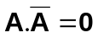.

However if we examine the signals at each point in the circuit and allow for a propagation delay of 5ns between each gate the situation is a little different, as the following timing diagrams will show.

Assume that A has been at logic 0 for some time.
Q
B
A
5 10 15 20 25 30 35
t(ns)
t(ns)
t(ns)
5 10 15 20 25 30 35
5 10 15 20 25 30 35
The signal at A changes to logic 1 at a time of 10ns.
The signal at B changes 5ns after A, because of the propagation delay time of 10ns.
The output Q responds to the 5ns period when A and B are at Logic 1, and produces a pulse of 5ns duration, 5ns after A becomes a Logic 1.
The timing diagrams show that the output of the transition gate is a very short pulse of just 5ns duration. If you study the diagrams carefully you should observe that when A drops to a logic 0 no output pulse will be provided as B will already be at Logic 0. Therefore the only time a pulse is produced is when the input changes from Logic 0 to Logic 1. i.e. on the rising edge of the clock.

We have achieved our objective of producing a very narrow pulse to trigger the D-type, and so our D-type circuit now looks like this.

This version of the D-type is called an edge-triggered D-type, and the vast majority of these operate on a rising-edge, so its full name would be a rising-edge-triggered D-type Flip-Flop. This is by far the most common type available, and you may have to hunt very hard to find a level-triggered D-type today.

The transition gate we have just looked at is only one design, there are many alternative designs, which produce a number of different pulses of varying times. Some transition gates produce pulses which go low for a short period of time, for different applications. We will now look at a few further variations before letting you loose to have a go yourself.

Examples of transition gates.

1. Three inverters + NAND gate.
If we again assume a propagation delay of 5ns per gate, and input A has been at Logic 0 for some time, then the timing diagrams are as follows.
A
D
B
C
Q
C
B
A
5 10 15 20 25 30 3540 t(ns)

5 10 15 20 25 30 3540 t(ns)

5 10 15 20 25 30 3540 t(ns)

The logic level at A changes to logic 1 at a time of 5ns.
The logic level at B initially at Logic 1 changes 5ns after A, because of the propagation delay time of 5ns.
The Logic Level at C initially at Logic 0 changes 5ns after B, because of the propagation delay time of 5ns, which is 10ns after A.

D
5 10 15 20 25 30 3540 t(ns)

The Logic Level at D initially at Logic 1 changes 5ns after C, because of the propagation delay time of 5ns, which is 15ns after A.

Q
5 10 15 20 25 30 3540 t(ns)

The output Q responds to the 15ns period when A and D are at Logic 1, and produces a Logic 0 pulse of 15ns duration, 5ns after A becomes a Logic 1.
2. Five NAND gates.
In this example NAND gates have been used throughout the design, this does not matter, as long as we know the propagation delay for each gate. We will assume a value of 5ns once again and that input A has been at Logic 0 for some time, then the timing diagrams are as follows.
A
B
Q
Q
B
A
5 10 15 20 25 30 3540 t(ns)

5 10 15 20 25 30 3540 t(ns)

5 10 15 20 25 30 3540 t(ns)

The logic level at A changes to logic 1 at a time of 5ns.
The logic level at B initially at Logic 1 changes 15ns after A, because of the propagation delay time of 3 x 5ns. Notice how we don’t need to draw the interim timing diagrams, once we know the propagation delay per gate and number of gates we can determine how long it will take for the logic level at point B to change.
The output Q responds to the 15ns period when A and B are at Logic 1, and produces a Logic 0 pulse of 15ns duration, 5ns after A becomes a Logic 1.

5 10 15 20 25 30 3540 t(ns)

The output
is the inverse of Q, just delayed by 5ns – the propagation delay caused by passing through the last NAND Inverter.

This example should show you that the behaviour of the transition gate can be determined quite easily if you draw careful timing diagrams.
There are a number of things to look for to help you decide what the behaviour of a transition gate is going to be, and also if you are asked to design one, which you could be asked to do in an examination. These are as follows:

- The output pulse will be positive i.e Logic 0 to Logic 1 to Logic 0 if the last gate is an AND gate.
- The output pulse will be negative i.e Logic 1 to Logic 0 to Logic 1 if the last gate is a NAND gate.
- The output pulse will start one propagation delay after the input changes from logic 0 to Logic 1, and last for the number inverters added to the input x the propagation delay per gate.
- Any additional gates added to the output will delay the pulse by a further propagation delay.

Here are a couple of examples for you to try:

Exercise 1:

1. The following transition gate is constructed from an inverter and a NAND gate.
A
Q
B

The propagation delay for each gate is 10ns. Complete the timing diagram below to show what happens after the input A is changed as shown on the graph.

Q
B
A
5 10 15 20 25 30 3540 t(ns)

5 10 15 20 25 30 3540 t(ns)

5 10 15 20 25 30 3540 t(ns)

2. The following transition gate is constructed from 3 inverters and an AND gate. The propagation delay for each gate is 5ns.
A
D
B
C
Q
Complete the timing diagram below to show what happens after the input A is changed as shown on the graph.
C
B
A
5 10 15 20 25 30 3540 t(ns)

5 10 15 20 25 30 3540 t(ns)

5 10 15 20 25 30 3540 t(ns)

D
5 10 15 20 25 30 3540 t(ns)

Q
5 10 15 20 25 30 3540 t(ns)

- Design a transition gate to produce a logic level 0 pulse of duration 25ns, using NAND gates only. Each NAND gate has a propagation delay of 5ns.

The i.c. based D-type.

As you can see adding all of these additional edge triggering circuits to our NAND gate version of the D-type is becoming very tedious, imagine if we had to make a circuit that contained four of these flip flops, there would be NAND gates everywhere!

We are fortunate that rising edge D-type flip flops are available in a 14-pin dual-in-line (d.i.l.) package. The symbol for this D-type flip flop is as shown below.

D
Q
S
R
CK

Two additional connections are shown here, S and R. These are connections which enable the user to SET the output Q = 1, = 0 by applying a Logic 1 to the S input, no matter what the state of the D input or clock (>CK). Similarly the user can RESET the output Q = 0, = 1 by applying a logic 1 to the R input, again irrespective of the state of D or Clock (>CK).

Example:

The circuit below shows a rising-edge-triggered D-type flip-flop.
D
Q
S
R
CK

The following graphs show the signals applied to the D and Clock (>) inputs, complete the remaining graphs to show the output Q and .
Q
Clock
D

In this example, only the rising edges of the clock pulses are important, since this is the only time that the logic state of D can be transferred to Q.
Step 1 : identify the rising edges of the clock pulses.
Q
Clock
D
Rising edges of clock pulse identified.
Step 2: transfer the logic state of D, to Q only at the times where the clock pulse is rising.

Q
Clock
D
Q is a zero for these three rising edges.
Q is a Logic 1 for this rising edges.
Step 3 : Complete which will be opposite of Q.

Q
Clock
D
Q is a zero for these three rising edges.
Q is a Logic 1 for this rising edges.

Now here are a couple for you to do.

Exercise 2:

1. The circuit below shows a rising-edge-triggered D-type flip-flop.
D
Q
S
R
CK

The following graphs show the signals applied to the D and Clock (>CK) inputs, complete the remaining graphs to show the output Q and .
Q
Clock
D

2. The circuit below shows a rising-edge-triggered D-type flip-flop.
D
Q
S
R
CK

The following graphs show the signals applied to the D and Clock (>CK) inputs, complete the remaining graphs to show the output Q and .
Q
Clock
D
3. The circuit below shows a rising-edge-triggered D-type flip-flop.

D
Q
S
R
CK
The following graphs show the signals applied to the D, S, R and Clock (>CK) inputs, complete the remaining graphs to show the output Q and .

R
S
Clock
D
Q

Practical Implications.

Over the last twenty years or so a large number of different types of integrated circuit D-type flip flops have been produced, and whilst they essentially behave in exactly the same way, there are some subtle differences in the symbols used for D-types, in different i.c. technologies. When researching for use in projects or to use in practical experiments it is important that you check which type you are using. The different variations of symbols you are likely to come across are shown below.
D
Q
S
R
CK

Rising edge triggered D-type.


Set and Reset are active high. i.e. a logic 1 signal applied to these inputs activates that function.
D
Q
CK

Rising edge triggered D-type.
Set and Reset are active low. i.e. a logic 0 signal applied to these inputs activates that fu

D
Q
S
R
CK

Rising edge triggered D-type.
Set and Reset are also active low {indicated by the small ‘o’ on the inputs.} i.e. a logic 0 signal applied to these inputs activates that function.
Solutions to Pupil Exercises.
Exercise 1:

1.
Q
B
A
5 10 15 20 25 30 3540 t(ns)
5 10 15 20 25 30 3540 t(ns)
5 10 15 20 25 30 3540 t(ns)

2.
C
B
A
5 10 15 20 25 30 3540 t(ns)

5 10 15 20 25 30 3540 t(ns)

5 10 15 20 25 30 3540 t(ns)

D
5 10 15 20 25 30 3540 t(ns)

Q
5 10 15 20 25 30 3540 t(ns)

3.

Exercise 2:

1.
Q
Clock
D

2.
Q
Clock
D

3.
R
S
Clock
D
Q

Examination Style Questions.

1. The D-type flip-flop in the diagram is rising-edge triggered.

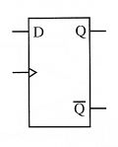

The signals applied to the clock and data inputs are shown below.
Complete the timing diagrams for the Q and 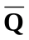 outputs.
[4]

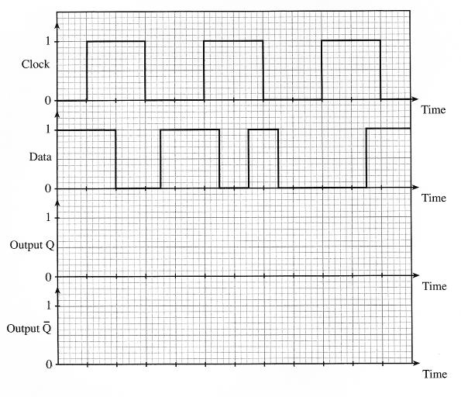

2. The following circuit contains a rising-edge triggered D-type flip-flop.

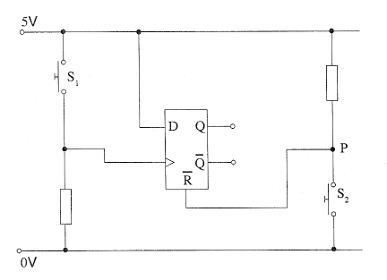
- What is the voltage at point P when switch S₂ in not pressed?

....................................................
[1]
(b) What is the significance of the bar over the ‘R’ in 

.................................................................................................................................................

.................................................................................................................................................
[1]

(c) Complete the timing diagram for outputs Q and .
The signals at the clock, and reset inputs are given, Initially, Q is at logic 0.
[4]

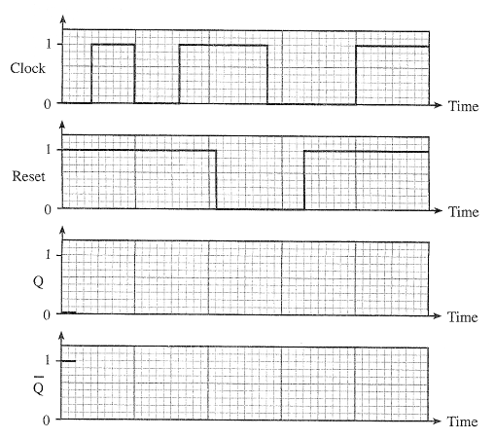

(d) Give an example of a system in which this circuit would be used, and describe its function within that system.

.................................................................................................................................................

.................................................................................................................................................

.................................................................................................................................................

.................................................................................................................................................
[2]

3. The D-type flip-flop in the diagram is rising-edge triggered.

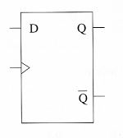

The signals applied to the clock and data inputs are shown below.

Complete the timing diagram for the new Q and outputs.
[2]
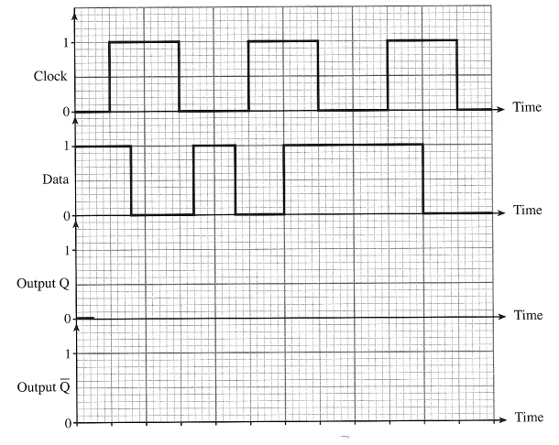

4. (a) The following transition gate is used within a D type flip-flop to provide edge triggering.
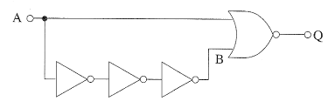

Each gate has a propagation delay of 10ns.
Complete the following diagram to show how the output Q changes when the pulse shown is applied to input A.
Initially, output Q is at logic 0.
[4]
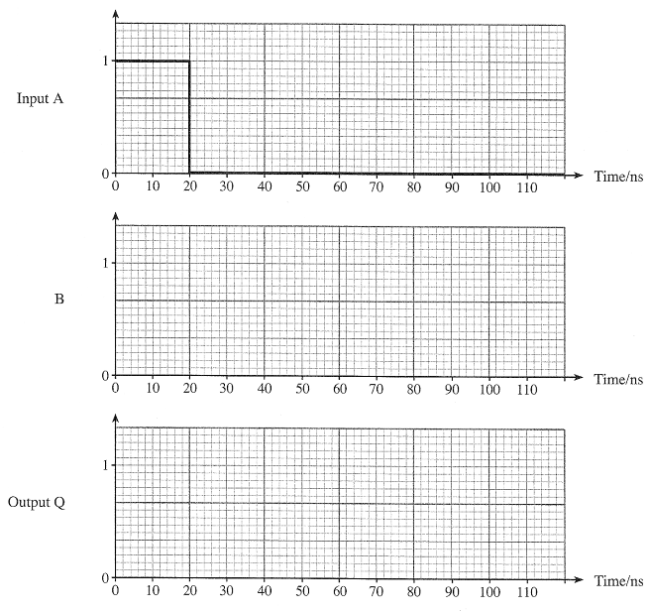
- The D-type flip-flop in the following diagram is rising-edge triggered. The Set and Reset inputs are active high.

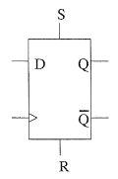

The signals shown in the timing diagram on the opposite page are applied to the D-type. Complete the timing diagram for the Q output.

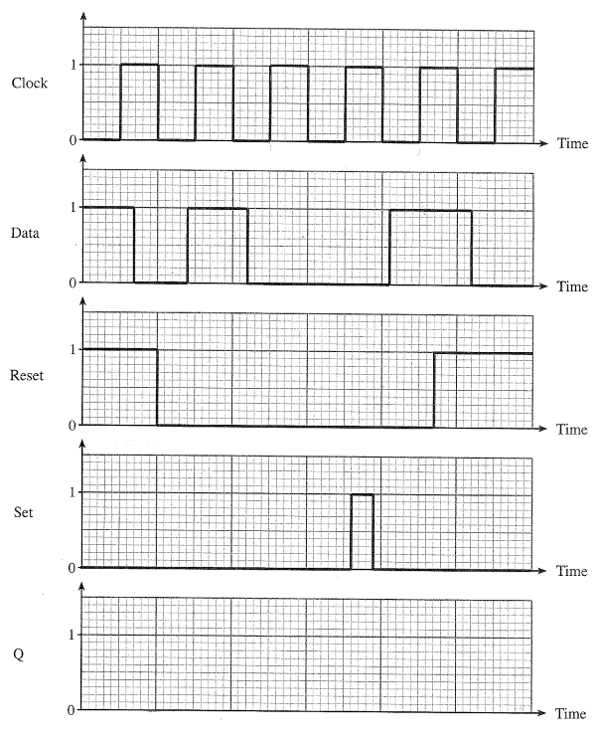

- The D-type flip-flop is modified as shown below. The Set and Reset inputs are disabled by connecting them to 0V.
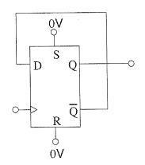

Complete the timing diagrams for the Q and outputs for the new arrangement.
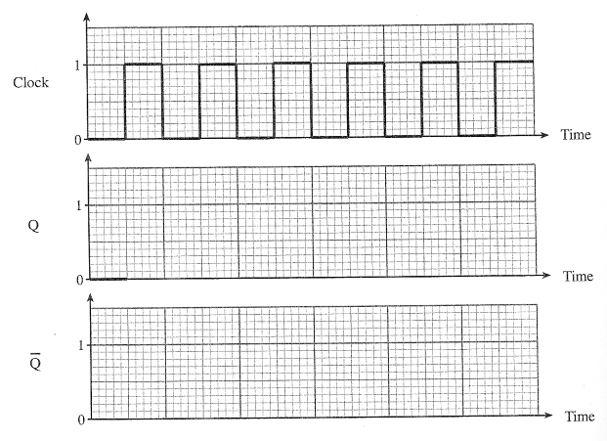
The Q output is initially at logic 0.
[2]

- Design a transition gate to produce a logic level 1 pulse of duration 15ns, using NAND gates only. Each NAND gate has a propagation delay of 5ns.
[5]
6. A D-type flip-flop contains a number of logic gates. Each gate has a propagation delay. The clock input of the D-type goes through a transition gate which uses this propagation delay.

- Explain what is meant by a propagation delay.
[1]
................................................................................................................................................

................................................................................................................................................

................................................................................................................................................

- Why does a D-type flip-flop need a transition gate on it’s clock input?
[1]
................................................................................................................................................

................................................................................................................................................

................................................................................................................................................

- A simple transition gate is shown below. The propagation delay for each logic gate is 10ns.

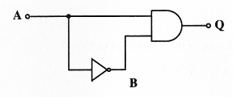

An input signal, shown on the timing diagram opposite, is applied to A.
Show on the diagram how the logic levels at B and Q change over the course of 80ns.
[4]

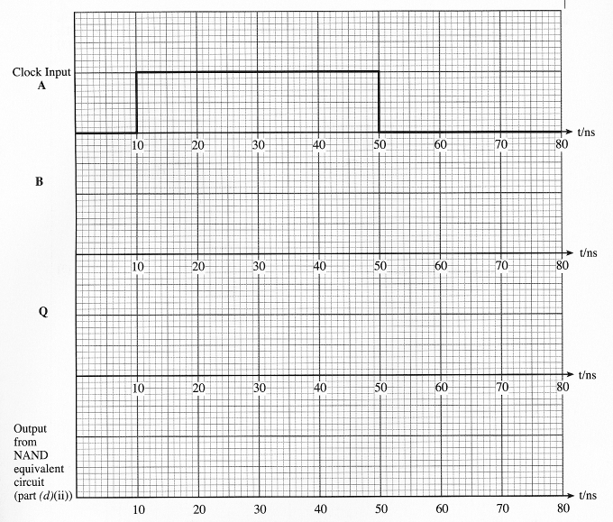
(d) (i) Redraw the transition gate using only NAND gates.
[1]

(ii) Show the effect of using this NAND gate equivalent circuit on the timing diagram above.
[1]

Supplementary Notes on the operation of the D-type flip-flop.
(The content of this section is non-examinable)

This first section shows how the Clocked S-R, flip flop obtains control over when the output changes, and makes the inputs active high. The diagram below shows the logic state of the flip-flop in its reset state, with the clock input at Logic 0, and S and R at Logic 0.
S
Clock
R
A
0
Q
0
0
0
1
1
1
1
1
1
0
0
B
C
D

From this diagram it should be clear that in order for the outputs Q and to change, the input to NAND gate C must become Logic 0, from the work done in the previous topic. This is the output of NAND gate A, which will never go to zero because the clock is at Logic 0 which will always make the output of NAND gate A Logic 1, since to give a Logic 0 output requires two Logic 1’s at the input to a NAND gate.

Therefore it doesn’t matter what is done to the S and R inputs in the current configuration, no change to S or R can cause any change at the output.

Now we will change the logic level of the clock to Logic 1, and leave inputs S and R at Logic 0 for the time being.
S
Clock
R
A
1
Q
1
0
0
1
1
1
1
1
1
0
0
B
C
D
The circuit looks much the same as it did before, the only exception being that a change to S or R now will make the outputs of NAND gates A and B respectively go to a Logic 0, the logic level required to potentially cause a change in output. This is only a potential opportunity because if R was the first line to be taken to Logic 1 we would end up with the following situation.
S
Clock
R
A
1
Q
1
0
0
1→0
1
1
1
1
1→0
0
0→1
B
C
D
In other words no change to the output at all, because the flip-flop was already in its reset state. Consider now what happens if S is taken to a Logic 1 when the clock is at Logic 1.
S
Clock
R
A
1
Q
1
0→1
0→1
1
1→0
1→0
1→0
1→0
1
0→1
0
B
C
D
The state of the outputs has been ‘flipped’ into the SET state where Q = 1, and = 0.
In the 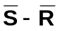flip-flop there was another issue in as much that if both inputs were taken to Logic 0 at the same time then both Q and would give a Logic 1 output which is highly undesirable.

What happens in this modified form of the circuit ? Well lets take a look.

S
Clock
R
A
1
Q
1
0→1
0→1
1→0
1→0→1
1→0
1→0
1→0
1→0
0→1
0→1
B
C
D

This is a little bit confusing on the diagram but assumes that S is taken to logic 1 first and remaining at logic 1, setting the flip-flop, then R is taken to Logic 1, causing a change in the output of NAND gates B and D to effectively make Q and both logic 1. In other words this problem still exists, even though the logic state at which this happens has been reversed, it is now two Logic 1 inputs that create two Logic 1 outputs.

The clocked S - R flip flop then only solves two of the three issues identified with the simple flip flop.

The final addition to the circuit to remove this last issue is the addition of a NOT gate as shown below.
D
Clock
Q

The next section will take you through the timing diagrams to show you what happens as signals change in the circuit.
Example.

The circuit below shows a D-type flip-flop.
D
Clock
Q

The following graphs show the signals applied to the D and Clock inputs, complete the remaining graphs to show the output Q and .
Q
Clock
D
As with our previous example we will complete the solution one step at a time. In reality you would complete this in several stages on the same diagram.

Step 1 : Concentrate on the Q output only – look for the change in the clock pulse – remember only when the clock is high, can the data be moved from the D-input to the output Q.
Q
Clock
D
Q stays low even though Clock is at Logic 1 because D is Logic 0
Q goes to Logic 1 when D changes to Logic 1 because clock is still at Logic 1.

Step 2 : Clock goes to Logic 0.

Q
Clock
D
Q stays high when the clock changes to Logic 0 because D is still Logic 1
Q remains at Logic 1 when D changes to Logic 0 because clock is now at Logic 0, so no changes can occur.

Step 3 : the next clock cycle.

Q
Clock
D
Q change to Logic 0 when the clock changes to Logic 1 because D is now at Logic 0
Q remains at Logic 0 when D changes to Logic 1 and then back to Logic 0 because the clock is at Logic 0, so no changes can occur.
Step 4 : the next clock cycle.

Q
Clock
D
Q remains at Logic 0 as there is no change in D, during the time when the clock is at Logic 1.
Step 5 : The final clock cycle.

Q
Clock
D
Q changes to Logic 1 when the clock changes to Logic 1 because D is also changing to now at Logic 1
Q falls to Logic 0 when D changes to Logic 0 because the clock is still at Logic 1.
Step 6 : Complete , which is simply the inverse of Q.

Q
Clock
D
is simply the inverse of Q

Now here’s a couple of examples for you to try.

Remember:
- there is no need to draw multiple diagrams you can complete your answers on the grid provided.
- Complete Q first and then invert it to produce .

Supplementary Exercise:

1. The circuit below shows a D-type flip-flop.
D
Clock
Q

The following graphs show the signals applied to the D and Clock inputs, complete the remaining graphs to show the output Q and .
Q
Clock
D

2. The circuit below shows a D-type flip-flop.
D
Clock
Q

The following graphs show the signals applied to the D and Clock inputs, complete the remaining graphs to show the output Q and .
Q
Clock
D

Solutions to Supplementary Exercise.

1.
Q
Clock
D
2.
Q
Clock
D

Self Evaluation Review

Learning Objectives | My personal review of these objectives:
Learning Objectives | ☺ | 😐 | ☹
draw a timing diagram to illustrate the significance of edge triggering;
draw a timing diagram to illustrate how a transition gate can be used to produce edge triggering;
distinguish between the operation of the clocked data input and the set / reset inputs on a D-type flip-flop;
design a transition gate to a given specification.

Targets: 1. ………………………………………………………………………………………………………………

………………………………………………………………………………………………………………

- ………………………………………………………………………………………………………………

………………………………………………………………………………………………………………

