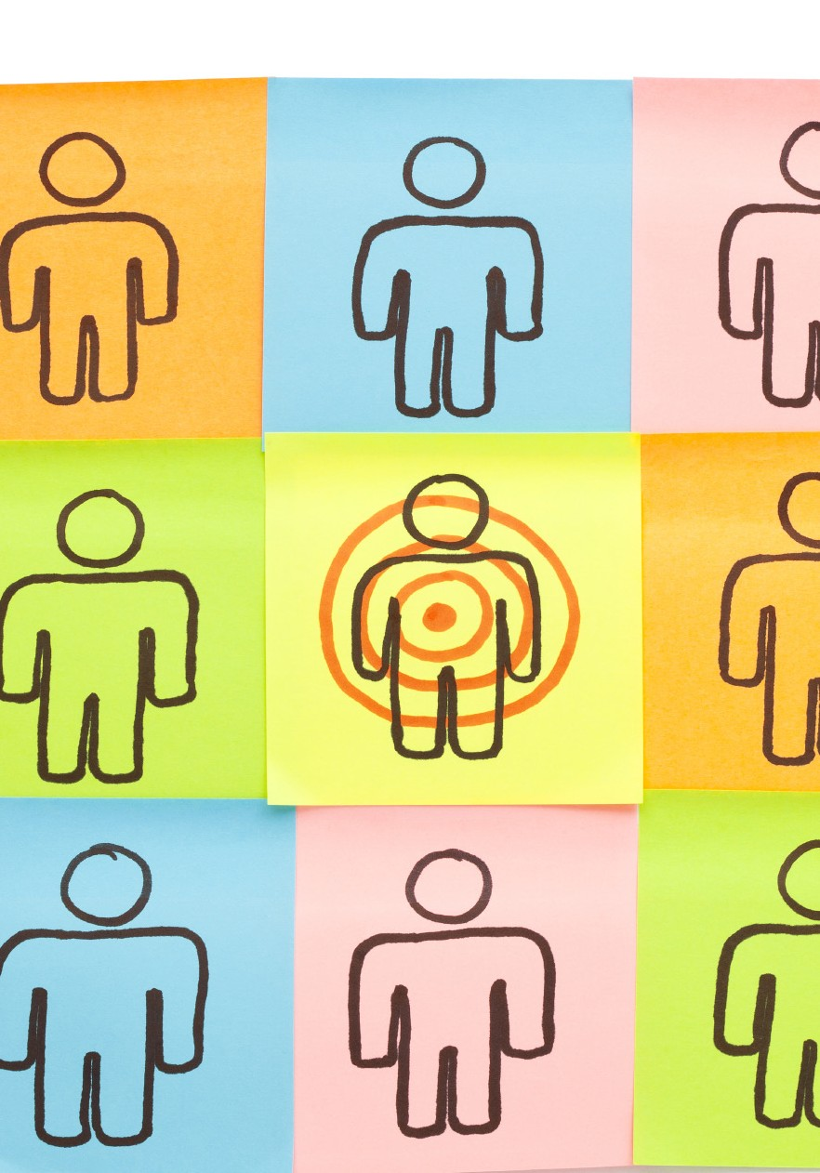
GCSE Business Studies

Businesses and their Customers

Support Materials

KS4 Business Studies

Businesses and their customers

These documents are part of a larger blended learning pack, developed to support GCSE Business Studies. Each document is complemented by a range of digital resources.

These digital resources could be used for whole class stimulus and discussion before directing the students to the corresponding work in the PDF documents, or the students could be asked to work in groups on the paper resources found in the packs and then the digital resource used for feedback and to check understanding.

Businesses and their Customers

The importance of market research

What is market research?

Market research is concerned with finding out information about the market in which a business operates. It involves collecting, presenting and analysing information about customers, competitors and market trends.

Market research will attempt to discover what potential customers need and want to buy, to enable the business to make decisions which are more likely to lead to success.

There are several ways of collecting market research data. Some large businesses have their own marketing departments, whilst others employ outside agencies to do the research for them.

The two main methods of market research are desk research and field research.

What is desk research?

Desk research is carried out using existing sources of information. Some research will already have been carried out by other businesses and organisations and there would be no point in repeating it.

It is called desk research because it is information that can be collected whilst sitting at a desk. As it has already been collected by someone else it is also known as secondary data.

The information may come from:

- Newspaper articles

- Office of National Statistics reports

- Magazine articles

- The Internet

- Libraries

- Government statistics

- Census reports

- Competitors’ reports

Desk research is quicker and easier to collect than field research and it is the cheapest way of collecting data,
but it might not be specific to the business and could be out of date.

Businesses and their Customers

Desk research

Identify the most appropriate forms of desk research for each of the business situations described below (There will be more than one for each situation):

Internet Market research agency publications
Newspapers Yellow Pages

Libraries Magazines Competitors reports and accounts
Office for National Statistics

Muzik, an online music download business would like to find out if consumers music tastes are changing.

Thomas the builder, a local sole trader, wants to find out how reliable a local supplier of building materials has been in recent years.

Davies and Sons, a local plumber wants to research the most reliable boiler to use for customers.

Italian Pizza wants to find out if the increase in healthy eating will affect their sales.

Hilary James wants to open up a day nursery in the local area, she has little money but would like to see how many competitors there will be and how long they have been in business.

Businesses and their Customers

What is field research

Field research involves collecting primary data, this is data from a new source collected especially for the business for a specific purpose. Field research is useful as it provides the business with the exact information it requires. However, there are disadvantages:

- Field research can be expensive to carry out.

- Field research is very time-consuming.

Field research can be carried out in different ways:

Observation involves looking at, and recording, what people do and how they behave. For example, a supermarket may find that sales in one aisle in the store are very poor. By observing people it would be possible to determine whether shoppers were avoiding the aisle. However, observation couldn’t determine the specific reasons why shoppers were avoiding the aisle.

Observation can also be expensive as many people may be needed to carry out the study.

Surveys are a popular method of field research and collecting primary data. Surveys are carried out through the use of QUESTIONNAIRES. There are different ways of conducting surveys:

Personal surveys - These are carried out face-to-face either in the street or through an interview in an agreed meeting place. They are expensive to carry out and can take time to complete. The interviewer can help people to understand the questions and often the interviewer rather than the interviewee will fill out the responses to the questions.

Postal surveys - involve the sending of questionnaires through the post. It is a relatively cheap method, but the response rate to postal surveys is poor; often only 10% or less are returned. Questions tend to be short, so detailed questioning may not be possible. Questionnaires must be well designed and easy to understand.

Telephone surveys can be expensive as interviewers have to phone many people. The response rate is not as good as personal surveys as people do not want to be disturbed at home. However, telephone surveys are cheaper than a personal survey and allow a wider geographical area to be covered.

Internet surveys are increasingly used due to the huge growth in the number of people with Internet access. Online surveys are cheap to carry out and response rates are getting better. Questionnaires have to be well-designed but a wide geographical area can be covered.

Focus groups are small, carefully-chosen groups of people who discuss products and services offered by a business and are encouraged to give their true opinion. A cross-section of the public is chosen to ensure a wide range of viewpoints are considered.

Focus groups normally involve a small number of people and are therefore a cheap method of research.

Businesses and their Customers

Suggest one advantage and one disadvantage of field research compared with desk research.

Advantage:

Disadvantage:

Businesses and their Customers

Field and desk research

Decide whether the activities listed below are field research or desk research.

Office for National Statistics reports

Field research Desk research
Focus group

Field research Desk research

Census reports
Observation

Field research Desk research
Field research Desk research

Survey
Newspaper articles

Field research Desk research
Field research Desk research

Competitors’ reports and accounts

Field research Desk research
Internet research

Field research Desk research

Businesses and their Customers

Market Research Revision Questions

  - What is market research?

  - Why do businesses need to carry out market research?

  - What sort of information might a business want to find out from its market research

  - Complete the table below by identifying the 2 main methods of market research.

Method of market research | Description | Advantages | Disadvantages

Businesses and their Customers

Market Research Revision Questions

  - Identify 5 sources which may be used when carrying out desk research.

  - Explain the following methods of field research

Surveys
Focus Groups
Test marketing
Consumer panels
Observation

Businesses and their Customers

Presenting Data

Once market research has been carried out, researchers need to present their data and decide what the information means.

There are a number of ways in which the data can be presented and each method has its own particular value. The main methods of presenting data include:-
- Pie charts
- Bar graphs
- Line graphs

Pie charts

A pie chart is named for its resemblance to a pie which has been sliced. It is a circular chart divided into sectors or segments. In a pie chart, the area is proportional to the quantity it represents.

Add up all the slices and you get the complete pie.

For example, four coffee shops in a particular high street may sell 400 cups of coffee in a day. The sales for each shop may be as follows:

Shop A | 200
Shop B | 100
Shop C | 50
Shop D | 50

This information may be shown in a pie chart as follows:

The complete circle represents 400 cups, so as Shop A sells 200 or half of this number, it takes up half of the circle and so on.

The chart shows how the market is divided between the

Shop D Shop C

four coffee shops. Shop A

Shop B

Businesses and their Customers

Bar graphs

A bar graph or bar chart is a diagram with rectangular bars with lengths proportional to the values that they represent. The bars can be plotted vertically or horizontally.

The information about the coffee shop shown above may be displayed as follows.

The graph compares the number of cups sold by each shop.
200

150
Cups of Coffee

100

50

A B C D

0

Shop

Line graphs

Line graphs show trends in data, so the coffee shop information shown above is unlikely to be displayed in line graphs.

However, if we consider Shop A: in the previous graphs, although it is now selling 200 cups of coffee a day it might have taken some time to build up to this number. The progress of coffee shop A may have been similar to that shown in the line graph below:

250

200

150
Cups of Coffee

100

50

0
2009

2010

2011

2012

2013

2014

Time

Businesses and their Customers

Market segmentation

What is market segmentation?

If a business sells its products to a wide range of people - its market - it may divide these into smaller groups called segments. This allows the business to make different products to meet the different needs of each group.

The market segment at which a business aims its products is called its target market.

How are markets segmented?

The market is usually segmented in the following ways:

- Age

- Gender

- Socio-economic

- Geographical/Location

- Income

- Lifestyle

- Ethnic and cultural

Age

A business will offer products that will appeal to people of certain ages.

How are the following products targeted at different age groups? Give examples to help explain your answer.

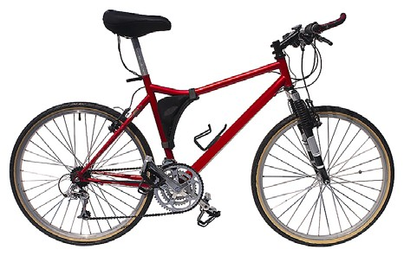
Chocolate bars

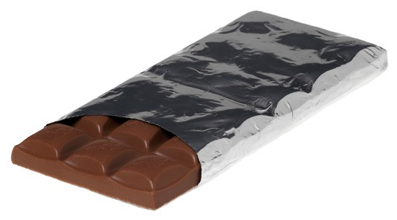
Bicycles

Businesses and their Customers

Gender

Some products are aimed at men and some at women. Some businesses will target a particular gender while others will adapt their products to appeal to both genders to increase sales.

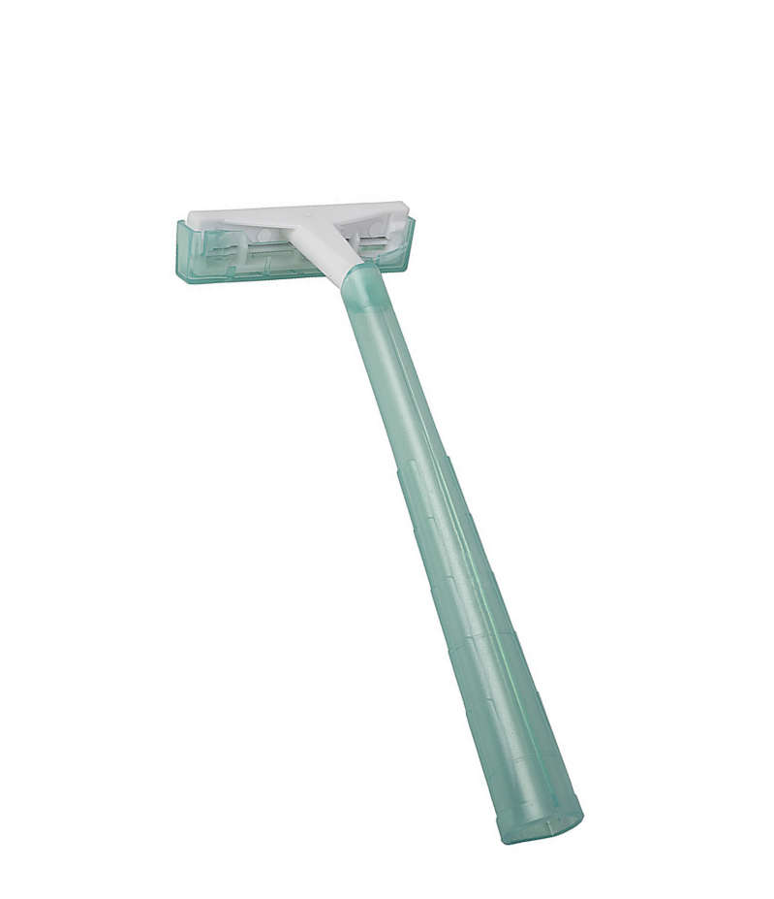
A business manufacturing razors wants to appeal to both the female and male market. How can they adapt their product to boost their sales?

Male market

Female market

Income

People who earn different amounts of money will buy more expensive or cheaper products. Businesses know this so they will offer a range of products at different prices.

Geographical/Location

Markets can be segmented according to where the customer lives. Businesses need to be aware of the different tastes, preferences and lifestyles of customers who live in different areas of the UK, Europe and the World.

For example, washing machines sold in Mediterranean countries have far lower spin speeds than those sold in northern Europe because the washing is much more likely to dry in the open air.

Lifestyle

A person’s lifestyle is their individual pattern of behaviour. This is made up of their attitudes, beliefs and habits. Lifestyle also includes people’s interests and hobbies, so businesses will target people who have a special interest in a particular activity. Lifestyles are changing all the time and businesses need to keep up with current trends.

Businesses and their Customers

Ethnic and cultural

Some goods and services are aimed at particular racial or religious segments of the market. Different groups can provide different opportunities to sell products and services. Equally, businesses need to be aware of cultural differences when selling products.

Socio-economic groups

A more detailed way of segmenting the market by income is by socio-economic grouping, which looks at a person’s occupation and assumes that people with similar jobs and income will have similar tastes and lifestyles.

Businesses assume that people in the higher socio-economic groups are more likely to buy more expensive products and products of a certain type. Once again companies will try to offer products that will appeal to all the socio-economic groups. Being a member of a particular socio-economic group is seen as an indication of spending power. Socio-economic status is often used to group newspaper readers, car owners, holidaymakers etc.

Some businesses will target the mass market with their products. A mass market is where a high volume of sales can be made as most people will be interested in buying the product. Niche markets offer different products that appeal to a smaller number of people.

Businesses and their Customers

Suggest and explain two reasons why it is important for a business to identify its target market.

Businesses and their customers

The Product Life Cycle

What is the product life cycle?

The product life cycle shows the stages through which a product passes through over time. The stages are:

- Development

- Launch/Introduction

- Growth

- Maturity

- Saturation

- Decline

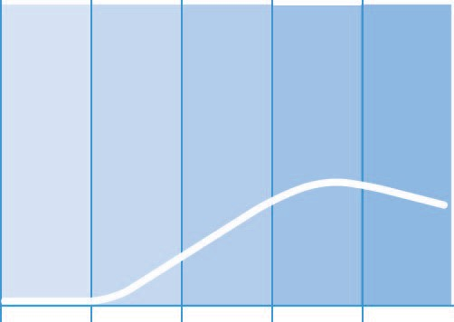
Sales
The product is being designed.
The new product is introduced to the market.
Retailers are more likely
to stock the product as brand recognition grows.
The product reaches its peak and sales become more stable.
Sales fall until product becomes ‘obsolete’

Saturation - sales reach their highest point

Development Introduction Growth Maturity Decline

Time

All products start at the development stage, this is where the research and development takes place and can take years for certain products. This is a very expensive stage for the business as it will invest a lot of money but as the product has not yet been completed there will be no sales.

At the introduction stage the product is then launched on to the market. The launch is normally backed up by an advertising campaign and other forms of promotion to increase awareness of the product, which can be expensive. Sales will gradually increase during this stage.

In the growth stage sales and profits rise and the products are sold in more and more outlets. Marketing will continue to focus on increasing awareness of the product.

Businesses and their customers

In the maturity stage the product reaches a peak in sales. All the research, development and advertising costs have been paid off. Marketing efforts will focus on persuading customers to make repeat purchases. The product
is profitable enough to finance the development of other products.

Towards the end of the maturity stage the market becomes saturated, this is where competitors bring out similar products and take sales away. Eventually the product will go into decline when there are big falls in sales and in some instances the product is withdrawn from the market.

All products will have their own life cycle, some are short, lasting only months, such as fashion, and some last for many years.

Extension strategies

When a product is in the maturity or decline stage of its life cycle, the business may decide to take the product off the market OR to prolong its life by carrying out an extension strategy.

Extension strategies include:

- Bringing out new versions
- Changing the packaging
- Lowering the price
- Finding new markets
- Finding new uses

Sales
Product extension

Development Introduction Growth Maturity Decline

Time

Businesses and their customers

Fill in the blanks in the diagram below to complete the product life cycle, using the following terms: Saturation; Introduction; Development; Maturity; Extension strategy; Decline; Growth.

Sales

Time

Businesses and their Customers

The Marketing Mix

What is the marketing mix?
The marketing mix consists of four important factors needed to market a product or service successfully. All of the factors begin with P - product, price, promotion and place - and so they are known collectively as the 4Ps. The 4 factors of the marketing mix combine to help the business sell as many of their products as possible.

A successful marketing mix will:

- Sell a good product that satisfies a customer’s needs.

- At the right price which customers are willing to pay and which makes a profit for the business.

- In the right place to allow a customer to access it.

- With effective promotion which informs and persuades the customer to buy.

Businesses MUST make sure they get their Marketing Mix right if they are to succeed. If they get just one of the 4Ps wrong, the business is more likely to fail.

The marketing mix will differ from business to business, depending on the product or service being sold.
Some products rely on advertising to sell, others carry out little advertising, some products are sold locally and some globally.

Product

The product itself is often thought of as the most important of the 4Ps. Getting the product right is the basis of the whole marketing process. It is important that businesses develop and design a product or service which satisfies the customers’ needs or wants.

The main features that make up an attractive product include:
- Reliability- is it fit for the purpose for which it was designed and does it do the job well?

- Quality - is the product top of the range or budget?

- Design – how does the product look, its size, colour, weight and shape.

- Flavour – how does the product taste?

- Image—the product needs to create its own identity.

- Features – what can the product do?

- Packaging – shape, size and design.

Product range

Businesses will often offer a range of products and not just one, this is called the product range. Most businesses produce a range of products because different consumers want different products. A business can sell more and make more profit by satisfying different consumers’ wants by targeting different market segments.

Product mix

The product range is part of a company’s total product mix. Many businesses produce more than one type of product, for example drinks, foods and household cleaning products. The product mix is the complete range of items sold by the business.

Businesses and their Customers

- Explain the term ‘product range’.

- Explain the term ‘product mix’.

- Investigate a local business and identify and describe:

Business name:

Range of products and services:

Mix of products and services:

Explain why you think this business provides a range of different products:

Identify the different market segments this organisation is targeting with its products and services.

Businesses and their Customers

Product differentiation

Product differentiation is used by businesses to make their products different from other products they sell and different from those offered by competitors. By altering the design, features, or some other aspect of their product, the business can target certain groups.

Packaging

Most products we buy have some sort of packaging so it is an essential part of the marketing mix.

Why is packaging needed?

Packaging has a number of important functions:

To protect and contain a product

The main purpose of packaging has always been to protect and contain a product. Packaging may protect the product from damage or keep it fresh and clean. Packaging may also be used to control the size of portions. Some packaging is designed to deter tampering, to ensure products reach the consumer in good condition.

Convenience

Packaging often enables products to be transported and displayed more easily. The shape and size of packaging is carefully designed to ensure products can be displayed effectively by retailers and easily used by consumers.

To provide information

Packaging is used to provide product information to consumers such as product ingredients, usage instructions and recycling details- some of which are required by law.

Branding and promoting the product

In a competitive market, branding and packaging are important. We instantly recognise products by the size, shape and colour of their packaging.

Businesses and their Customers

Past Paper Examination Question- 2009 - Adapted

Simon Duffy and Rhodri Ferrier have set up their own business called Bulldog selling male toiletries.

The design of the packaging became important to the business.

Outline reasons why packaging is important in the selling of products by
businesses such as Bulldog. (4)

Businesses and their Customers

Branding

A brand is a named product which:

- Customers see as being different from other products.

- Is easily recognised.

- Builds its image through the use of a recognisable name, logo and packaging.

- A business may be able to charge a higher price for the product.

- May develop a loyal following of customers who are willing to make repeat purchases.

An own brand is a product which is sold under the brand name of a supermarket chain or other retailer, rather than that of the manufacturer of the product. Own brands are usually cheaper than branded products.

Often own brand products are of a similar quality to that of branded products but can be sold for lower prices due to savings made in promotion and packaging costs.

Businesses and their Customers

Past Paper Examination Question- 2013

The Virgin Group has created more than 300 branded products. The Virgin brand is very important to the business.

Why is the brand so important in the marketing of products? (4)

Businesses and their Customers

Price

Marketing also involves getting the price right, so that the product is affordable to customers, but sold at a price that allows the business to make a profit.

The price of the product must reflect the value the customers place on the product. Businesses want to sell at high prices, but consumers want to buy at low prices.

What should a business consider when deciding on a price?

When pricing their product businesses need to consider:

Cost-plus pricing

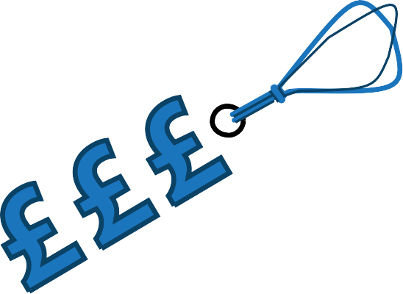
A business will charge a price based on the production costs and a mark-up to allow a profit to be made.

Market-led pricing

A business will charge a price based on an analysis of the market and consideration of the price customers are likely to be willing to pay. This information can be found out by market research.

A higher price may be charged for popular, high quality products. For products where there is a lot of competition in the market then the business must be careful and may need to lower their prices. Low prices also tend to be set for low quality products.

Competitive pricing

Considers what competitors charge. If the price for
the same goods is higher in one business than others, then customers are more likely to go elsewhere.

The role of demand and supply

The marketplace forces the price to be acceptable to buyers and sellers. If the price is too low there will be a high demand, as customers will be keen to buy the product so there will be fewer goods available. If the price is too high then customers will be unwilling to buy the product and the producers will find themselves with too many unsold goods.

Eventually, price comes to a point where businesses get what they want for goods and consumers pay the price they want to pay.

Businesses and their Customers

Pricing strategies

There are a number of ways businesses can price goods in order to increase sales, particularly when they are introducing new goods on to the market. These include:

Penetration pricing

Penetration pricing is the term used when a business charges a very low price for a product, in order to get lots of people interested and to build up brand loyalty. When the product has become established the business will
increase the price. A problem that may arise when the price is increased is that consumers may refuse to continue to buy the product.

Some good examples of the types of products that would benefit from the use of penetration pricing are chocolate bars and magazines, as the markets are so competitive.

Skimming/Creaming pricing

Skimming or creaming pricing is the opposite of penetration pricing and involves setting a high price when the product is introduced to the market, it will then be lowered later on. This strategy will result in high profits but not high sales and helps to make the product desirable. The idea is to introduce products as luxury goods; charging a high price for them so that only the wealthy or enthusiasts will buy them.

Eventually, the price drops after they have “skimmed” the market by taking off the top layer of consumers who have more money to spend. When the price drops the products become available to the mass market and attract a higher number of sales.

Loss leader pricing

Loss leader pricing is a strategy whereby a business sells a product at cost price, or at less than cost price in order to gain a share of the market. Such pricing is used by businesses to attract customers into their stores.

Loss leader pricing is also used by businesses who know that the product they sell will lead to the consumer having to make further, more expensive and profitable, purchases.

Discrimination pricing

Discrimination pricing is a strategy whereby businesses charge different prices to different customers for the same product. Discrimination pricing can be based on:

- Geography - different prices are charged in different regions of the country / world.
- Time - high prices can be charged at busy times.
- Age - people of different ages are charged different prices for the same product.
- Concessions by market - different prices are changed to different markets, for example consumers may be charged more than business customers.

Psychological pricing

Psychological pricing is a pricing method whereby the business wants the consumer to respond to their prices on an emotional, rather than rational, basis. Examples of psychological pricing are:

- The use of persuasive language when pricing, for example “only £1".
- The use of values which are slightly lower than a rounded figure, such as 99p or £995.

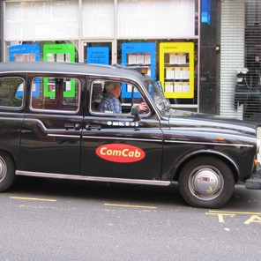
Businesses and their Customers

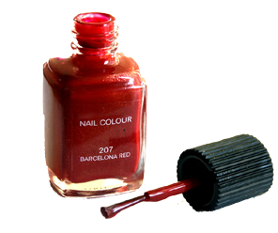
Decide which methods of pricing each of the following small businesses should use. Give reasons for your choices:

A nail bar

A shop that makes cakes to order for special occasions

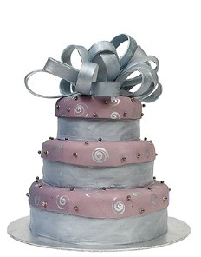
A taxi firm

Businesses and their Customers

Past Paper Examination Question- 2013

Evaluate ways in which the retailers of audio and video equipment can use pricing strategies to maintain the sales of their products. (10)

Businesses and their Customers

Promotion

What is promotion?
Promotion is a type of communication used to inform the public of a product and persuade them to buy it. Promotion involves:

- Making the potential customer aware that there is a product for sale.

- Explaining what the product is.

- Making the potential customer aware of how the product will satisfy their needs.

- Persuading them to buy the product.

Promotional techniques

There are a number of methods or techniques a business can use to promote their products and services, including:

- Advertising

- Sales promotion

- Direct marketing

Businesses and their Customers

Advertising

Advertising includes any paid messages sent to customers about a business or its products.

Advertising is carried out through the media. There are many types of media that can be used, the most popular are:

Television advertising

Television advertising can reach millions of people in most households, it is very expensive both to book advertising slots and to create the advert. Television advertising is generally used by larger businesses. Smaller businesses may be limited to advertising during off-peak time slots that tend to be cheaper due to lower viewing figures.

The use of music, famous personalities, colour, humour and appealing scenery makes television
advertising very effective.

Radio advertising

Radio advertising is cheaper than that on television, but is a very effective advertising medium. Radio advertising can use sounds and music to appeal to the audience. The audiences are smaller than the main television channels, although there are many commercial radio stations that are aimed at specific audiences, allowing advertisers to target a particular market.

There are many regional radio stations - this suits local businesses as they can afford the advertising and target their local customers.

Newspaper advertising

Newspaper advertising accounts for a quarter of all expenditure on advertising in the UK. There are several different types of newspapers:

- National newspapers

- Local newspapers

- Free newspapers

Advertising in a national newspaper can be very expensive, costing up to tens of thousands of pounds for a full page advert. However, local newspapers are fairly cheap in comparison, costing hundreds of pounds.

The cheapest form of advertising in newspapers is classified advertising. Free newspapers are very good for small businesses with low advertising budgets. Free newspapers make their money from advertising revenue; the bigger their readership, the more they can charge businesses to advertise.

Businesses and their Customers

Magazines

Magazines may be weekly or monthly, and are even more effective than newspapers at targeting consumers. Particular magazines appeal to particular segments of the market.

Adverts can be placed in the most popular mass-circulation magazines in order to reach the widest possible audiences. A further advantage is that magazines tend to be kept longer than newspapers – just think of your dentist’s waiting room!

Posters and Billboards

Posters and billboards have a very high visual impact and can stay in place for a long time, being seen daily by a large number of people. However, billboards are often near roads and drivers only see them for a few seconds, therefore they cannot contain much information.

The use of striking images and short catchy slogans are very important design considerations. Posters and billboards are also vulnerable to wind, rain and graffiti. Outdoor advertising, particularly billboard advertising can be very expensive. Small local businesses tend to advertise using posters in their local area.

Transport

Transport is an effective way to advertise, at bus and railway stations and on the sides of vehicles etc. Advertising is also prominent on racing cars.

Cinemas

Cinema provides a platform for businesses to produce effective adverts, with high impact. Businesses can target certain types of films. Cinema advertising provides a captive audience. Cinema advertisements can be longer versions of television advertisements or they may even advertise products that are not allowed to be advertised on television. There are cinema slots available for local businesses.

Leaflets and flyers

Leaflets and flyers are cheap to produce and distribute, they are used by small businesses because of their low cost and can be targeted at specific groups.

Direct or junk mail

Direct or junk mail involves sending advertising leaflets or letters directly to households or businesses through the post. It is a way of targeting particular customers.

Many businesses now keep databases of customer details to enable them to contact them directly and this allows direct mail to be personalised.

Businesses and their Customers

Online advertising

Online advertising on websites has rapidly grown to become a major medium of choice for businesses. There are many different types of online advertising including:
- Adverts on search engine results pages

- Pop-ups

- Adverts on social networking sites

- Directly to email, often called spam

Internet advertising is relatively cheap and is effective at reaching specific target groups searching for a particular site.

There is clearly a wide range of advertising methods available to businesses, but they should consider the aim of the advert, its target audience and the cost of producing and distributing the advertisement.

Businesses and their Customers

Complete the table below by assessing each of the advertising media. You will need to consider:

Cost Target market Reach Effectiveness

 | Advantages | Disadvantages
Television
Radio
National Newspapers
Local Newspapers
Website
Leaflet
Posters

Businesses and their Customers

Sales promotion

Sales promotion is an attempt to give a short-term boost to sales and there are many methods a business can use:

Buy one get one free (BOGOF)
A method of promotion used by many businesses, for a range of products.

Discounts
A good way to get people to notice a product is to provide money off deals using coupons or seasonal sales.

Better value

Better value offers are very popular and include increasing the quantity of the product sold for the same price.

Competitions

Businesses offer prizes in competitions to encourage the customer to buy the product.

Free gifts

Free gifts may be given when a product is bought. It may make the product more appealing, for example a magazine with a free nail varnish.

Customer loyalty cards

Customers collect points every time they make a purchase and are rewarded with money off deals or cash coupons. Loyalty cards are meant to ensure that customers will keep returning to the same store.

Product trials

Product trials are often used in supermarkets, frequently for foods and drinks, in an attempt to attract new customers who may not have tried the product before. A product trial may involve the business setting up a small stall in the store and inviting customers to try their products for free.

Another example of a product trial would be a prospective car buyer being taken out for a test-drive.

Point of sale material

Point of sale material is promotion that takes place where the product is sold. Manufacturers will provide posters, leaflets and displays to retailers to promote the product. There may be large displays in prominent places in shops to help sell the product.

Businesses and their Customers

Direct marketing

A business can profile customers and build up a database of information that they can then use to directly target specific groups who may be attracted to their products or services. Direct marketing usually involves sending advertising leaflets through the post - it is usually referred to as direct mail. The Internet and email are also used by many businesses to target potential customers.

Match the words to the correct definition.

Promotion Direct Mail Advertising Sales Promotion

A method of promotion which aims to give a short term boost to sales e.g. BOGOF.

A paid-for form of communication used to provide information or persuade an audience using the media.

A method of promotion which involves targeting particular customers through sending advertising leaflets through the post.

Type of communication used to inform the public about a product and persuade them to buy it.

Businesses and their Customers

Identify which business is most likely to use each method of promotion, a small sole trader business with a low marketing budget, or a large PLC with a high marketing budget.

Daily television advertisements
Sponsorship of the local under 16 football team

Sole Trader PLC
Sole Trader PLC

Weekly advertisements in the local evening newspaper
A national cinema advertising campaign

Sole Trade PLC
Sole Trader PLC

Door-to-door delivery of promotional leaflets in the local are
A one line listing in the Yellow Pages

Sole Trader PLC
Sole Trader PLC

Celebrity product-endorsement
A daily advertisement on national radio

Sole Trader PLC
Sole Trader PLC

Businesses and their Customers

Place

Place is a very important part of the marketing mix, and refers to how the product is made available and distributed to customers. Businesses have to decide how to get their product to the customer.

For a product to sell it must be in the right place, at the right time. A product is unlikely to be a success if consumers find it difficult to buy.

Channels of distribution
The way in which the product gets from the manufacturer/producer to the consumer is called the channel of
distribution.

The main channels of distribution are shown in the diagram below:

Manufacturer

Wholesaler Wholesaler

Retailer Retailer

Consumer

The manufacturer or producer makes the product in large quantities and sells it on to another business, or directly to the consumer.

The wholesaler buys from producers and manufacturers in bulk at relatively low prices. The main customers for wholesalers are small shops and other traders.

The retailer is any outlet where the consumer can buy the product. Most retailing takes place through shops, ranging from giant superstores to independent small corner shops. Other retail outlets include vending machines, mail order catalogues and direct-mail selling, online shopping and telephone sales.

Traditionally, the retailer’s preferred location was in prime locations such as town centres, but in recent years there has been a growth in the number of retail parks being established in out-of-town areas. A retail park provides the customer with the benefit of a wide range of stores being located in a compact area with convenient parking.

Businesses and their Customers

Methods of distributing products

Internet

Buying and selling via the Internet is known as e-commerce. In recent years there has been a huge increase in online shopping due to the growth in home Internet access. Many businesses that use mail order
catalogues now also have Internet shopping sites. Some businesses sell through a combination of retail outlets and e-commerce.

Customers benefit from e-commerce as it allows them to shop from the comfort of their own homes, 24 hours a day. Prices are often lower for online customers as businesses can make cost savings from not needing to run retail outlets.

Door-to-door selling/telesales

Some businesses employ sales representatives to visit people in their own homes. The sales reps will receive a basic wage, but will need to sell the products or services in order to earn a commission, no sales means low wages. Typical products sold door-to-door include double glazing, telephone/internet services and energy deals.

Many businesses use telephone sales to try to sell their products, this is very popular with financial products, such as insurance, and mobile phone sales.

Mail order

Some businesses supply their goods using mail-order catalogues, whereby goods are delivered through the post or by special delivery. Some larger businesses may have their own delivery vans.

Vending machines

Vending machines are increasingly used to sell a wide range of products, including confectionary and drinks in leisure centres, personal hygiene products in public toilets and even reading glasses and electrical products in airports.

Businesses and their Customers

Past Paper Examination Question- 2009

Beth Jones owns and runs a shop called Cambria Grocer. The shop sells food such as fruit, vegetables, cold meats and dairy products. Her customers are local people, however, tourists and some customers are willing to travel to her to buy her high quality goods.

Beth has realised the importance of using the Internet to sell her products. Therefore, she is considering using the Internet to sell her goods on her own site.

Evaluate Beth’s plan to sell her products by using the Internet. (8)

Businesses and their Customers

Past Paper Examination Question- 2013

Ryan Davies has been a keen reader since childhood. After being made redundant from a travel agent business, where he had worked for a number of years, he decided to set up a shop selling new and second hand books.

Shopkeepers such as Ryan are sometimes called retailers. Briefly describe
one function of retailers. (2)

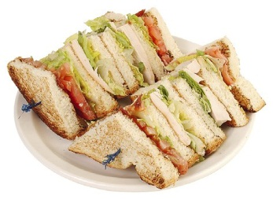
Businesses and their Customers

Sally is starting a new business, she wants to set up a sandwich bar in the town centre.

Sally will make fresh sandwiches to sell to shoppers and workers, and she wants to use fresh local produce to make good quality sandwiches and rolls. Sally also wants to sell other healthy snacks and drinks.

Produce a marketing mix for Sally by completing the grid below.

Product | Price
Place | Promotion

Businesses and their Customers

Marketing Constraints

Businesses use marketing to inform and persuade customers to buy their products and services, so that they can make a profit.

Sometimes businesses may become over-enthusiastic or aggressive with their advertising and develop marketing campaigns that are inappropriate or misleading. Boundaries must be set to define the limits of acceptable behaviour.

Businesses have to carefully consider their marketing activities and ensure they are acceptable to:

- Customers

- Regulatory organisations

- Pressure groups

Customers

Consumers themselves will impose constraints on businesses in a number of ways, namely:

- Refusing to purchase goods that are overpriced or poor quality and that do not offer value for money or meet their needs.

- Reacting negatively to aggressive marketing campaigns such as cold-calling activities.

- Not buying products that are deemed detrimental to the environment or their health e.g. contaminated food.

- Complaining about advertising campaigns.

Regulatory organisations

Organisations must carefully consider the content of their advertising materials. It is important not to offend different groups within society as offence may lead to complaints to the Advertising Standards Authority.

The Advertising Standards Authority (ASA)

The Advertising Standards Authority monitors and controls advertising and judges what can be broadcast, printed or displayed. The ASA has developed a Code of Conduct which guides advertisers on how to carry out advertising activities. The ASA also responds to complaints made by consumers concerning advertising content.

Trading Standards

Trading Standards Departments are operated by local councils. They aim to protect consumers and to encourage honest business practices, as well as to target organisations that are operating unfairly and illegally.

Trading Standards are also interested in the marketing activities of organisations and are concerned with ensuring that advertising is carried out in a way that adheres to legislation such as the Trade Descriptions Act.

Businesses and their Customers

Consumer legislation

Businesses need to be aware of, and understand, the various consumer laws that exist when carrying out marketing activities.

There are many laws which protect consumers from being sold, namely products that are:

- Poor quality, so they break easily

- Wrongly described

- Incorrectly weighed or measured

- Advertised in a misleading manner

- Sent to the buyer without being ordered

- Sold on credit with misleading information regarding interest rates, repayment dates etc.

Businesses should ensure that products are described accurately in advertisements and that no misleading claims are made about the product being advertised.

Pressure groups

Pressure groups are organised groups of people who may disagree with the sale of certain products, or the advertising campaigns of particular organisations. Protests by pressure groups can sometimes influence the marketing decisions made by a business as they want to avoid bad publicity.

Pressure groups may encourage the public to boycott a business’s products or services until it changes its policies.
A few examples of well-known pressure groups are:

- Greenpeace

- Friends of the Earth

- Mencap

- Earth First

Businesses and their Customers

Marketing constraints

Decide whether you agree or disagree with the following statements:

All businesses can be relied upon to market their products fairly and responsibly

Agree Disagree

The Advertising Standards Authority is an organisation that monitors and controls advertising

Agree Disagree

Pressure groups are groups of people who use their collective power to influence the actions of a business

Agree Disagree

Consumers can complain to the Advertising Standards Authority if they are offended by an advertisement

Agree Disagree

The legal restrictions on advertising have reduced in recent years allowing advertising to be more controversial

Agree Disagree

Businesses are able to market their products with very few restrictions

Agree Disagree

Consumers will often themselves impose restrictions on unethical businesses by refusing to purchase their products.

Agree Disagree

