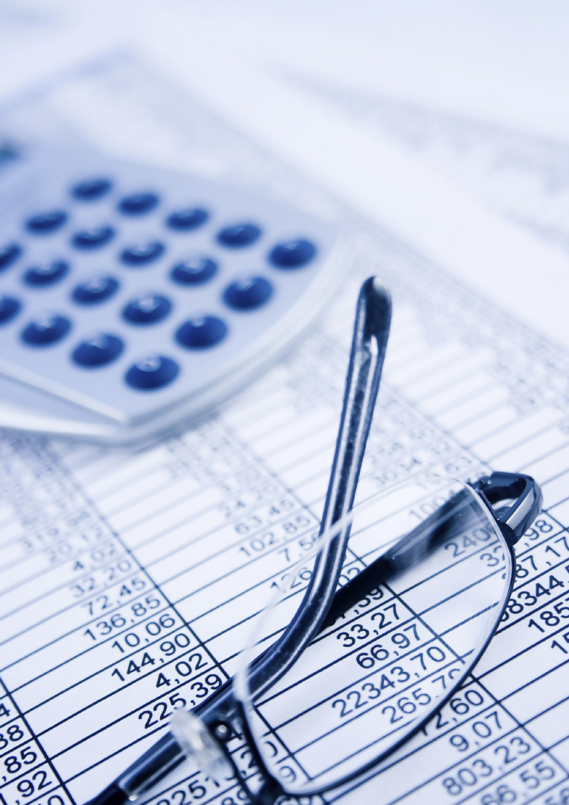
GCSE Business Studies

Business Finance and Control

Support Materials

Business Finance and Control

These documents are part of a larger blended learning pack, developed to support GCSE Business Studies. Each document is complemented by a range of digital resources.

These digital resources could be used for whole class stimulus and discussion before directing the students to the corresponding work in the PDF documents, or the students could be asked to work in groups on the paper resources found in the packs and then the digital resource used for feedback and to check understanding.

Business Finance and Control

Sources of Finance

All businesses need money or finance to be able to operate. Finance allows:
- The setting up of the business - this is often known as Start Up Capital.

- The expansion of the business - this usually involves extending buildings, buying new sites, purchasing machinery, vehicles and equipment i.e. Capital.

- Businesses to pay their day-to-day bills.

Where do businesses get their money?

- Internal sources

- External sources

Internal sources are sources of money from within the business, from the owner or from previous business income.

External sources are sources of money from outside the business, from other people putting money into the business.

Internal sources of finance

1. Owners’ funds

This is money that is put into the business from the private savings of the owners. Many businesses are started using the owners’ own savings, an inheritance or redundancy pay from a previous employer.

2. Reinvested profits

When businesses make profits, the owners can decide to spend these on themselves or to use some or all of the profits to expand and improve the business. Such profits are also called:

RETAINED PROFITS or PLOUGHED BACK PROFITS

as they may not be used straight away and are available for future investment.

Business Finance and Control

3. Selling assets

Some businesses will have possessions that they no longer need. These can be sold off to raise money needed for other investments. Such assets may include:

- MACHINERY— which is still usable. It is sold to competitors or to businesses just setting up. If it is not usable it is sold for scrap.

- LAND—property and buildings no longer required.

- PARTS OF THE BUSINESS—perhaps a brand or whole factory may be sold to a rival because the business wants to concentrate on producing a smaller range of goods.

Business Finance and Control

External sources of finance

- Borrowing from banks

For most businesses the main source of finance is commercial banks such as Barclays, HSBC, RBS and Lloyds.

These organisations look after the money for depositors - individuals and businesses - knowing that these people will not want the money straight away, they will lend this money to other individuals and businesses.

The two main types of finance banks provide are:

- Loans

- Overdrafts

Loans

These are provided to businesses:

- Usually for a fixed number of years—often around 5 to 10.

- For large sums of money.

- Usually to buy capital goods.

- Usually with a fixed rate of interest.

- Repayment is often made in instalments, at set times of the month\year.

- Includes mortgages, which are loans secured against property or land.

- They are long term liabilities of the business. (Find out about this later).

Overdrafts

Overdrafts allow businesses to take more from their accounts than they have in them. The business is allowed to overdraw up to a certain limit.

Features of overdrafts include:

- They can be brought to an end at any time if the bank is not happy with the way the business is being run or are uncertain about whether debts can be repaid.

- Usually for smaller sums of money.

- To pay for day-to-day expenses.

- The interest rate may vary but, if the overdrawn amount is reduced as money is paid in, the amount of interest may be low.

- They are short term liabilities of the business. (Again, find out about this later).

Business Finance and Control

- Share issues

Limited companies are able to raise extra finance by selling new shares.

What is the difference between Public Limited Companies and Private Limited Companies on where they can sell their shares?

- Taking on new partners

A sole trader, or a partnership, may invite people to become a partner in the business. The new partners would invest their own money into the company.

Fill in the table below to show two advantages and two disadvantages to a business of taking on extra partners.

Advantages | Disadvantages
1. | 1.
2. | 2.

Business Finance and Control

- Hire purchase (HP)

This is a type of finance used to fund a specific purchase such as a machine or vehicle where:

- Money is borrowed from Finance Houses - many of these are owned by banks.

- Finance Houses charge fairly high rates of interest.

- A deposit has to be paid.

- Payments are made in regular instalments.

- The item purchased remains the property of the Finance House until the final payment is paid, at which time when ownership passes to the borrower.

- Goods can be reclaimed by the Finance House for non-payment.

Leasing

This involves renting machinery, equipment and vehicles. The business never owns these items but it makes a regular payment to the owners of the asset. The main advantages of this are that:

- Maintenance and repair costs are paid by the owner of the asset rather than the owner of the business.

- Updated equipment will be provided by the owner of the asset.

Explain why HP and leasing are external sources of finance for a business.

Business Finance and Control

The owner of a printing business needs a new printing press. Would you advise the owner to purchase the machinery through HP financing or leasing? Give reasons for your choice.

- Grants

There are a whole range of grants made available by a wide number of organisations including local and national governments and the European Union, to persuade businesses to settle in a particular region.
The area usually has high levels of unemployment and/or land available and has the potential for growth. The grants can take a number of forms such as:

- Money given to support specific projects

- Rent free land or factories

- New business training and support

- Tax breaks so that the business has reduced or no tax payments for a certain length of time. There may be no need to pay corporation tax or business rates or employers national insurance.

These grants obviously cut the costs of setting up businesses and encourage firms to move into a specific region.

Trade credit

- This is a short term method of financing a business.

- Trade credit is used to buy stock or materials from a supplier who allows up to 30 days of interest free credit to other businesses.

- The buyer is often able to sell the goods before they need to be paid for to be able to make a fairly quick profit.

Venture capital

Venture capital is money provided by investors, mainly to new businesses with potential for growth but in fairly risky markets. The investor supplies the money and has part ownership of the business.

Businesses at least partly-funded by venture capital tend to be in high-tech industries, such as biotechnology, IT and software design.

Business Finance and Control

Past Paper Examination Question - 2012

Below are examples of types of finance which may be required by businesses.

Select those which are external forms of finance.

(3)

Bank loan | Retained Profit
Government Grants | Selling assets
Personal Savings | Selling shares on the Stock Exchange

External Finance
1.
2.
3.

Business Finance and Control

Past Paper Examination Question - 2008 - Adapted

Fred Little and Carol Taylor are business partners who sell walking and cycling equipment in their shop in a Mid Wales town.

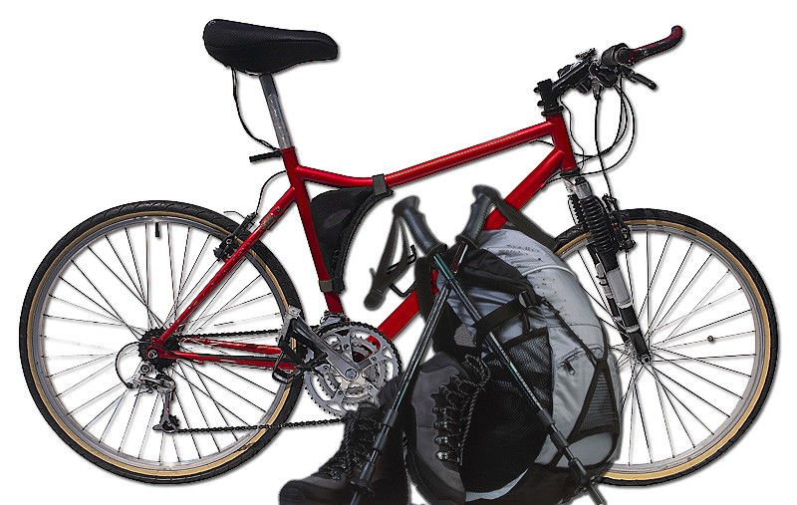

Suggest and describe two sources of finance Fred and Carol may use to gain the money to buy and equip the shop.

(4)

(i)

(ii)

Business Finance and Control

Choosing the Right Finance

Businesses have a number of types of finance to choose from. The decision on where to obtain the money will be based on a number of factors.

1. Availability of finance

- Banks or Finance Houses may not be willing to lend to certain businesses.

- Sole Traders and Partnerships cannot sell shares.

- The business may be in the wrong location for government grants.

Interest charged

Some sources of finance will charge higher rates of interest than others but the total amount of interest paid may be lower.

The rate of interest is often based on the possible risk to the lender so less risky businesses will usually pay lower rates of interest.

Time for repayment

Some borrowers will be given a long term to repay, other loans may need to be paid back sooner.

Suggest a type of finance which would need to be paid back sooner.

Suggest two types of finance where the borrower is given longer to repay.

Suggest two types of finance which may never need to be repaid.

Business Finance and Control

- Amount of money needed

Some types of finance are more suitable for borrowing small sums of money, others for large sums. Which of the following are likely to require large sums of borrowing and which will require small sums?

Extending a factory
Buying materials

Large sums Small sums
Large sums Small sums

Paying the electricity bill
Financing a lorry

Large sums Small sums
Large sums Small sums

- Capital and revenue finance

Some finance is needed to buy capital goods, some to cover day-to-day running costs of the business.

Long and short term finance

Some finance is needed for the short-term and some for the long-term.

Which of the following are likely to be needed short-term and which long-term?

Extending a factory
Buying materials

Long term Short term
Long term Short term

Paying the electricity bill
Financing a lorry

Long term Short term
Long term Short term

Business Finance and Control

- Effect on business ownership

Some types of finance may have an impact on the ownership and running of the business, whereas other types of finance just provide money and will not affect ownership.

Suggest three types of finance which may affect ownership.

- Liability

The type of finance may be determined by the effects of limited and unlimited liability.

What is meant by the statement above and how will the type of finance be influenced by
the liability of the business?

- Administration charges

Sometimes it costs businesses to arrange finance. Such charges pay for the costs of the clerical workers who arrange the finance and for the legal costs which need to be paid to administer the finance.
These charges may influence where the finance is obtained.

Business Finance and Control

Obtaining finance from banks and selling shares

There are differences between obtaining finance from banks and from selling shares. Consider the differences between the two under the following headings:

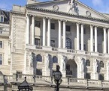
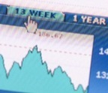
Payment to lender :

 | Banks | Shares

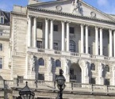
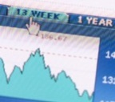
Repayment time :

 | Banks | Shares

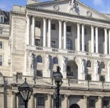
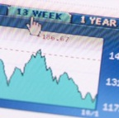
Control over business :

 | Banks | Shares

Business Finance and Control

Past Paper Examination Question - 2004

Halen Môn is natural Welsh sea salt, harvested from the waters around Anglesey.
The Anglesey Sea Salt Company Ltd. has developed processes to obtain this traditional product. Halen Môn salt is suitable for kitchen or table use, and is particularly delicious with fresh raw vegetables and salads. The salt is sold by food shops and food catalogues throughout the United Kingdom.

Suggest and evaluate ways in which The Anglesey Sea Salt Company Ltd could raise finance
if it wishes to expand production.
(8)

Business Finance and Control

Business Plan

To be successful, businesses should have a plan for their development. This is particularly true if they need to borrow money from financial institutions such as banks or if they want to persuade potential investors or shareholders to put money into the business.

Items which may be found in a business plan include:

Legal details:

Such as the business name and address.

Suggest a reason why legal details should be included in a business plan.

Current owners:

Current owners’ details, including possibly their CVs.

Suggest a reason why current owners’ details should be included in a business plan.

Type of ownership:

Whether this is sole trader or partnership or limited company.

Suggest a reason why type of ownership details should be included in a business plan.

Business Finance and Control

Purpose of loan:

Loans and other finance are most likely to be given for projects involving the expansion or profitability of the business rather than for day-to-day expenses. However, a business plan may be needed if the bank is being asked for an overdraft.

Type of product/service:

Suggest a reason why type of product/service details should be included in a business plan.

Current and projected financial information:

Details such as:

- Cash flow forecast *

- Profit and loss account*

- Balance sheet*

Details of market research:

Market research shows whether there is a market for the good or service so that sales, revenue and profit can be estimated. Research results can also help a business when considering the type of marketing and promotion needed.

* These will be explained in detail later

Business Finance and Control

Past Paper Examination Question - 2012

Ali has set up a juice bar in a busy town centre location. Here he uses fresh fruit which is processed to create a healthy drink.

Ali competes with a number of other – mainly larger – businesses in the town. He is thinking about expanding his business and realises that he will need to draw up a business plan.

(i)
Why will Ali draw up a business plan if he is going to expand the business?

(2)

(ii)

1)
Apart from name and contact details, suggest two items Ali will need to include in his business plan.

(2)

2)

Business Finance and Control

Past Paper Examination Questions - 2006 and 2009

Mohammed Quereshi is applying to his bank for a loan. He has been asked to send a business plan. List three pieces of financial information that Mohammed could include in his business plan.
(3)

(i)

(ii)

(iii)

Freda Bassett owns a small shop selling old fashioned sweets. She wants to expand by buying the shop next door.

Outline two pieces of information Freda should include in her business plan. (Do not include Freda's name, address or telephone number in your answer).

(i)
(4)

(ii)

Business Finance and Control

Cash Flow Forecasts

All businesses and people need cash.

Cash is made up of notes and coins found in the cash boxes and tills of businesses and in the pockets, wallets and purses of people. To save us from carrying large amounts of cash on our person it is often kept in bank accounts. Cash can be easily accessed from ATM’s, using cheques, making purchases on debit cards and internet money transfers.

Cash allows individuals to pay their day-to-day expenses and their bills. Businesses will also need to pay their day-to-day expenses and wages to their employees.

Without cash in the long-term, suppliers of materials will not provide materials, electricity will not be available and workers will not work. However, businesses will be able to survive in the short-term without cash by using short-term loans.

Suggest a type of short term lending provided by the banks.

Suggest a method by which one business can allow another business a short amount of time to pay its bills.

Flow

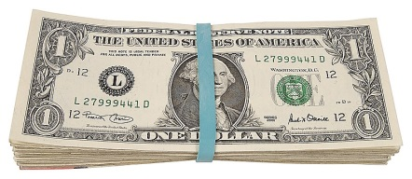
Cash is not held for its own sake. It flows into and out of businesses all the time.

Inflow
£ Outflow

Inflow :
This may also be known as Income OR Revenue OR Turnover.

It is the money which enters the businesses tills or bank account as a result of selling goods and services.

Outflow :
This is expenditure, it is money which leaves the business to pay for the day-to-day costs of the business.

Business Finance and Control

What might some of these costs be? Write a list.

Expenditure List
1. | 6.
2. | 7.
3. | 8.
4. | 9.
5. | 10.

Business Finance and Control

Businesses will try to ensure that the amount of money flowing into the business will be greater than the amount of money flowing out of the business. In time this should give them a positive bank balance.

List three stakeholders and suggest what might happen to each if outflows are greater than inflows.

Remember that too much cash can also be bad for a business. Suggest reasons why this might be so.

Business Finance and Control

Forecasts

A forecast is a prediction: it is an estimate of the business’s position in the future. The estimates need to be realistic.
The Inflow needs to take into account the market conditions at the time the predictions are made.

When would you expect each of the following to have the greatest number of sales?

Ice Cream Overcoats Tree Lights Sun Cream
Birthday Cards

Umbrellas Bedding Plants
Tomatoes Root Vegetables Strawberries
Summer Autumn Winter Spring

The Outflow figure must also be realistic.

Every business will have different costs to include in its cash flow forecast. Banks often provide templates or outlines of what to include in a cash flow forecast but these can be very complicated.

Business Finance and Control

Costs may have to be paid each month, every three months (quarterly) or once a year. Below are some of the most common categories found in cash flow forecasts.

Withdrawals
This is the money taken by the owner from the business to cover personal needs. Sometimes, in the early days of the business, the owner will not plan to take any money out as personal wages.

Cost of materials or stock
These may vary throughout the year and will be based on expected output or sales. Estimates that are too high will show that cash is being tied up in stock and too low an estimate suggests that shortages will be expected in production or sales.

Rent
This is paid to the owner of the property or land for the right to use that property or land for a length of time.

Business rates
These are paid as a tax to government based on the value of property.

Wages
Businesses need to estimate the number of workers to employ. The estimate will be based on the type of good or service being produced and the number of customers expected at various times. Too few workers will
mean that goods cannot be produced in large enough quantities or that there will be a lengthy delay in serving customers. Too many workers means that they are being paid but they are not being given any work to do.

The cost of the workers will depend on the type of workers. Unskilled workers may be paid the minimum wage.

What is meant by minimum wage?

Highly skilled or qualified workers will be paid considerably more. The number and skills of the workers should be reflected in the cash flow forecast so for example a business employing 2 minimum wage employees for a forty hour week will have a wages bill of around £500 per week.

Businesses will also have to pay other costs for each worker, such as National Insurance contributions, and these should be included.

What is meant by National Insurance contributions?

Business Finance and Control

- Utility bills
Utility bills are the costs of heating and lighting paid to gas and electricity companies as well as water costs and telephone bills.

The costs of utilities will vary and will depend on the type of goods being sold and produced and the time of year.

Other selling costs
There are other costs incurred; such as insurance, advertising, postage etc.

Cash Flow Forecast

Once the business has estimated its revenue and costs it can draw up a table showing its predicted cash flow. Such tables will differ but most will look very much like the one shown below.

CASH FLOW FORECAST FOR A GIFT SHOP OCTOBER 2013 TO MARCH 2014

 | OCT | NOV | DEC | JAN | FEB | MAR
Inflow | 6000 | 7000 | 8000 | 2500 | 4000 | 6000
Outflow
Cost of sales | 4000 | 2500 | 3000 | 1000 | 1500 | 1500
Rent and Business Rates | 1000 | 1000 | 1000 | 1000 | 1000 | 1000
Gas & Electricity | 500 |  |  | 500
Wages | 1000 | 1500 | 1500 | 1000 | 1000 | 1000
Other costs |  | 500 | 500 |  | 500 | 500
Total Outflow | 6500 | 5500 | 6000 | 3500 | 4000 | 4000
Net Cash Flow | -500 | 1500 | 2000 | -1000 | 0 | 2000
Opening Bank Balance | 0 | -500 | 1000 | 3000 | 2000 | 2000
Closing Bank Balance | -500 | 1000 | 3000 | 2000 | 2000 | 4000

Business Finance and Control

What does this forecast show?

- The time period covered by the forecast.

- When the business expects to take in the most money.

Which month has the greatest revenue?

Why would you expect this to be the case?

- When the cost of sales is greatest.

Suggest a reason why cost of sales is greatest in October.

- Payments for rent, heating and lighting, wages and so on.

Why do you think expected payments for gas and electricity are not made every month?

Why do you think expected wage costs are so high in November and December?

Then come the calculations...

Business Finance and Control

Total outflow

Total outflow is calculated by adding all the costs

Net cash flow

Net cash flow is inflow - total outflow

Opening bank balance

Opening bank balance is the money the business expects to have in the bank at the start of the month.

Closing bank balance

Closing bank balance is the money the business expects to have in the bank at the end of the month. It is calculated by:

Net cash flow + opening bank balance.

This becomes the opening bank balance for the next month.

Notice that in October the closing bank balance is a negative number.
How do you think the business can finance this?

Business Finance and Control

Improving cash flow

So far we have looked at cash flow forecasts, but businesses will also need to keep a watch on their current cash flow situation and take action if their outflows of cash are becoming greater than their inflows.

Their actions could involve:

- Trying to increase revenue

- Cutting costs

- Rescheduling of payments and receipts.

Trying to increase revenue

This usually takes the form of attempting to increase sales by carrying out strategies involving the marketing mix.

Name each of the 4 Ps and suggest a strategy aimed at increasing revenue.

  - P

Strategy:

  - P

Strategy:

  - P

Strategy:

  - P

Strategy:

Business Finance and Control

Your strategies may have increased revenue, but discuss whether each may have worsened cash flow.

- P

Strategy:

Discussion:

- P

Strategy:

Discussion:

- P

Strategy:

Discussion:

4. P

Strategy:

Discussion:

Business Finance and Control

Cutting costs

Cutting costs will reduce the outflow of cash. The table below shows a number of costs.
For each cost shown below suggest how the outflow of cash can be reduced. In each case also suggest the negative effects of the cost-cutting.

 | How to cut | Negative effect
Cost of stock
Rent
Gas & electricity
Owners’ withdrawals
Wages for employees
Other costs

Business Finance and Control

Rescheduling of payments and receipts

All businesses owe others money and are owed money either in the short-term or the long-term.

Suggest how businesses can improve their cash flow in terms of the money they owe
and the money they are owed.

- Money they owe

- Money they are owed

Business Finance and Control

Past Paper Examination Question - 2010 - Adapted

Bill Stanley produces handmade greetings cards which are sold to customers at craft fairs
and through craft shops. Bill has drawn up a cash flow forecast for the rest of the year.

BILL’S CASH FLOW FORECAST JUNE TO DECEMBER 2010

 | JUN | JUL | AUG | SEPT | OCT | NOV | DEC
Receipts | £ | £ | £ | £ | £ | £ | £
Turnover | 2000 | 2000 |  | 2000 | 2200 |  | 2500
Payments
Materials |  | 450 | 500 | 550 |  | 500 | 550
Wages | 1500 | 1500 | 1500 | 1500 | 1500 | 1500 | 1500
Electricity |  |  |  |  |  | 300
Business rates | 5100
Insurance | 50 | 50 | 50 | 50 | 50 | 50 | 50
Total Payment | 7050 |  | 2250 | 2100 | 2100 |  | 2100
Net cash flow |  | 0 | 50 | -100 | 100 | 50
Opening bank balance | 6000 |  | 950 | 1000 | 900 | 1000 | 1050
Closing bank balance | 950 | 950 | 1000 | 900 |  | 1050

(a)
Study the cash flow forecast and complete the shaded areas. (12)

(b) (i)
What is a cash flow forecast? (2)

Business Finance and Control

(b) (ii)
Suggest one way in which a cash flow forecast might be useful to a business such as
Bill’s.

(2)

(c)
What is meant by the term Turnover? (2)

(d)
Bill would like to further improve his expected cash flow position. Evaluate ways in which
he may achieve this.

(8)

Business Finance and Control

Profit and Loss Account

The aim of any business is to earn a profit or, to be more precise, to make as much profit or least loss as possible. Every year businesses will draw up a table to show how their profits were achieved.

This is essential to:

- Show how well the business is doing to satisfy its owners (shareholders).

- Calculate its tax liabilities.

- Use in a business plan when applying for finance.

Harry Sanders owns a newsagents shop, called Newsround, in the small market town of Kenilworth. In his shop Harry sells newspapers, stationery and sweets.

His profit and loss account for 2013 is shown below:

NEWSROUND PROFIT AND LOSS ACCOUNT FOR 2013

SALES REVENUE | £ | £ 200 000
Cost of newspapers | 60 000
Cost of stationery | 20 000
Cost of sweets | 20 000
COST OF SALES | 100 000 | -100 000
GROSS PROFIT |  | 100 000
Wages | 30 000
Gas & electricity | 1 000
Rent | 12 000
Rates | 12 000
Other costs | 1 000
EXPENSES | 56 000 | -56 000
NET PROFIT |  | 44 000

Business Finance and Control

To summarise, the profit and loss account will calculate the final profit or NET PROFIT. GROSS PROFIT = SALES REVENUE - THE COST OF THOSE SALES.
NET PROFIT = GROSS PROFIT - EXPENSES.

The Net Profit will be shared by a number of stakeholders:

- Some will be taken as tax by the Government.

- Some will be distributed to the owners.

- Some will be ploughed back into the business.

- Some will be kept in reserve for future use.

Percentage profit

Gross profit and net profit will often show how successful a business is but the figures don’t always show the true picture.

Two businesses with net profits of £100,000 will appear to be equally successful but if one has sales of £1m and the other sales of £200,000 this is not the case. Therefore, to measure the success of a business it is more useful to calculate the profit as a percentage over sales revenue.

GROSS % PROFIT = GROSS PROFIT SALES REVENUE

x 100

NET % PROFIT = NET PROFIT SALES REVENUE

x 100

These calculations are sometimes referred to as gross profit margin and net profit margin.

Business Finance and Control

Calculate the gross profit margin and net profit margin for the following business:

 | 2012 | 2013
Gross profit | £10 000 | £20 000
Net Profit | £5 000 | £10 000
Sales Revenue | £100 000 | £160 000

- The gross profit margin is (show your workings). 2012

2013

- The net profit margin is (show your workings). 2012

2013

3. Did the business perform better in 2012 or 2013? Explain your answer.

Business Finance and Control

Improving profit/reducing loss

As with cash flow, strategies are needed to increases sales and/or to reduce costs.

Increasing sales
The marketing mix is a good place to start.

What negative effect might a change in product quality have on revenue and costs?

Revenue

Costs

Prices might go up to increase revenue but this strategy might fail. Why?

Would a cut in price be a good idea to increase revenue? Explain your answer.

Business Finance and Control

Place could involve moving the business to a more popular location or introducing internet sales. Would this work to increase revenue? Explain your answer.

Promotion should increase sales but may also impact on costs and so not lead to an
increase in profit.

Explain why television advertising might be good for sales revenue but bad for costs. Sales Revenue

Costs

Business Finance and Control

- Reducing costs
Clearly businesses wanting to increase profits or reduce losses should aim to cut costs.

Suggest one way in which businesses could reduce the cost of sales.

What negative effect might this have on profits?

Expenses might also be reduced.

Suggest one way in which businesses could reduce their wages bill.

What negative effect might this have on profits?

What negative effect might attempts to cut gas and electricity costs have on the profits
of a shop?

Business Finance and Control

Give two examples of “Other Costs” which businesses may pay and consider the effects
of cutting each of these on profits.

Business Finance and Control

Past Paper Examination Question - 2009 - Adapted

De La Rue plc is the world’s largest security printer and papermaker.

PROFIT AND LOSS ACCOUNT DE LA RUE PLC 2007
 | 2007 | 2006
 | £million | £million
Turnover | 687.5
Cost of Sales | 597.1 | 543.9
Gross Profit |  | 66.9
Expenses | 18.6
Net Profit |  | 51.8

(a)
What is meant by the term turnover as used in profit and loss accounts such as the one
above?

(2)

(b) Complete the shaded areas in the profit and loss account above. (4)

(Continued on next page)

Business Finance and Control

(c)
Calculate the gross percentage profit and net percentage profit earned by De La Rue in 2006 and 2007. (Show your workings).

(8)

2006

Gross % Profit

Net % Profit

2007

Gross % Profit

Net % Profit

(Continued on next page)

Business Finance and Control

(d) Identify two stakeholders who would be interested in the profit and loss account and
explain why they have an interest.

(6)

(i)

(ii)

Business Finance and Control

Balance Sheets

Everyone has possessions. It should be possible to add up the value of everything we own to find our total wealth.

List your 5 most prized possessions and suggest how much they are worth in money terms.

1.

2.

3.

4.

5.

We may also have debts which reduce our wealth. In addition, some of our possessions last a long time, whereas others are used up very quickly. This means that our wealth changes every day.

We gain possessions with money earned from work, or from gifts received, or we take out loans to buy items.

Business wealth

Businesses need to calculate the value of their wealth at a particular moment - usually on one date each year - so that they can calculate whether or not they are becoming more profitable. This is particularly valuable information for those who provided the money to set up and run the business and for those considering investing or lending money to the business in the future.

The value of a business at a particular time is known as a balance sheet. To be able to read the balance sheet we need to understand the meaning of the following terms:

- Assets

- Liabilities

ASSETS are anything that a business owns and add value to the business.

LIABILTIES are anything that the business owes and subtracts value from the business.

ASSETS and LIABILTIES can be further divided into:

- Short-term or CURRENT which can change quickly—usually in less than a year.

- Long-term which are unlikely to change in the year (In the case of ASSETS these are said to be FIXED).

Business Finance and Control

Assets and liabilities

Fixed assets
These are the possessions of a business which are not going to be sold. They generally last a long time and are used in the production of goods and services. They are producer goods.

Examples include:

- Land and buildings

- Machinery

- Vehicles

None of these assets are easily turned into cash.

Current assets
These are possessions used in production. They are always changing, and generally held for a small period of time.

Examples include:
- Cash (both in-hand and in bank accounts).

- Stock (made up of materials, semi-finished goods and finished goods).

- Debtors (people who owe the business money).

All these assets are said to be fairly easy to turn into cash if necessary.

How might some of these assets be more difficult to turn into cash?

Business Finance and Control

Current liabilities

These are owed by the business and will need to be paid in the near future. They may include:

- Short term loans (including overdrafts).

- Money owed to suppliers (known as creditors).

- Taxes owed (particularly corporation tax).

- Dividends owed to shareholders.

Net current assets

NET CURRENT ASSETS =

CURRENT ASSETS - CURRENT LIABILITIES

Long term liabilities
These are owed by the business but repayment will not be required for some time— usually more than one year.

Such liabilities usually involve long-term loans needed to buy fixed assets. As long as the business can keep up the repayments and interest costs, the owners will face few problems with these liabilities.

Net assets
We are now in a position to calculate the overall wealth of the business, using the formula:

NET ASSETS =

FIXED ASSETS + CURRENT ASSETS - CURRENT LIABILITIES - LONG TERM LIABILITIES

Where’s the balance?

Balance suggests that at least two things should be equal. The balance is determined by considering where the money to buy the net assets came from. The finance is mainly from:

- Share capital (the amount originally invested by shareholders and by debenture holders).

- Reserves (mainly made up of profits not distributed to shareholders in the past).

- Profits from the current profit and loss account not distributed to shareholders.

Together these three different sources of money are known as CAPITAL EMPLOYED. The balance refers to the fact that: NET ASSETS = CAPITAL EMPLOYED.

Business Finance and Control

The balance sheet

Having looked at the different parts of a balance sheet, we can now see how the whole thing pieces together.

Raga plc manufactures a range of products used in domestic kitchens and by catering businesses. The balance sheet for the business for 31 December 2013 is shown below.

£million £million
FIXED ASSETS 220
CURRENT ASSETS
Stocks 61
Debtors 103
Cash at bank and in hand 52
TOTAL CURRENT ASSETS 216 216

CURRENT LIABILITIES
Creditors
Short term borrowing—such as overdrafts
TOTAL CURRENT LIABILITIES | 102 -102
NET CURRENT ASSETS | 114
LONG TERM LIABILITIES | -52
TOTAL NET ASSETS | 282
CAPITAL AND RESERVES  Share capital Reserves  Profit and loss account | 92  38  152
 | 282 282

100
2

Business Finance and Control

Working capital

Businesses need to be fairly certain that they have sufficient resources that can be converted into cash to cover their current liabilities. If the business could not cover these liabilities then stakeholders may be affected.

What would be the effect if the business could not cover the following?

Short term loans including overdrafts:

Money owed to suppliers (known as creditors):

Taxes owed to the Government particularly corporation tax:

Dividends owed to shareholders:

Businesses will therefore need current assets. The difference between current assets and current liabilities is known as working capital.

WORKING CAPITAL = CURRENT ASSETS - CURRENT LIABILITIES

If the answer is a positive number then the business is fairly safe. However, remember that it may not be as easy to convert current assets into cash as business owners may think.

Business Finance and Control

Suggest and explain one example of a situation whereby it may be difficult to convert
current assets into cash.

Business Finance and Control

Past Paper Examination Question - 2011 - Adapted

Greggs plc is a leading bakery retailer serving 5 million customers per week. The business sells bread, cakes and savoury products such as pies, sandwiches and pasties through its 1400 shops.

Below is the Balance Sheet for Greggs plc.

GREGGS PLC BALANCE SHEETS AS AT JUNE 2009 AND 2008

£m | June 2009 | June 2008
Fixed Assets | 208
Stocks | 12 | 11
Debtors | 25
Cash | 15 | 8
Total Current Assets |  | 42
Total Assets |  | 240
Current Liabilities |  | 84
Long Term Liabilities | 33 | 16
Total Liabilities | 114
Total Net Assets
Total capital employed

- Complete the shaded areas in the balance sheet above. (10)

(Continued on next page)

Business Finance and Control

(c)
What is meant by the term Fixed Assets? (2)

(d)
Why are the balance sheets shown above useful to the shareholders of Greggs plc? (4)

Business Finance and Control

Business Performance

The cash flow forecast, the profit and loss account, the balance sheet and other information are used to judge business performance. The stakeholders all want to know how the business is doing now and how it is likely to look in the future.

Suggest why the following stakeholders will be interested in the performance of a business.

Shareholders:

Managers:

Employees:

Suppliers:

Customers:

Neighbours of the business:

Pressure groups such as environmental campaigners:

Business Finance and Control

Judging Performance

Business performance can be judged in a number of ways.

Performance over time

Businesses need to compare certain aspects of the business (such as profit) over a number of years. If profits (or sales or number of employees) are rising the owners will consider the business as being successful. The business will also be considered a success if costs are falling. The balance sheet may indicate growth or decline of the business.

Other than profit, sales, costs and number of employees suggest 2 factors that may
change over time to show the success of a business.

Against set targets

All firms will have targets for sales, profits and growth. They will consider the relative success of the business based on these targets. The cash flow forecast itself is a prediction or target.

Against other firms’ performances

Comparing with similar firms will help to determine how successful a business is; are competitors making greater percentage profits? Are they selling more? Are they growing faster? Market share is another important aspect when considering the success of a business.

If managers/owners do not see an improvement in performance year-on-year, then they will need to look at the reasons why they failed to meet their targets and develop strategies for improvements.

Business Finance and Control

Past Paper Examination Question - 2010

Bill Stanley produces handmade greetings cards which are sold to customers at craft fairs and through craft shops.

Suggest and explain three ways in which Bill could measure the success of his business.

(6)

(i)

(ii)

(iii)

Business Finance and Control

Key Term Revision - Finance

Match the terms below to the definitions on the following pages.

Overdraft Capital employed

Balance sheet Current liabilities

Expenses Hire purchase

Working capital Profit and loss account

Fixed assets Stock

Trade credit Net cash flow

Gross profit Turnover

Creditors Start up capital

Opening bank balance Net profit

Business plan Business rates

Debtors Cash flow forecast

Percentage profit Current assets

Business Finance and Control

Taking more from a bank current account than is in the account.
The profit earned by a business after all
costs and expenses have been paid.

Partly-finished goods are examples of this. Assets made up of the money owed to a
business by others.

Details about a business and its development used to attract finance mainly from banks.
The total of all the capital which has been put into a business.

The amount of cash a business has at the beginning of each month.
Long term assets which are used over and over to produce goods and services.

Borrowing from the suppliers of materials to be repaid within one month.
Liabilities consisting of money owed to others.

A record of all the assets and liabilities in a business at a particular date.
The profit made by a business before
expenses have been deducted.

Business Finance and Control

An estimate of the money which is expected to enter and leave a business.
Costs of a business which often have to be paid even if the business doesn’t make or sell anything.

A calculation of the profit or loss earned by
a business usually within one year.
The amount a business owes to be repaid within one year.

A system of borrowing where the lender owns an asset when the final payment is made.
These are paid as a tax to government based on the value of property.

The value of sales by a business. Those items owned by a business that are
changing from day to day.

Money needed to set up a business. The net amount of current assets a
business has i.e. net assets minus current liabilities.

The profit of a business as a percentage of
the income from sales.
The difference between money into a business and money out during a month.

