**GCSE Business Studies**

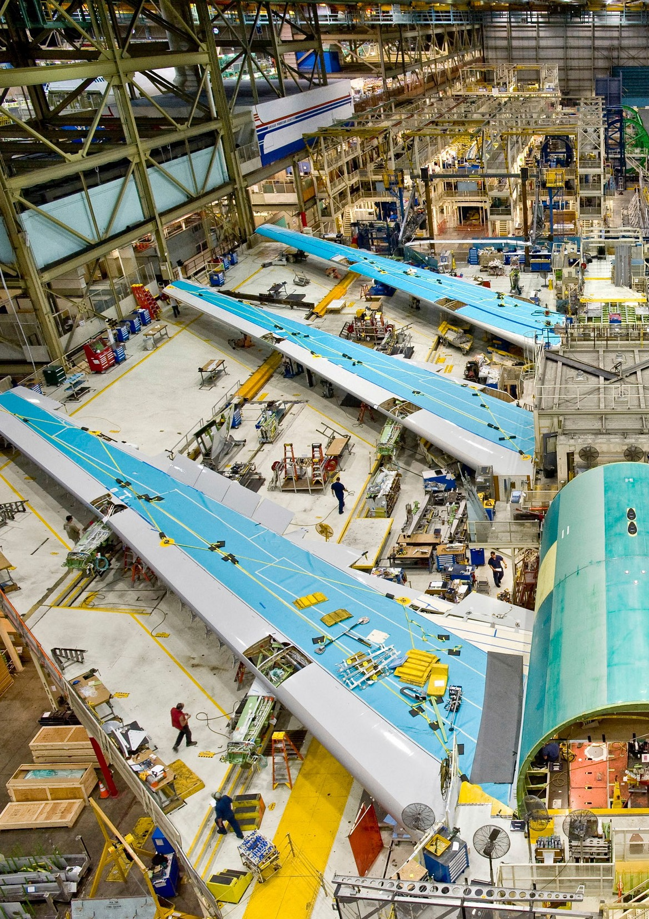

**Producing Goods and Services**

**Support Materials**

##### Producing Goods and Services

These documents are part of a larger blended learning pack, developed to support GCSE Business Studies. Each document is complemented by a range of digital resources.

These digital resources could be used for whole class stimulus and discussion before directing the students to the corresponding work in the PDF documents, or the students could be asked to work in groups on the paper resources found in the packs and then the digital resource used for feedback and to check understanding.

##### Producing Goods and Services

**Producing Goods and Services**

**Goods and services**

Businesses produce goods and services.

Goods are products which can be seen, handled, turned on, lived in, driven and so on. They are produced by manufacturers who buy raw materials from producers and then add value to turn the materials into something else.

Other producers of goods combine manufactured goods to construct new products. Goods can be divided into two kinds:

##### Consumer goods

Consumer goods are goods bought and used by the final consumer.

Consumer goods can themselves be divided into two types:

* Single use – They are mainly used just once or by just one consumer and will generally have no other value.
* Durable goods – These will generally last a long time and may have a second-hand value which may be greater or less than the original purchase price.

##### Producer goods

Producer goods are goods used by businesses to help to produce goods for other businesses and for consumers.

##### Producing Goods and Services

**What type of goods are the following?**

**Oil tanker**

**Wrist watch**

**Single use consumer good**

**Consumer durable good**

**Producer good**



**Single use consumer good**

**Consumer durable good**

**Producer good**



**Laptop PC**

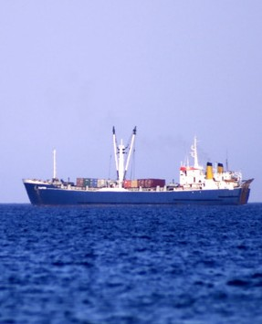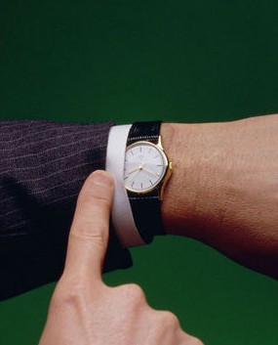

**Breakfast cereal**

**Single use consumer good**

**Consumer durable good**

**Producer good**

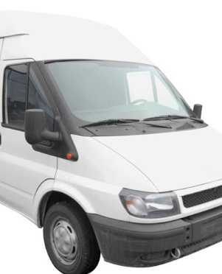

**Single use consumer good**

**Consumer durable good**

**Producer good**

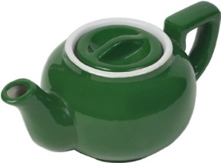

**Goods van**

**Teapot**

**Single use consumer good**

**Consumer durable good**

**Producer good**

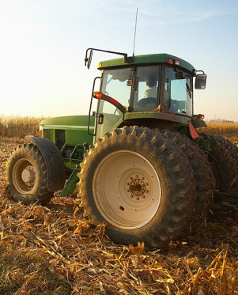

**Single use consumer good**

**Consumer durable good**

**Producer good**

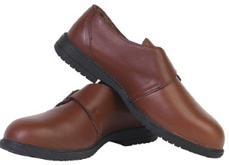

**Tractor**

**Single use consumer good**

**Consumer durable good**

**Producer good**

**Pair of men’s shoes**

**Single use consumer good**

**Consumer durable good**

**Producer good**

**Producing Goods and Services**

**What type of goods are the following? - continued**

**Chocolate bar**

**Loaf of bread**

**Single use consumer good**

**Consumer durable good**

**Producer good**

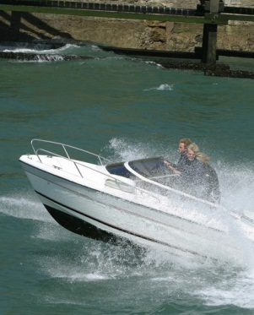

**Single use consumer good**

**Consumer durable good**

**Producer good**

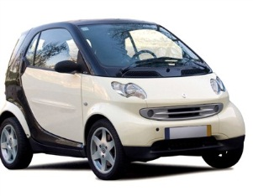

**Speedboat**

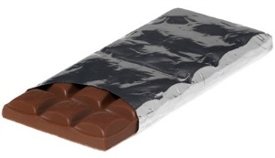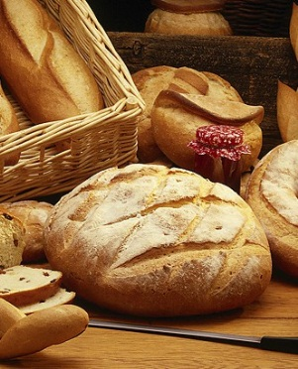

**Small urban car**

**Single use consumer good**

**Consumer durable good**

**Producer good**

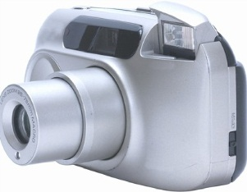

**Single use consumer good**

**Consumer durable good**

**Producer good**

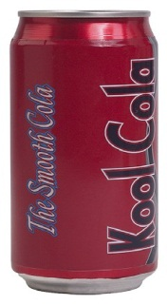

**Digital camera**

**Single use consumer good**

**Consumer durable good**

**Producer good**

**Can of soft drink**

**Single use consumer good**

**Consumer durable good**

**Producer good**

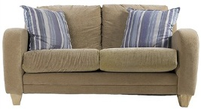

**Producing Goods and Services**

**Past Paper Examination Question - 2009**

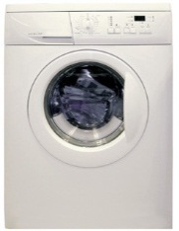**Which *three* of the following are usually regarded as examples of *consumer durable goods*? Tick *three* boxes only (3)**

|  |  |  |  |
| --- | --- | --- | --- |
| **Delivery van** |  | **Home washing machine** |  |
| **Box of chocolates** |  | **Family holiday** |  |
| **Personal Music Player** |  | **Living room**  **furniture** |  |

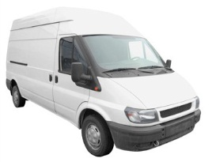

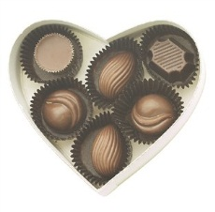

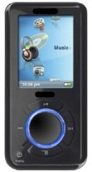

##### Producing Goods and Services

**Services**

Services are also said to be produced but they cannot be handled or seen. A service is a non-physical item that can be purchased.

Services can be divided into two kinds:

* Personal or direct services - aimed at consumers.
* Commercial services – aimed at businesses.

##### What type of services are the following?

Images of services are listed below, identify the service and state whether you think they are personal services or commercial services.



##### Example Name of service Service Type

**Personal**

**Commercial**

**Personal**

**Commercial**

**Personal**

**Commercial**

**Personal**

**Commercial**

**Producing Goods and Services**

**Growing importance of the service sector**

Two hundred years ago most workers produced goods, mainly food, close to where people lived and were sold at local markets. The clothes and household goods people needed were also manufactured locally. Anything not produced in the area was transported around the coast or by pack horses. A small number of goods not made in this country were imported.

As agricultural practices became more efficient fewer workers were needed, but more food was produced. People moved to the towns, the population grew and most workers were involved in manufacturing cloth, machines, coal and iron.

Over the past fifty years more countries have been producing goods so we have been able to import more of these from abroad. Improved standards of education and technological developments have lead people to move, in increasing numbers, into the same sector. There is particular global demand for our banking, insurance and design services.

Which three of the following are likely to be providing goods rather than services?

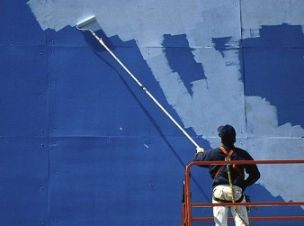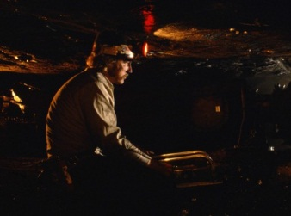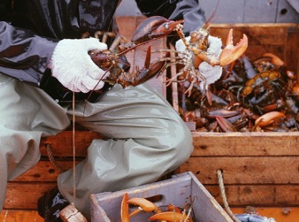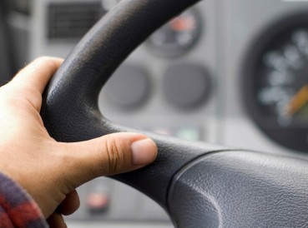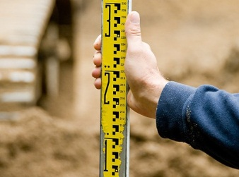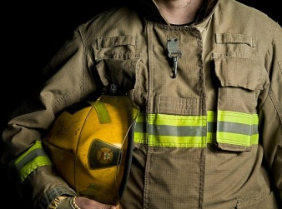

##### Painter

**Miner**

**Doctor**

**Fisherman**

**Lorry driver**

**Bank clerk**

**Surveyor**

**Firefighter**

**Producing Goods and Services**

**Private and Public sectors**

Goods and services can be produced by:

* The private sector and/or
* The public sector

##### Public Sector Private Sector

These are set up by public organisations to provide a good or service not provided by the private sector, or provided by the private sector at too high a price.

These are businesses run by individuals or

groups for their own benefit.

Their main aim is to make a profit for the

owners.

Most goods and services in Britain are produced by the private sector by businesses big and small. Individuals set up the business, people pay for the goods and services, the income is used to produce more and the profits provide a return to the owners or enable the business to expand.

However, because private sector businesses are not always willing to produce at a price the majority of people are able to pay, the public sector provides many goods and services. The goods and services are paid for

by taxpayers and by government borrowing. Sometimes the users will also contribute towards the cost. Any money earned goes to the government or local councils to add to their income and to further improve services. Public sector organisations are not generally expected to make a profit.

##### Producing Goods and Services

**Past Paper Examination Question - 2008**

**Which *three* of the following workers are usually found in *private sector* jobs?**

**Tick *three* boxes only (3)**

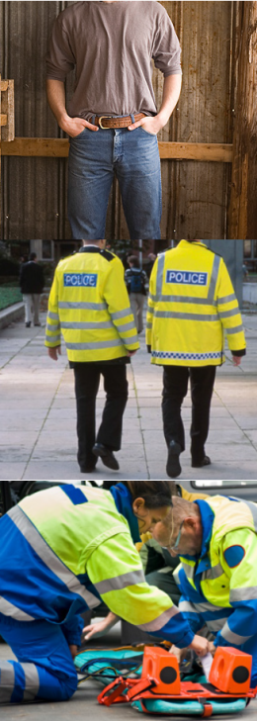

**Farm Workers**

**Soldiers**

**Police**

**Officers**

**Bank Clerks**

**Paramedics Hairdressers**

##### Producing Goods and Services

**Which services are most important?**

Number the services from 1 to 8 in order of their importance to society, 1 being the most important and 8 the least.

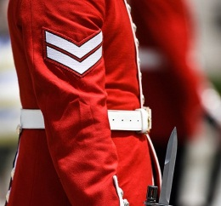

##### The Armed Forces

**Leisure facilities**

**Emergency Services Education**



**Health Transport**

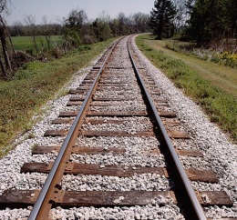

**Libraries Tourism**

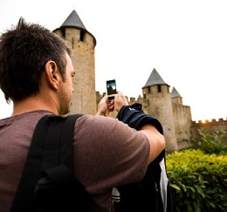

**Producing Goods and Services**

It is important to note that goods and services do not have to be provided exclusively by either the private or the

public sectors.

Until the 1980s many businesses operated in the public sector, but they were sold into private ownership (privatisation), these included:

* British Gas
* British Telecom
* British Airways

In 2013 the government announced plans to privitise the Royal Mail.

##### Public sector services also provided in the private sector

There are examples of services provided mainly in the public sector which are provided on a smaller scale in

the private sector e.g.

##### Leisure facilities

There are private leisure gymnasiums and sporting clubs.

**Education**

There are private schools-some, oddly enough, are called public schools.

**Health**

People can be treated by private doctors and hospitals.

**Transport**

The road network is mainly provided by the Public Sector but toll roads such as the M6 Toll and the Severn Bridge are owned by the Private Sector.

**Social care**

There are private nursing homes.

**Emergency services**

Factories might have their own fire engines and private security firms exist.

**Producing Goods and Services**

**Job / Batch / Flow Production**

There is no one way to produce goods and services.

Your auntie’s favourite vase was probably produced by a person sitting at a potter’s wheel, your doughnuts were produced at the bakery one hundred at a time and you family car was produced at an enormous factory by thousands of workers.

What do you think would happen to the price and quality of the car if it were made in the same way as the vase? Suggest a reason in each case.

##### What would happen to the price of the car?

**Reason?**

**What would happen to the quality of the car?**

**Reason?**

Each of the products mentioned above was manufactured using either job, batch or flow production.

##### Producing Goods and Services

**Job production**

Job Production is a method of production whereby businesses use all their factors of production to complete one job at a time. Job production processes are usually used when the products are all different, non-standard, made-to-order goods. The items are often produced on a very small scale and in workshops, for example, your auntie’s favourite vase, made-to-measure suits, sailing boats etc

##### The main problems associated with this style of production are:

* + Costs per good tend to be high because production runs are short and the workers are highly-skilled and will demand higher wages.
  + Specialist equipment will tend to be underused - the worker can only use one tool at a time.
  + There is often a lengthy production time.

**Advantages for consumers include:**

* + Products will match consumer tastes and individual requirements.
  + Goods are exclusive/unique so few other people will have similar products.
  + Will fit in particular space or be a specific size.
  + Goods will generally be higher quality as goods are made with greater care.

**Disadvantages for consumers include:**

* + Goods tend to have higher prices than mass-produced products, as more attention is paid in the manufacturing process. Workers tend to have higher skill levels.
  + Need to wait for goods as they take longer to produce due to the the greater attention to detail and high quality.
  + Replacements will be difficult to find as the products were made for a specific purpose to a particular design. This also means that spare parts may also be more difficult to find.

**Producing Goods and Services**

**Batch production**

Batch Production involves the manufacture of different versions of the same basic product in batches, e.g. different colours, different types of paint, different varieties of jam tarts.

##### Advantages to producers include:

* + Workers can specialise in performing set tasks.
  + Specialist machinery may be used.
  + Costs for producing each good are lower.
  + Production is more efficient.

**Disadvantages to producers include:**

* + Production is not continuous and short production runs increase costs per good to a

level greater than would be the case under flow production.

* + Parts have to be stored in large quantities - this is expensive.
  + Machines have to be cleaned and re-set before producing a different batch - this takes time and adds to costs.
  + Workers can be demotivated by doing the same job every day.

Auntie’s favourite vase was produced using job production at the potter’s wheel.

It was then fired in a kiln to finish production.

##### In which way might this involve batch production?

**Suggest 3 goods which may be produced using batch production.**

**1.**

**2.**

**3.**

**Producing Goods and Services**

**Flow production**

This is where production takes place as a continuous process. The product flows from one process into the next. This will usually happen where the products made are identical and can be made using a production line method. Each worker adds one part of the finished product as it passes them on the production line, so they become specialised in what they do. Specialist machinery will greatly assist the workers.

This is sometimes called MASS PRODUCTION (benefiting from ECONOMIES OF SCALE ) and involves DIVISION OF LABOUR.

##### Advantages of flow production:

* + Many more goods can be produced than when using other methods.
  + With long production runs costs per good will be low.
  + This means that goods can be sold at lower prices than if they had been produced
  + under job or batch methods. Workers can be very skilled at what they do as they are doing the same job over and over.
  + Short training periods are required as workers need to be taught only a small number of skills.

**Disadvantages of flow production:**

* + The high cost of machinery when setting up flow production.
  + The workers are doing the same job all the time, this is boring for them and they

may make mistakes, so the quality of the final product is reduced.

* + Stocks of materials and partly finished products are stored, storage is expensive.
  + A breakdown in one part of the production line can lead to a complete shutdown of the factory.

**Cars are manufactured using flow production. In which way might batch production**

**be involved?**

**Producing Goods and Services**

Below are a number of products, decide whether each is likely to be produced using job, batch or flow methods.

## Washing machine

##### Job

**Batch Flow**

**False teeth**

**Job**

**Batch Flow**

**Fork-lift truck**

**Job**

**Batch Flow**

**Poster showing well-known band**

**Job**

**Batch Flow**

**Sets of saucepans**

**Job**

**Batch Flow**

**Loaf of sliced bread**

**Job**

**Batch Flow**

**Producing Goods and Services**

Below are a number of products, decide whether each is likely to be produced using job, batch or flow methods.

## Shirts sold in well-known chainstore

##### Job

**Batch Flow**

**Motor cars**

**Job**

**Batch Flow**

**A landscape painting**

**Job**

**Batch Flow**

**Television sets**

**Job**

**Batch Flow**

**Windows for an individually-designed house**

**Job**

**Batch Flow**

**A designer dress**

**Job**

**Batch Flow**

**Producing Goods and Services**

**Past Paper Examination Question - 2009**

**A British car manufacturer is The Morgan Motor Company which has been producing cars since 1909. They build handmade sports cars for customers wanting to buy individual cars very different from those sold by the larger mass production makers such as Honda.**

**Production takes place in a small factory in Herefordshire where 155 workers are employed. Output is nine cars a week and each car takes three months to build.**

**(a)**

**Honda’s assembly line operates using flow production. Which type of production is**

**likely to be used by Morgan? (1)**

**(b) Suggest and explain one advantage and one disadvantage to Morgan customers of their handmade cars.**

**(4)**

**Advantage**

**Disadvantage**

HINTS: In (b), remember to mention one advantage and one disadvantage but then explain what you mean by

each i.e. write an additional point about each.

##### Producing Goods and Services

**Past Paper Examination Question - 2010**

**In each case below tick whether the goods mentioned are most likely to have been**

**produced using job, batch or flow production. (2)**

**(i)**

**A florist making a bouquet ordered for a wedding.**

**Tick *one* box only**

# Job Batch Flow

##### (ii)

**A small bakery making loaves and rolls for a local supermarket.**

**Tick *one* box only**

# Job Batch Flow

##### Great Gates and Co Ltd. has a factory in South Wales. In this factory it produces gates. Some are made to supply garden centres and do-it-yourself (DIY) shops. These are made to standard sizes and designs. Some gates, however, are made to meet individual orders based on sizes and designs provided by customers.

**Suggest and explain the *method of production* Great Gates and Co Ltd would use for making**

##### standard gates and (ii) individually designed gates.

* 1. **Standard gates.**

**(2)**

##### Individually designed gates. (2)

**Producing Goods and Services**

**Specialisation and Division of Labour**

Specialisation involves people concentrating on what they do best. Some people are good at gardening, others at making things or with words, music, numbers or sport. Specialisation applies to countries and

businesses as well as individuals.

There are many ways in which specialisation can take place, but in business we are mainly concerned with how specialisation can be used in producing goods and services. specialisation involves division of labour i.e. splitting up the production process so that workers perform the tasks they do best. When this happens

more goods can be produced at a lower cost to everyone’s benefit.

**ALSO**

* Use of machinery means less physical effort.
* Tasks are simple to learn, so workers can develop many skills.
* Wages tend to be higher.

## BUT

disadvantages for businesses and workers include:

* Work is boring.
* Worker boredom means mistakes by workers and lower quality goods.
* Workers may have less pride in their work.
* Factories are larger so there may be greater separation between workers and managers. Industrial disputes are more likely.
* Workers become interdependent so breakdowns lead to bottlenecks.
* Improvements in technology mean that some skills are no longer needed, unemployment may follow.
* Workers do not feel that they are creating the finished product, they have less pride in their work.
* Workers may feel vulnerable as their jobs may be moved elsewhere to be done by lower paid workers.

##### Producing Goods and Services

**Minimising waste**

Businesses aim to maximise profits. In order to achieve this, costs should be kept as low as possible. Costs can be kept down by reducing the wastage of materials and finished products, this will involve:

* Stock control
* Quality control

##### Stock control

Stock is very important in a business, it can be one of three kinds:

##### 1. Materials needed so that production can continue

These have the same problems regarding storage as the finished goods i.e. they are costly to keep.

##### Why are materials expensive to keep?

Some businesses are able to cover the cost of storage by purchasing materials in bulk thereby gaining price reductions. However, if materials are not available then production may have to stop, a fine balance needs to be kept between having too much and too little in stocks of materials.

##### 2. Partly finished goods

Partly finished goods are goods that were being worked on at the end of the previous day. Partly finished goods are particularly important with flow production, workers do not have to wait for production further down the line. Goods will generally be stored within the factory.

##### Finished goods awaiting sale

Finished goods are expensive to keep and, depending on the type of goods, may need special care involving refrigeration or protection from the weather. All finished goods will also need a secure storage place.

Finished goods should be placed on the market as soon as possible, not just to reduce storage costs, but also to earn money for the business.

##### Producing Goods and Services

**How to control stock**

The traditional method of holding stock was to use a warehouse, filled with the materials needed for production. As goods were produced stocks were run down until an estimate was made as to when new materials should be ordered. There was a fine balance between saving storage costs and deciding how much stock to keep.

##### What would be the consequence for production of holding too little stock?

Stock was often bought in large quantities to reduce the congestion of deliveries at the factory and also to

benefit from price reductions for buying in bulk.

##### Suggest three possible disadvantages of holding too much stock.



**Producing Goods and Services**

**Just in Time (JIT)**

Japanese producers realised that the costs of building, maintaining and securing large warehouses were high and so the idea of Just in Time was developed.



**Just in Time (JIT)**

Supplies are delivered directly to the factory only when they are needed. This means for example, that a computer manufacturer may receive the exact number of cases required for one or two day’s production.

The suppliers will be expected to deliver the right goods, in perfect condition, to the correct part of the factory, at a particular time.

**Advantages of Just in Time Disadvantages of Just in Time**

* Less storage space is needed so rent,

security and other costs are reduced.

* Less money is tied up in stock.
* There is less chance of stock being damaged or going out of date.
* JIT also applies to the stocks of finished goods so there is less chance of a build- up of stocks of completed products, which can occur with sudden changes in the level of demand.
* Less time is spent checking deliveries as the supplier is expected to get everything right.
* There is little room for mistakes as stock levels are so low.
* Production depends on suppliers and if stock is not delivered on time due to unforeseen circumstances e.g. traffic congestion or bad weather, production can be held up.
* There are no spare finished products available to meet unexpected demand.

**Producing Goods and Services**

**Quality control**

Producing quality goods is important to all businesses.

* High quality promotes and maintains sales and increases profits as customers want to buy quality products.
* Reputation of the business is further enhanced.
* It saves waste as faulty products do not have to be replaced or repaired or refunds given.

Controlling quality takes place at all three stages of production:

# Input Production Finished Good

**Input**

Anything used to produce the final product must be of the best quality.

Worker quality can be ensured by making sure that workers have the right qualifications, that the correct recruitment processes are used to find the best workers for the job, and that workers’ training provides them with the appropriate skills.

Quality is ensured by finding suppliers who are themselves keen on keeping the same high quality standards. This may involve finding suppliers with good reputations and/or awards for quality, inspecting suppliers’ factories and checking deliveries as they arrive from suppliers.

Machines need to be bought from suppliers with good reputations, these can be expensive but may be less likely to breakdown and hold up production.

Firms still need efficient specialist workers to maintain and repair machines. However, advances in technology may mean that machines have to be replaced frequently, so good quality machines may need to be replaced before they are fully worn out.

##### Producing Goods and Services

**Production**

Every stage of the production process must be carried out to the highest possible standards.

Workers need to be supervised during the production process to ensure that they are working correctly, skillfully and safely.

Sometimes production will be tested to make sure that the goods meet the required standard.

It becomes very expensive to allow faulty partly finished goods to continue along the production line. Faulty goods will be returned to a previous stage for correction, or will be scrapped. Whatever happens delays can add to costs significantly.

In some workplaces, supervisors are not used. The workers need to motivate themselves to work to the highest standard. This responsibility gives the workers a sense of worth in the work place, a pride in their work and a sense of belonging in the business.

Businesses that provide bonuses for good quality work, or a share in the ownership of the business, will often save money in not supervising production.

# Finished Good

The final product must be of the best quality and ready for sale to the final consumer.

Checks are carried out on the finished goods to ensure that they appear to be fit for sale. On larger items each individual product is checked, for example televisions are switched on and cars are driven from the production line. On large quantities of small goods this is more difficult so a sample of goods is checked.

Selling faulty goods can be expensive for businesses. Consumer laws mean that customers can obtain a refund, a replacement or a repair when they are sold a faulty product. Whichever replacement option is chosen, it will add to the cost to the business.

##### Producing Goods and Services

**Past Paper Examination Question - 2010**

**Tapio is a Japanese business which produces a range of electronic products including computers and mobile telephones in a number of countries around the world.**

**Tapio has a reputation for producing high quality products.**

**Outline *two* ways in which Tapio can ensure that it maintains its reputation for high quality products. (4)**

**(i)**

**(ii)**

**Producing Goods and Services**

**Past Paper Examination Question - 2013**

**One way in which the manufacturers of audio and video equipment can maintain sales is by providing quality products.**

**Suggest and explain three ways in which the manufacturers of audio and video equipment can make sure that they can provide quality products. (6)**

**(i)**

**(ii)**

**(iii)**

**Producing Goods and Services**

**Inter-relationship between Functional Departments**

**Suggest 4 skills the owner of a sole trader business should have.**



Partnerships are sometimes set up so that a variety of skills are brought to the business, but even then other workers will need to be employed or other businesses may be used to perform certain tasks.

As businesses grow it becomes difficult for a small number of people to run them as a whole, and so these businesses are restructured into specific departments. Each department employs specialists who are responsible for completing work within their small part of the business.

All businesses differ in terms of which departments they have and the names they give them. The main departments may include:

##### Purchasing

The purchasing department is responsible for buying anything required by the business, for example, for

production or administration.

##### Production

The production department is responsible for all aspects of producing goods, from the input of raw materials

through to the finished product.

##### Marketing

The marketing department is responsible for managing all aspects of the marketing mix and market research.

##### Sales

The sales department is responsible for finding new customers and looking after existing customers who have

ordered and received goods.

##### Personnel or Human Resources

The human resources department is responsible for all aspects of the relationship between the business and its

workers from before recruitment until after the employee has left the firm.

##### Finance or Accounts

The finance department is responsible for all money-related aspects of the business, including paying the bills,

receiving payments, keeping records and drawing up accounts.

##### Producing Goods and Services

**Departmental organisation**

In the table below are the departments commonly found in many businesses. On the next page is a list of

tasks that must be performed by businesses. Place these tasks in the correct department.

|  |  |
| --- | --- |
| **Sales Department** | **Finance Department** |
|  |  |
|  |  |
|  |  |
|  |  |
|  |  |
|  |  |
| **Marketing Department** | **Personnel Department** |
|  |  |
|  |  |
|  |  |
|  |  |
|  |  |
|  |  |
| **Purchasing Department** | **Production Department** |
|  |  |
|  |  |
|  |  |
|  |  |
|  |  |
|  |  |

##### Producing Goods and Services

Collecting debts Advertising for new staff

Organising staff rotas Arranging induction and training

Drawing up profit and loss accounts Ordering food for staff canteen

Keeping financial records Keeping staff records

Storing finished goods Finding sites for advertising posters

Employing sales staff Organising production workers

Settling bills Checking quality of products

Ordering materials Arranging interviews

Setting the prices of goods Paying wages

Dealing with staff welfare Organising trade exhibitions

Supervising production Organising selling of goods

Contacting advertising agencies Buying replacement office computers

Paying tax to the Government Making sure price lists are printed

**Producing Goods and Services**

No department can operate in isolation. Departments have to work together to ensure the success of the business. Some of the links between departments will be stronger than others, and some departments interlink with all other departments.

Purchasing

Finance

Production

Personnel

Sales

Marketing

**Which 2 departments are likely to interact with all the other departments?**



**Explain your answer.**

**Producing Goods and Services**

Suggest how each of the following departments might co-operate with another.

Production Department

**with**

Purchasing Department

Production Department

**with**

Sales Department

Sales Department

**with**

Marketing Department

**Producing Goods and Services**

**Past Paper Examination Question - 2006**

**Which *three* of the following are the responsibilities of a company’s personnel or human resources department?**

**Tick *three* boxes only (3)**



|  |  |  |  |
| --- | --- | --- | --- |
| **Customer complaints** |  | **Completing the accounts** |  |
| **Advertising jobs** |  | **Looking after the welfare of workers** |  |
| **Selecting new job applicants** |  | **Planning production** |  |

##### Producing Goods and Services

**Past Paper Examination Question - 2003**

**The Castlé Group is a Hotel chain which owns 5 hotels.**

**The Castlé Group is divided into departments to try to make sure that the business is well organised. Describe the work of the Finance/Accounts Department and the Personnel Department at businesses such as the Castlé Group.**

1. **the Finance/Accounts Department**

**(4)**

##### the Personnel Department (4)

**Producing Goods and Services**

**Break Even**

The main aim of most businesses is to earn a profit for their owners, the simple way to earn a profit is to

take in more money from sales (total revenue) than it costs to produce (total cost) those goods or services. The point where:

**Total Revenue = Total Cost**

Is that level of output where break even is reached.

Produce one less good and the business makes a loss, produce one more and it makes a profit.

To understand break even we need to look a little more closely at cost and revenue:

##### Cost

This is the money the businesses spends to buy products and services. There are two types of cost:

* Fixed costs
* Variable costs

##### Fixed costs

Fixed costs remain the same no matter how many goods a business produces or sells. If a business makes one good or if it produces 1000 goods it will still have to pay for the rent on the building or for the machinery it uses.

##### Suggest two other fixed costs a business may have to pay.



(In the longer term fixed costs may increase, for example if the factory is extended, but ignore that for now.)

##### Variable costs

Variable costs change according to how many goods a business produces or sells. Materials have to be bought for each good made; a 30cm ruler will require a certain amount of wood, 10 of these will want 10 times as much and 1000 a 1000 times as much and so the costs will rise with all the extra wood bought.

##### Producing Goods and Services

**Past Paper Examination Question - 2009 - Adapted**

**Joe Gerrish had taken early retirement from his job as a civil servant. He had always wanted to run his own business. Joe discovered the right business for him hiring out rowing boats on the River Usk.**

**He borrowed £50,000 from the bank to buy the business which helped him to rent a building alongside the river to store his twenty boats and to buy other equipment. Joe employed one worker who was paid £250 per week.**

**Joe has to pay fixed costs.**

1. **What is meant by the term fixed cost?**

**(2)**

##### Give one example of a fixed cost Joe will pay. (1)

**Producing Goods and Services**

**Fixed costs**

A particular ice cream seller may have to pay £100 per day no matter how many ice creams are sold.

Complete the table below to show the fixed cost

Your answers can be shown on a graph. Complete the graph below to show your answers.

|  |  |
| --- | --- |
| Number of ice creams sold | Fixed cost  (£) |
| **0** |  |
| **50** |  |
| **100** |  |
| **150** |  |
| **200** |  |
| **250** |  |
| **300** |  |
| **350** |  |

Label your graph FIXED COST

£350

|  |  |  |  |  |  |  |  |  |  |  |  |  |  |  |  |  |  |  |  |  |  |  |  |  |  |  |  |
| --- | --- | --- | --- | --- | --- | --- | --- | --- | --- | --- | --- | --- | --- | --- | --- | --- | --- | --- | --- | --- | --- | --- | --- | --- | --- | --- | --- |
|  |  |  |  |  |  |  |  |  |  |  |  |  |  |  |  |  |  |  |  |  |  |  |  |  |  |  |  |
|  |  |  |  |  |  |  |  |  |  |  |  |  |  |  |  |  |  |  |  |  |  |  |  |  |  |  |  |
|  |  |  |  |  |  |  |  |  |  |  |  |  |  |  |  |  |  |  |  |  |  |  |  |  |  |  |  |
|  |  |  |  |  |  |  |  |  |  |  |  |  |  |  |  |  |  |  |  |  |  |  |  |  |  |  |  |
|  |  |  |  |  |  |  |  |  |  |  |  |  |  |  |  |  |  |  |  |  |  |  |  |  |  |  |  |
|  |  |  |  |  |  |  |  |  |  |  |  |  |  |  |  |  |  |  |  |  |  |  |  |  |  |  |  |
|  |  |  |  |  |  |  |  |  |  |  |  |  |  |  |  |  |  |  |  |  |  |  |  |  |  |  |  |
|  |  |  |  |  |  |  |  |  |  |  |  |  |  |  |  |  |  |  |  |  |  |  |  |  |  |  |  |
|  |  |  |  |  |  |  |  |  |  |  |  |  |  |  |  |  |  |  |  |  |  |  |  |  |  |  |  |
|  |  |  |  |  |  |  |  |  |  |  |  |  |  |  |  |  |  |  |  |  |  |  |  |  |  |  |  |
|  |  |  |  |  |  |  |  |  |  |  |  |  |  |  |  |  |  |  |  |  |  |  |  |  |  |  |  |
|  |  |  |  |  |  |  |  |  |  |  |  |  |  |  |  |  |  |  |  |  |  |  |  |  |  |  |  |
|  |  |  |  |  |  |  |  |  |  |  |  |  |  |  |  |  |  |  |  |  |  |  |  |  |  |  |  |
|  |  |  |  |  |  |  |  |  |  |  |  |  |  |  |  |  |  |  |  |  |  |  |  |  |  |  |  |
|  |  |  |  |  |  |  |  |  |  |  |  |  |  |  |  |  |  |  |  |  |  |  |  |  |  |  |  |
|  |  |  |  |  |  |  |  |  |  |  |  |  |  |  |  |  |  |  |  |  |  |  |  |  |  |  |  |
|  |  |  |  |  |  |  |  |  |  |  |  |  |  |  |  |  |  |  |  |  |  |  |  |  |  |  |  |
|  |  |  |  |  |  |  |  |  |  |  |  |  |  |  |  |  |  |  |  |  |  |  |  |  |  |  |  |
|  |  |  |  |  |  |  |  |  |  |  |  |  |  |  |  |  |  |  |  |  |  |  |  |  |  |  |  |
|  |  |  |  |  |  |  |  |  |  |  |  |  |  |  |  |  |  |  |  |  |  |  |  |  |  |  |  |
|  |  |  |  |  |  |  |  |  |  |  |  |  |  |  |  |  |  |  |  |  |  |  |  |  |  |  |  |
|  |  |  |  |  |  |  |  |  |  |  |  |  |  |  |  |  |  |  |  |  |  |  |  |  |  |  |  |
|  |  |  |  |  |  |  |  |  |  |  |  |  |  |  |  |  |  |  |  |  |  |  |  |  |  |  |  |
|  |  |  |  |  |  |  |  |  |  |  |  |  |  |  |  |  |  |  |  |  |  |  |  |  |  |  |  |
|  |  |  |  |  |  |  |  |  |  |  |  |  |  |  |  |  |  |  |  |  |  |  |  |  |  |  |  |
|  |  |  |  |  |  |  |  |  |  |  |  |  |  |  |  |  |  |  |  |  |  |  |  |  |  |  |  |
|  |  |  |  |  |  |  |  |  |  |  |  |  |  |  |  |  |  |  |  |  |  |  |  |  |  |  |  |
|  |  |  |  |  |  |  |  |  |  |  |  |  |  |  |  |  |  |  |  |  |  |  |  |  |  |  |  |
|  |  |  |  |  |  |  |  |  |  |  |  |  |  |  |  |  |  |  |  |  |  |  |  |  |  |  |  |
|  |  |  |  |  |  |  |  |  |  |  |  |  |  |  |  |  |  |  |  |  |  |  |  |  |  |  |  |
|  |  |  |  |  |  |  |  |  |  |  |  |  |  |  |  |  |  |  |  |  |  |  |  |  |  |  |  |
|  |  |  |  |  |  |  |  |  |  |  |  |  |  |  |  |  |  |  |  |  |  |  |  |  |  |  |  |

£300

£250

£200

£150

Cost

£100

£50

£0

0 50 100 150 200 250 300 350

##### Producing Goods and Services

**Variable costs**

A similar exercise can be carried out for variable cost. Carrying on the example from above, it might cost the

ice cream seller 50p for the materials to sell one ice cream. Complete the table below to show the variable cost.

Your answers can be shown on a graph. Complete the graph below to show your answers.

|  |  |
| --- | --- |
| Number of ice creams produced | Variable cost  (Number x 50p) |
| **0** |  |
| **50** |  |
| **100** |  |
| **150** |  |
| **200** |  |
| **250** |  |
| **300** |  |
| **350** |  |

Label your graph VARIABLE COST

£350

|  |  |  |  |  |  |  |  |  |  |  |  |  |  |  |  |  |  |  |  |  |  |  |  |  |  |  |  |
| --- | --- | --- | --- | --- | --- | --- | --- | --- | --- | --- | --- | --- | --- | --- | --- | --- | --- | --- | --- | --- | --- | --- | --- | --- | --- | --- | --- |
|  |  |  |  |  |  |  |  |  |  |  |  |  |  |  |  |  |  |  |  |  |  |  |  |  |  |  |  |
|  |  |  |  |  |  |  |  |  |  |  |  |  |  |  |  |  |  |  |  |  |  |  |  |  |  |  |  |
|  |  |  |  |  |  |  |  |  |  |  |  |  |  |  |  |  |  |  |  |  |  |  |  |  |  |  |  |
|  |  |  |  |  |  |  |  |  |  |  |  |  |  |  |  |  |  |  |  |  |  |  |  |  |  |  |  |
|  |  |  |  |  |  |  |  |  |  |  |  |  |  |  |  |  |  |  |  |  |  |  |  |  |  |  |  |
|  |  |  |  |  |  |  |  |  |  |  |  |  |  |  |  |  |  |  |  |  |  |  |  |  |  |  |  |
|  |  |  |  |  |  |  |  |  |  |  |  |  |  |  |  |  |  |  |  |  |  |  |  |  |  |  |  |
|  |  |  |  |  |  |  |  |  |  |  |  |  |  |  |  |  |  |  |  |  |  |  |  |  |  |  |  |
|  |  |  |  |  |  |  |  |  |  |  |  |  |  |  |  |  |  |  |  |  |  |  |  |  |  |  |  |
|  |  |  |  |  |  |  |  |  |  |  |  |  |  |  |  |  |  |  |  |  |  |  |  |  |  |  |  |
|  |  |  |  |  |  |  |  |  |  |  |  |  |  |  |  |  |  |  |  |  |  |  |  |  |  |  |  |
|  |  |  |  |  |  |  |  |  |  |  |  |  |  |  |  |  |  |  |  |  |  |  |  |  |  |  |  |
|  |  |  |  |  |  |  |  |  |  |  |  |  |  |  |  |  |  |  |  |  |  |  |  |  |  |  |  |
|  |  |  |  |  |  |  |  |  |  |  |  |  |  |  |  |  |  |  |  |  |  |  |  |  |  |  |  |
|  |  |  |  |  |  |  |  |  |  |  |  |  |  |  |  |  |  |  |  |  |  |  |  |  |  |  |  |
|  |  |  |  |  |  |  |  |  |  |  |  |  |  |  |  |  |  |  |  |  |  |  |  |  |  |  |  |
|  |  |  |  |  |  |  |  |  |  |  |  |  |  |  |  |  |  |  |  |  |  |  |  |  |  |  |  |
|  |  |  |  |  |  |  |  |  |  |  |  |  |  |  |  |  |  |  |  |  |  |  |  |  |  |  |  |
|  |  |  |  |  |  |  |  |  |  |  |  |  |  |  |  |  |  |  |  |  |  |  |  |  |  |  |  |
|  |  |  |  |  |  |  |  |  |  |  |  |  |  |  |  |  |  |  |  |  |  |  |  |  |  |  |  |
|  |  |  |  |  |  |  |  |  |  |  |  |  |  |  |  |  |  |  |  |  |  |  |  |  |  |  |  |
|  |  |  |  |  |  |  |  |  |  |  |  |  |  |  |  |  |  |  |  |  |  |  |  |  |  |  |  |
|  |  |  |  |  |  |  |  |  |  |  |  |  |  |  |  |  |  |  |  |  |  |  |  |  |  |  |  |
|  |  |  |  |  |  |  |  |  |  |  |  |  |  |  |  |  |  |  |  |  |  |  |  |  |  |  |  |
|  |  |  |  |  |  |  |  |  |  |  |  |  |  |  |  |  |  |  |  |  |  |  |  |  |  |  |  |
|  |  |  |  |  |  |  |  |  |  |  |  |  |  |  |  |  |  |  |  |  |  |  |  |  |  |  |  |
|  |  |  |  |  |  |  |  |  |  |  |  |  |  |  |  |  |  |  |  |  |  |  |  |  |  |  |  |
|  |  |  |  |  |  |  |  |  |  |  |  |  |  |  |  |  |  |  |  |  |  |  |  |  |  |  |  |
|  |  |  |  |  |  |  |  |  |  |  |  |  |  |  |  |  |  |  |  |  |  |  |  |  |  |  |  |
|  |  |  |  |  |  |  |  |  |  |  |  |  |  |  |  |  |  |  |  |  |  |  |  |  |  |  |  |
|  |  |  |  |  |  |  |  |  |  |  |  |  |  |  |  |  |  |  |  |  |  |  |  |  |  |  |  |
|  |  |  |  |  |  |  |  |  |  |  |  |  |  |  |  |  |  |  |  |  |  |  |  |  |  |  |  |

£300

£250

£200

£150

Cost

£100

£50

£0

0 50 100 150 200 250 300 350

Number of Ice Creams

**Producing Goods and Services**

**Total cost**

Now we must add our calculations so far to find total cost as :

**Total Cost = Fixed Cost + Variable Cost**

So using the same figures from above we have:

|  |  |  |  |
| --- | --- | --- | --- |
| Number of ice creams produced | Fixed cost | Variable cost  (Number x 50p) | Total cost |
| **0** |  |  |  |
| **50** |  |  |  |
| **100** |  |  |  |
| **150** |  |  |  |
| **200** |  |  |  |
| **250** |  |  |  |
| **300** |  |  |  |
| **350** |  |  |  |

Using your figures complete the graph below by drawing lines showing fixed cost, variable cost and

total cost.

Label each of your lines with FIXED COST, VARIABLE COST and TOTAL COST.

£350

|  |  |  |  |  |  |  |  |  |  |  |  |  |  |  |  |  |  |  |  |  |  |  |  |  |  |  |  |
| --- | --- | --- | --- | --- | --- | --- | --- | --- | --- | --- | --- | --- | --- | --- | --- | --- | --- | --- | --- | --- | --- | --- | --- | --- | --- | --- | --- |
|  |  |  |  |  |  |  |  |  |  |  |  |  |  |  |  |  |  |  |  |  |  |  |  |  |  |  |  |
|  |  |  |  |  |  |  |  |  |  |  |  |  |  |  |  |  |  |  |  |  |  |  |  |  |  |  |  |
|  |  |  |  |  |  |  |  |  |  |  |  |  |  |  |  |  |  |  |  |  |  |  |  |  |  |  |  |
|  |  |  |  |  |  |  |  |  |  |  |  |  |  |  |  |  |  |  |  |  |  |  |  |  |  |  |  |
|  |  |  |  |  |  |  |  |  |  |  |  |  |  |  |  |  |  |  |  |  |  |  |  |  |  |  |  |
|  |  |  |  |  |  |  |  |  |  |  |  |  |  |  |  |  |  |  |  |  |  |  |  |  |  |  |  |
|  |  |  |  |  |  |  |  |  |  |  |  |  |  |  |  |  |  |  |  |  |  |  |  |  |  |  |  |
|  |  |  |  |  |  |  |  |  |  |  |  |  |  |  |  |  |  |  |  |  |  |  |  |  |  |  |  |
|  |  |  |  |  |  |  |  |  |  |  |  |  |  |  |  |  |  |  |  |  |  |  |  |  |  |  |  |
|  |  |  |  |  |  |  |  |  |  |  |  |  |  |  |  |  |  |  |  |  |  |  |  |  |  |  |  |
|  |  |  |  |  |  |  |  |  |  |  |  |  |  |  |  |  |  |  |  |  |  |  |  |  |  |  |  |
|  |  |  |  |  |  |  |  |  |  |  |  |  |  |  |  |  |  |  |  |  |  |  |  |  |  |  |  |
|  |  |  |  |  |  |  |  |  |  |  |  |  |  |  |  |  |  |  |  |  |  |  |  |  |  |  |  |
|  |  |  |  |  |  |  |  |  |  |  |  |  |  |  |  |  |  |  |  |  |  |  |  |  |  |  |  |
|  |  |  |  |  |  |  |  |  |  |  |  |  |  |  |  |  |  |  |  |  |  |  |  |  |  |  |  |
|  |  |  |  |  |  |  |  |  |  |  |  |  |  |  |  |  |  |  |  |  |  |  |  |  |  |  |  |
|  |  |  |  |  |  |  |  |  |  |  |  |  |  |  |  |  |  |  |  |  |  |  |  |  |  |  |  |
|  |  |  |  |  |  |  |  |  |  |  |  |  |  |  |  |  |  |  |  |  |  |  |  |  |  |  |  |
|  |  |  |  |  |  |  |  |  |  |  |  |  |  |  |  |  |  |  |  |  |  |  |  |  |  |  |  |
|  |  |  |  |  |  |  |  |  |  |  |  |  |  |  |  |  |  |  |  |  |  |  |  |  |  |  |  |
|  |  |  |  |  |  |  |  |  |  |  |  |  |  |  |  |  |  |  |  |  |  |  |  |  |  |  |  |
|  |  |  |  |  |  |  |  |  |  |  |  |  |  |  |  |  |  |  |  |  |  |  |  |  |  |  |  |
|  |  |  |  |  |  |  |  |  |  |  |  |  |  |  |  |  |  |  |  |  |  |  |  |  |  |  |  |
|  |  |  |  |  |  |  |  |  |  |  |  |  |  |  |  |  |  |  |  |  |  |  |  |  |  |  |  |
|  |  |  |  |  |  |  |  |  |  |  |  |  |  |  |  |  |  |  |  |  |  |  |  |  |  |  |  |
|  |  |  |  |  |  |  |  |  |  |  |  |  |  |  |  |  |  |  |  |  |  |  |  |  |  |  |  |
|  |  |  |  |  |  |  |  |  |  |  |  |  |  |  |  |  |  |  |  |  |  |  |  |  |  |  |  |
|  |  |  |  |  |  |  |  |  |  |  |  |  |  |  |  |  |  |  |  |  |  |  |  |  |  |  |  |
|  |  |  |  |  |  |  |  |  |  |  |  |  |  |  |  |  |  |  |  |  |  |  |  |  |  |  |  |
|  |  |  |  |  |  |  |  |  |  |  |  |  |  |  |  |  |  |  |  |  |  |  |  |  |  |  |  |
|  |  |  |  |  |  |  |  |  |  |  |  |  |  |  |  |  |  |  |  |  |  |  |  |  |  |  |  |
|  |  |  |  |  |  |  |  |  |  |  |  |  |  |  |  |  |  |  |  |  |  |  |  |  |  |  |  |

£300

£250

£200

£150

Cost

£100

£50

£0

0 50 100 150 200 250 300 350

Number of Ice Creams

##### Producing Goods and Services

**Revenue**

Earlier it was stated that break even was found where: **Total Revenue = Total Cost.**

Total cost has been calculated in our example and now total revenue (the money taken from selling goods)

needs to be worked out.

Using the same example from above, if we assume that the ice cream seller sells his goods at £1 each we can

calculate how much revenue he takes in from selling ice creams.

Again, a graph can be drawn to show these figures.

|  |  |
| --- | --- |
| Number of ice creams produced | Total revenue  (Number x £1) |
| **0** |  |
| **50** |  |
| **100** |  |
| **150** |  |
| **200** |  |
| **250** |  |
| **300** |  |
| **350** |  |

Complete the graph below.

Label your graph TOTAL REVENUE

£350

|  |  |  |  |  |  |  |  |  |  |  |  |  |  |  |  |  |  |  |  |  |  |  |  |  |  |  |  |
| --- | --- | --- | --- | --- | --- | --- | --- | --- | --- | --- | --- | --- | --- | --- | --- | --- | --- | --- | --- | --- | --- | --- | --- | --- | --- | --- | --- |
|  |  |  |  |  |  |  |  |  |  |  |  |  |  |  |  |  |  |  |  |  |  |  |  |  |  |  |  |
|  |  |  |  |  |  |  |  |  |  |  |  |  |  |  |  |  |  |  |  |  |  |  |  |  |  |  |  |
|  |  |  |  |  |  |  |  |  |  |  |  |  |  |  |  |  |  |  |  |  |  |  |  |  |  |  |  |
|  |  |  |  |  |  |  |  |  |  |  |  |  |  |  |  |  |  |  |  |  |  |  |  |  |  |  |  |
|  |  |  |  |  |  |  |  |  |  |  |  |  |  |  |  |  |  |  |  |  |  |  |  |  |  |  |  |
|  |  |  |  |  |  |  |  |  |  |  |  |  |  |  |  |  |  |  |  |  |  |  |  |  |  |  |  |
|  |  |  |  |  |  |  |  |  |  |  |  |  |  |  |  |  |  |  |  |  |  |  |  |  |  |  |  |
|  |  |  |  |  |  |  |  |  |  |  |  |  |  |  |  |  |  |  |  |  |  |  |  |  |  |  |  |
|  |  |  |  |  |  |  |  |  |  |  |  |  |  |  |  |  |  |  |  |  |  |  |  |  |  |  |  |
|  |  |  |  |  |  |  |  |  |  |  |  |  |  |  |  |  |  |  |  |  |  |  |  |  |  |  |  |
|  |  |  |  |  |  |  |  |  |  |  |  |  |  |  |  |  |  |  |  |  |  |  |  |  |  |  |  |
|  |  |  |  |  |  |  |  |  |  |  |  |  |  |  |  |  |  |  |  |  |  |  |  |  |  |  |  |
|  |  |  |  |  |  |  |  |  |  |  |  |  |  |  |  |  |  |  |  |  |  |  |  |  |  |  |  |
|  |  |  |  |  |  |  |  |  |  |  |  |  |  |  |  |  |  |  |  |  |  |  |  |  |  |  |  |
|  |  |  |  |  |  |  |  |  |  |  |  |  |  |  |  |  |  |  |  |  |  |  |  |  |  |  |  |
|  |  |  |  |  |  |  |  |  |  |  |  |  |  |  |  |  |  |  |  |  |  |  |  |  |  |  |  |
|  |  |  |  |  |  |  |  |  |  |  |  |  |  |  |  |  |  |  |  |  |  |  |  |  |  |  |  |
|  |  |  |  |  |  |  |  |  |  |  |  |  |  |  |  |  |  |  |  |  |  |  |  |  |  |  |  |
|  |  |  |  |  |  |  |  |  |  |  |  |  |  |  |  |  |  |  |  |  |  |  |  |  |  |  |  |
|  |  |  |  |  |  |  |  |  |  |  |  |  |  |  |  |  |  |  |  |  |  |  |  |  |  |  |  |
|  |  |  |  |  |  |  |  |  |  |  |  |  |  |  |  |  |  |  |  |  |  |  |  |  |  |  |  |
|  |  |  |  |  |  |  |  |  |  |  |  |  |  |  |  |  |  |  |  |  |  |  |  |  |  |  |  |
|  |  |  |  |  |  |  |  |  |  |  |  |  |  |  |  |  |  |  |  |  |  |  |  |  |  |  |  |
|  |  |  |  |  |  |  |  |  |  |  |  |  |  |  |  |  |  |  |  |  |  |  |  |  |  |  |  |
|  |  |  |  |  |  |  |  |  |  |  |  |  |  |  |  |  |  |  |  |  |  |  |  |  |  |  |  |
|  |  |  |  |  |  |  |  |  |  |  |  |  |  |  |  |  |  |  |  |  |  |  |  |  |  |  |  |
|  |  |  |  |  |  |  |  |  |  |  |  |  |  |  |  |  |  |  |  |  |  |  |  |  |  |  |  |
|  |  |  |  |  |  |  |  |  |  |  |  |  |  |  |  |  |  |  |  |  |  |  |  |  |  |  |  |
|  |  |  |  |  |  |  |  |  |  |  |  |  |  |  |  |  |  |  |  |  |  |  |  |  |  |  |  |
|  |  |  |  |  |  |  |  |  |  |  |  |  |  |  |  |  |  |  |  |  |  |  |  |  |  |  |  |
|  |  |  |  |  |  |  |  |  |  |  |  |  |  |  |  |  |  |  |  |  |  |  |  |  |  |  |  |
|  |  |  |  |  |  |  |  |  |  |  |  |  |  |  |  |  |  |  |  |  |  |  |  |  |  |  |  |

£300

£250

£200

£150

Cost

£100

£50

£0

0 50 100 150 200 250 300 350

Number of Ice Creams

##### Producing Goods and Services

**Break Even**

To find the number of ice creams the seller needs to sell to break even, that is to make no profit or loss, we need

to combine the graphs showing total cost and total revenue.

£300

Total Revenue

Total Cost

In this example, the BREAK EVEN Point is at

200 ice creams.

£250

£200

##### How much profit is made if 200

**ice creams are sold?**

£150

Cost \ Revenue

£100

Fixed Cost

##### How much profit is made if 300

**ice creams are sold?**

£50

£0

0 100 200 300 400

Number of Ice Creams

Complete the table below to suggest what you expect to happen to the break even point and to the profit from

selling 200 goods if each of the following happens:

* Price goes up
* Variable cost falls
* Fixed cost rises

|  |  |  |
| --- | --- | --- |
| **Event** | **Break Even Point** | **Profit from Selling**  **200 Goods** |
| **Price Goes Up** |  |  |
| **Variable Costs Fall** |  |  |
| **Fixed Cost Rises** |  |  |

##### Producing Goods and Services

**Past Paper Examination Question - 2012**

**Ali has set up a juice bar in a busy town centre location. He uses fresh fruit which is processed to create a healthy drink.**

**Ali wants to find how many drinks he will need to sell in order to make a profit. To do this he has drawn up a break even chart showing weekly costs and revenue. This break even chart is shown below.**

£1200

Total Cost

£800

COSTS AND REVENUE

£400

Fixed Cost

£0

0 200 400 600 800 1000 1200

NUMBER OF DRINKS

##### (a)

**The drinks sell for £1 per glass. Draw and label the total revenue line for Ali’s business.**

**(2)**

1. **(i) How many glasses of juice will Ali have to sell each week to break even? (1)**
   1. **How much profit (or loss) will be made each week if 1200 juices are sold? (1)**

**Producing Goods and Services**

**Ali is considering selling ‘smoothies’ in the juice bar. This involves adding yoghurt to the juice to produce a refreshing drink. This will add to the variable cost of the business.**

**(c)**

1. **What is meant by the term variable cost? (1)**
2. **Apart from yoghurt, give *one* other example of a variable cost Ali’s business**

**will pay. (1)**

**Producing Goods and Services**

**Business Growth**

Nearly all businesses started as small businesses—usually as sole traders or partnerships. Think of how each of the following started:

* Marks and Spencer - a market stall in Leeds
* Boots - a chemist shop in Nottingham
* Tesco - a market stall in London
* Virgin - a record shop in London
* Facebook - a social network at Harvard University, USA
* Microsoft - 2 computer “geeks” in the USA

Over time these businesses grew to become the very large-scale businesses that they are today.

They have enormous sales → revenues → profits resulting from enormous capital, marketing budgets and

workforces.

##### Why did they grow?

**To increase profits**

Bigger businesses make larger profits. The owners of small businesses want to earn more to improve their own lifestyles. Think of some of the owners of the firms mentioned above, they are now very rich themselves.

##### To improve market share

Market share is the proportion of the market that you control. For example, Tesco controls about 30% of the market of goods sold in supermarkets. Sainsbury’s was once the market leader but at one stage the owners and managers of Tesco wanted to grow faster to overtake Sainsbury and become the market leader.

##### To reduce competition

As some businesses grow their competitors are unable to keep up, in terms of the goods supplied or the price charged, and so they drop out of the market. Think of how the number of specialist greengrocers and butchers has fallen with the growth of supermarkets.

##### To secure the market

Strength in the market means that as businesses become bigger they become better known and are more likely to keep their customers. Their reputation is all-important.

##### To secure supplies

Bigger businesses are also likely to have the trust of their suppliers and so they will always have goods to sell or materials to produce. Large companies can even control the suppliers by determining the prices they pay for goods, owning the sources of materials or by having goods made for them (own brand goods).

##### Producing Goods and Services

**To spread risks**

Bigger businesses can operate in a number of markets in terms of where they sell or what they produce. A fall in sales in one market can be offset by continued sales in another.

##### To benefit from internal economies of scale

The more a business produces or sells, the less it costs to produce or sell each good.

##### Economies of scale

As businesses grow they have higher costs, but these costs can be spread over a large number of goods produced. It is said that the unit cost is lower, this comes about because of economies of scale.

There are 5 types of economies of scale.

* 1. Purchasing 2. Marketing 3. Managerial

4. Technical 5. Financial

**1. Purchasing**

Money is saved because other businesses are willing to charge less per good the more you buy. Supplies want to encourage larger sales as it costs less per item to deliver larger quantities.

**Explain two reasons why small businesses find it difficult to buy in bulk.**



**Producing Goods and Services**

1. **Marketing**

Large businesses have large marketing budgets and can afford to advertise on the television,

to sponsor big events and sports teams. The marketing costs can be spread across all the extra sales made from this marketing. Small firms cannot afford to do this but they market through leaflets and local media, which cost less but are not seen by so many people, and so the cost per extra customer is higher.

1. **Managerial**

Big businesses can afford to employ specialists such as accountants, marketing, human resources departments, lawyers, production workers and so on. This means high wages and salary costs, but these can be spread over the large number of goods produced so that the cost added for each of these workers is small. In smaller businesses tasks tend to be carried out by the owners, or services may be bought in at high cost when needed.

1. **Technical**

Large firms can afford to buy expensive machinery and build large factories to produce many goods. The cost can be spread amongst all the customers. Small firms cannot afford to do this. This is linked to Financial Economies.

1. **Financial**

Large firms are able to negotiate cheaper finance deals with banks. Interest rates are often

lower for large companies than those charged to smaller businesses.

**Why are small firms likely to be charged higher rates of interest?**

**Producing Goods and Services**

**Past Paper Examination Question - 2009**

**Read the article below and answer the question which follows.**

**Honda is a Japanese business which produces a range of products including cars. They have had a factory in Swindon since 1989. Since then the factory has grown so that today it is capable of producing up to 250,000 cars every year. Alongside this factory is another which assembles up to 1000 car engines per day.**

Adapted [from www.mfg.honda.co.uk](http://www.mfg.honda.co.uk/)

##### Honda operates on a very large scale. Suggest and explain *two* economies of scale from

**which large businesses benefit. (4)**

**(i)**

**(ii)**

**Producing Goods and Services**

**Past Paper Examination Question - 2008**

**WH Smith plc has 672 stores across the UK. They employ 23,120 people across the UK and they sell 1.5 million magazines every week and over 40 million books per year.**

**WH Smith plc benefits from economies of scale.**

**(i) What is meant by the term *economies of scale*? (2)**

##### (ii) Explain how WH Smith plc benefits from marketing economies. (2)

**Producing Goods and Services**

**How businesses grow**

There are 2 ways in which businesses can grow:

* INTERNAL GROWTH - This involves using resources from within the business to expand in steady stages.
* EXTERNAL GROWTH - This involves buying up already existing businesses.

Both kinds of growth may require a business to:

* Expand the site in which it operates.
* Move to different locations, even becoming multinational and operating abroad.
* Increase their product range/mix—this is called diversification.

##### Diversification

Diversification involves producing a different range of goods that may appeal to similar, or totally different,

markets.

Businesses diversify for a number of reasons:

* to increase their sales from different markets.
* in the hope of greater profits.
* to spread the risks amongst a range of products. A fall in sales in one market is made up for by sales in another.
* to allow customer satisfaction with one product to lead to sales of others.
* to become bigger, gain a better reputation and gain customer loyalty.

**Diversification may have its problems:**

* + Bigger premises and more equipment may be needed. This increases costs such as interest on loans, which in turn may increase the liabilities of the business.
  + More workers may be needed.
  + New workers will have to be trained, as will existing workers dealing with the new products.
  + A bad reputation gained in selling one product may affect the sales of others.
  + Existing customers may resent the business entering different markets.

**Producing Goods and Services**

**Past Paper Examination Question - 2010**

**Associated British Foods plc (ABF) is a British company.**

**ABF has diversified into four areas. These are Grocery, Sugar, Ingredients and Retail.**

**ABF is the second largest producer in the world operating in nine countries.**

**ABF produces ingredients for food & non-food products.**

**INGREDIENT**

**SUGAR**

**ABF RETAIL**

**ABF is a major producer of grocery products**

**GROCERY**

**e.g. Kingsmill, Ovaltine and Ryvita**

**ABF has 184 stores in the UK, Republic of Ireland**

**and Spain.**

**i.e. Primark**

**Explain why businesses, such as ABF, diversify into a variety of different goods and services.**

**(6)**

**Producing Goods and Services**

**External growth**

External growth involves a business buying or joining existing businesses, there are two ways in which this can

be achieved:

* MERGER
* ACQUISITION

|  |  |
| --- | --- |
| **MERGER** | **ACQUISITION** |
| **Two or more businesses join together to be one.**  **The businesses tend to be of similar size.** | **One business buys another business.**  **This can involve the business buying the whole business (sometimes referred to as a takeover) or buying part of a business.** |
| **The bigger business can benefit from economies of scale and can be more able to compete with other businesses.**  **Duplication and waste can be reduced.** | **The bigger business can benefit from economies of scale and can be more able to compete with other businesses.**  **Duplication and waste can be reduced.** |

##### Producing Goods and Services

**Past Paper Examination Question - 2007**

**COSI was set up in South Africa in 1992 as a packaging company. Its early success led to it winning contracts to package products made by Ponds cosmetics. In 1998 it became interested in the British market and this led to the acquisition of two manufacturers in England. These produced cosmetics and toiletries for a number of businesses such as Body Shop. In 2001 COSI took over Revlon’s cosmetics and toiletries factory in South Wales.**

**(a)**

**State what is meant by the term *acquisitions*? (1)**

##### (b) Give *two* reasons why an acquisition might take place. (2)

**(i)**

**(ii)**

**Producing Goods and Services**

**Past Paper Examination Question - 2010**

**British Petroleum plc may be considering taking over another business owning a number of**

**oil refineries.**

**Explain one possible effect on *each* of the following stakeholders if the takeover happens.**

1. **BP workers**

**(6)**

1. **BP customers**
2. **BP shareholders**

**Producing Goods and Services**

**Horizontal and Vertical Integration**

Mergers and acquisitions result in an integration of businesses, this can involve businesses who operate in the same, or completely different, markets.

**Horizontal integration**

Horizontal integration is when businesses at the same stage of the production chain join together. For example, a shoe manufacturer buys another shoe manufacturer.

**Vertical integration**

Vertical integration is when a business joins with another business that operates at a different stage of production. For example, a shoe manufacturer buys a factory producing the leather or a chain of shoe-selling shops.

Complete the diagram below with a suitable example.

#### Vertical

#### integration

Example:

**Horizontal integration**

Example:

joins with

**Chain of production**

joins with

joins with

**Producing Goods and Services**

**Why are there so many small businesses?**

Despite all the advantages of operating as a large organisation, the vast majority of businesses still operate on a small scale. Why is this so?

* Many businesses are set up each year, most are small even if their owners would see growth as one of their aims.
* Some businesses do not have the capital to grow, they have not made enough profit in the past, or bank and other financial institutions are not willing to lend to them.
* The owners of some businesses have the skills to run a small business, but not a large-scale organisation.
* The owner may be happy to run just as a small business.
* There may be a limited market for the goods made or sold.
* The business may operate in a small locality.

Small businesses find it difficult to compete on price and so they have to offer products that meet the needs

of their customers and provide a more personal service to distinguish them from their larger competitors. Suggest 3 ways in which a small business may offer a more personalised service.

#### 



##### Producing Goods and Services

**Past Paper Examination Question - 2004**

**Read the following newspaper story about the takeover of Buzz Airlines by Ryanair and answer the questions which follow.**

**Ryanair swoops on Buzz**

**Ryanair has revealed plans to buy its rival Buzz for £15.6m. Ryanair immediately gains 21 routes from London Stansted Airport to Germany, Holland, France and Spain. It will also take over 14 aircraft.**

**Ryanair has so far avoided acquisitions because they prefer internal growth, but “there are a number of features of Buzz which makes this a favourable move at this time,” commented Mr Michael Leary, Ryanair Chief Executive.**

**Mr Leary said it would close a number of Buzz’s unprofitable routes, while increasing the frequency and reducing the cost of other routes. This will mean 400 job cuts representing two-thirds of Buzz’s current workforce. It predicted it would be able to double Buzz’s passengers and improve its performance.**

**“The management believes that by applying Ryanair’s low fares/low cost formula, the traffic in Buzz can be increased this year from under 2 million to over 4 million passengers and the losses will be eliminated and profitability achieved” said Mr Leary.**

**What impact will the deal have on air fares? It should increase competition between Ryanair and easyJet in important markets, which is potentially good news for consumers. The two companies now dominate Europe’s budget air market so there is likely to be no let-up in price-cutting tactics from either firm.**

**(a)**

**What type of *integration* is involved in the takeover of Buzz by Ryanair? (1)**

**(b) What type of integration would be involved if Ryanair were to take over a chain of travel agents?**

**(1)**

(*Continued on next page)*

**Producing Goods and Services**

**(c)**

**What do you understand by the terms (i) *acquisitions* and (ii) *internal growth*? (4)**

##### acquisitions

1. **internal growth**
2. **Outline the likely benefits to Ryanair of taking over Buzz. (6)**

(*Continued on next page)*

**Producing Goods and Services**

**(e)**

**Assess the effects of the takeover on the various stakeholders of Buzz. (8)**

**Producing Goods and Services**

**Location of Business**

When businesses are set up it is very important that they are located in a place which is best for them i.e.

where they can keep costs at their lowest, take in the most money and therefore make the greatest profit.

In general this means that businesses need to be as close as possible to their materials, labour or source of power, and / or to their market. Historically, the best location for an organisation has depended on whether the business:

(a)

Needs lots of materials that are reduced in size (bulk reducing) for example, the making of steel

OR

(b)

Is selling products where the product is bigger than the materials (bulk increasing) for

example the making of furniture

Over time, the need to be close to materials or to the market has been reduced by improvements in transport and developments in ICT.

It is unusual for a business to find the perfect site, and so in reality a business must find the best location for

them by balancing the relative importance of the different factors.

Every business is different and so they will each have to consider different factors. A small business may only need to consider a few factors, while larger businesses may have to balance a complex mixture of location factors.

The main factors of location are:

* + Land and Premises
  + The Market
  + Raw Materials and Power
  + Labour
  + Infrastructure
  + Government Assistance
  + Others

**Producing Goods and Services**

**Land and premises**

This is to do with the:

* Availability of land
* Cost of land

##### Availability of land

Britain is a fairly overcrowded country; it has roughly the same population as France, but is about one third of its size, and so land is in relatively short supply. The land that is available needs to be used as efficiently as possible for the benefit of all.

Another consideration may be is whether there is room for expansion?

##### Why might this be important?

**Greenfield sites**

Manufacturers may locate in GREENFIELD sites, specially-developed on rural land that should be close to

good infrastructure.

##### What is “infrastructure”?

**Producing Goods and Services**

**Why should greenfield sites be close to good infrastructure?**

**Brownfield sites**

Buying land in a town or city that has already been built on is called a BROWNFIELD site, and these tend to be more expensive.

##### Why is land on brownfield sites likely to be more expensive than that on greenfield sites?

Brownfield sites are often considered to be on regeneration land.

The London 2012 Olympic Park was built on brownfield land. Suggest two arguments for, and two against, the site which may have been considered when trying to find a suitable location for the games.

|  |  |
| --- | --- |
| **FOR** | **AGAINST** |
| **1.** | **1.** |
| **2.** | **2.** |

##### Producing Goods and Services

**Cost of land**

As businesses want to keep their costs low the purchase price or the rental cost of land is also important. Business rates for the location are also an important factor.

Premises costs tend to be higher in some places than in others. Around the country retail premises will cost more in city centres or major shopping centres. Costs will be lower in outlying shopping areas around a town or city.

Retail or office premises that are on the ground floor of a high street will be more expensive than those above

street level or located away from the high street.

The cost of industrial or warehouse premises will be affected by how close the premises are to major motorway and rail networks.

Rank the following retail sites from the most expensive (1) to the cheapest (6).

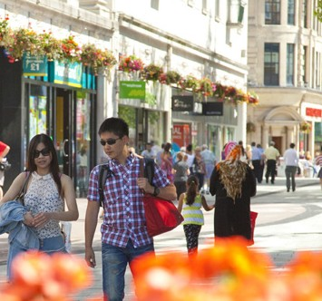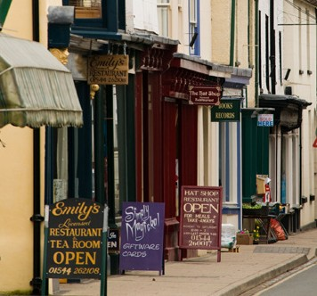

**Cardiff City Centre**

**Small Town High Street**

**Out of Town Shopping Precinct Oxford Street, London**

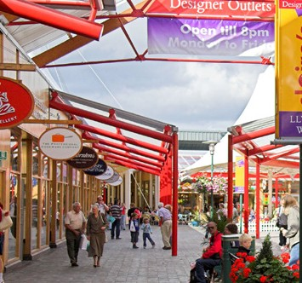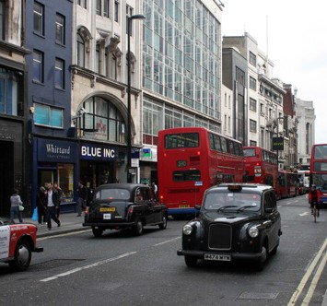

##### Town Suburb Swansea Market

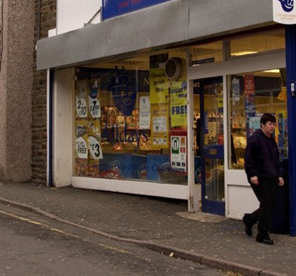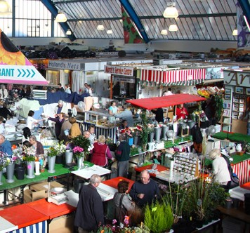

**Producing Goods and Services**

**The Market**

Being close to the market (the customers) is vital for a number of businesses. A retailer, for example, sited on

a high street or in a retail shopping park, is likely to sell more than a shop in a small town.

There are a number of industries, in addition to retailing where being near to the market is vital. For example, in personal services, such as hairdressing or the restaurant trade, location is important. Banks also need convenient locations for their customers although this is less true today.

##### There are now fewer bank branches than previously around the UK. Why is it now less important for banks to be close to their customers?

Perishable foods that cannot be processed, such as fish and lettuces, are often produced close to their market, although improvements in transport and growing methods have meant that they can now be transported longer distances.

Tick the box to identify which of the following businesses need to be close to their customers?

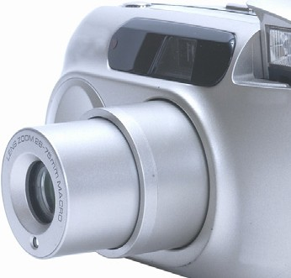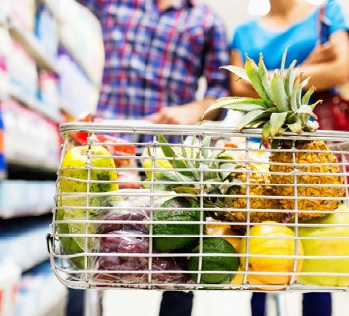

**Hairdresser**

**Camera Manufacturer Supermarket**

**Snack Bar Hotel MP3 Manufacturer**

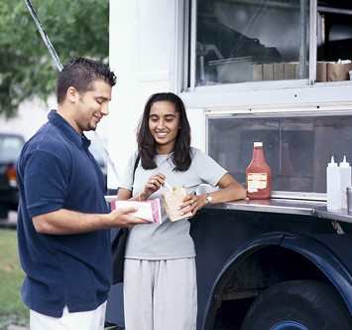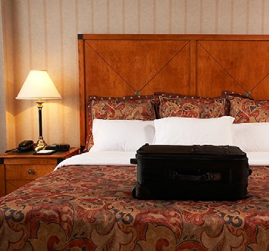

**Producing Goods and Services**

For some businesses it is important to be close to the customer because the finished product is bulkier than

the ingredients put into the product.

These are called **bulk increasing** businesses.

##### Why is it cheaper to locate the factory near to the market?

**Why are factories that bulk increase normally located next to good road links?**

**Producing Goods and Services**

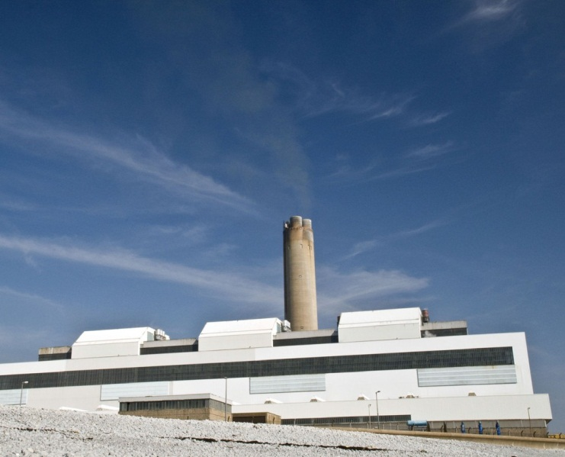**Raw Materials and Power**

Today, in the United Kingdom, there are fewer heavy industries than there were more than one hundred years ago. When factories were built close to the sources of raw materials. Towns such as Swansea and Merthyr Tydfil grew as a result of this. As these resources ran out, factories were located close to good transport links.

Increased competition from abroad and with the increased costs of production in the UK, many of those factories went into decline.

Even though the power station at Aberthaw in South Wales depends very much on coal from by Hirwaun, being close to the source of materials is generally not so important in the UK today. Materials can be imported from other countries.

The source of power tends not to be as important today because the National Grid is able to transport electricity around the UK to where it is needed.

##### Labour

However, some businesses may decide to relocate outside the UK as wages for low-skilled jobs may be cheaper in less-developed countries.

Consideration of the availability of labour is only relevant for large businesses or when highly-skilled labour is needed. For small businesses (which represent most of the business activity in the UK) who employ only a few people the availability of labour is not a major concern.

##### Producing Goods and Services

However, some businesses may decide to relocate outside the UK as wages for low-skilled jobs may be cheaper in less-developed countries.

Consideration of the availability of labour is only relevant for large businesses or when highly-skilled labour is needed. For small businesses (which represent most of the business activity in the UK) who employ only a few people the availability of labour is not a major concern.

##### Infrastructure

All businesses need good sources of energy and water, efficient drainage and waste disposal and good transportation.

Generally, in a developed country such as the UK energy, water and waste services are very good and can be supplied to most parts of the country.

Many manufacturing firms need good transport facilities in order to obtain materials and components and to move the finished goods to the customer.

Good transport facilities are important to retail business for numerous reasons; it is important that goods can be delivered to customers over long distances, and also vital to allow easy access to the store both for customers and employees. This is often an issue in older town centres that were not designed with modern transport needs in mind.

The pedestrianisation of town centres has improved areas for customers, but has made making deliveries more difficult.

Out of town shopping facilities have been developed close to roads to the benefit of both suppliers and customers with their own transport, or within easy access of public transport. The success of out-of-town shopping centres has been at the expense of town centre traders.

Many firms have moved away from town centres and

cities to less urban locations, near to motorways,

to avoid traffic congestion. Major airports have also attracted businesses that have close connections with other countries.

##### Producing Goods and Services

**Government Assistance**

Businesses create jobs and prosperity, therefore attracting business to an area can be very important to a local council or a government.

In the UK businesses may receive help from a local council, the UK Government or the European Union. In Wales, businesses may also receive help from the Welsh Government.

Help may be in the form of grants to businesses who set up in areas of high unemployment, in run down urban

areas. Businesses can also receive help through tax breaks or loans with low or no interest to pay.

There is also help available in the form of advice and training for new staff.

Examples of regional aid include:



##### Enterprise zones

Mainly in inner city areas that have high unemployment. Businesses are charged lower rent and rates.

**Regional selective assistance**

Available in certain areas, grants are available to help businesses to buy machinery and train staff.

**Regional development agencies**

A number of regions in the UK have these agencies who try to attract businesses to set up in their region.

**Urban development loans**

Available to certain businesses who help to regenerate urban areas.

**European Union grants**

Available to areas which meet certain conditions like high levels of unemployment.

**Producing Goods and Services**

**Other Location Factors**

**Historical factors**

Sometimes the reasons for an industry developing in a particular area in the past are no longer relevant and yet the industry remains because it is well established and the costs of moving are high.

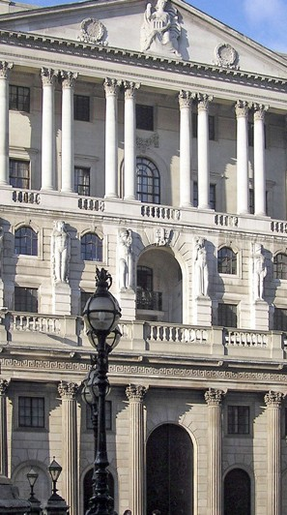

**Climate**

Some businesses can only locate in certain areas. Examples include agriculture — no banana farms in the UK and very few vineyards.

An example of this is the Cumbria pencil industry, which originally relied on local supplies of graphite, but now uses synthetic materials.

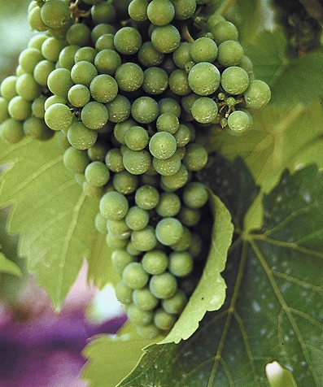

**Linkages**

Some businesses depend on others or may need to be in close personal contact with similar types of businesses.

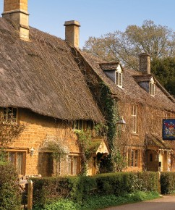

**Personal reasons**



Owners and managers may want somewhere nice to work and live so they might locate their business in an area they like.

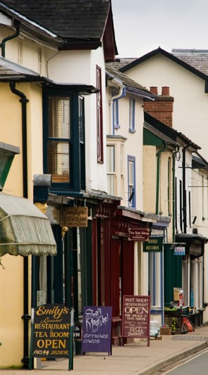

This can be seen in the City of London where there is a tremendous concentration of financial businesses close to the

Bank of England and the Stock Exchange.

**Near to competitors**

Sometimes being near to your competitors is a good idea as there will be lots of local skilled labour and your customers know where to come.

Your suppliers will also want to locate near to you which can reduce transport costs and delays.

**Producing Goods and Services**

**Past Paper Examination Question - 2010**

**Jane Budge is planning to set up a shoe shop in a small market town. She would like to concentrate on selling more expensive shoes to attract better off customers with high paid jobs.**

**Jane is considering a number of different locations to set up her shop.**

**Outline two factors Jane should take into account when deciding on the best site to locate her business within the town.**

**(4)**

**(i)**

**(ii)**

**Producing Goods and Services**

**International Trade**

Businesses and consumers around the world buy goods and services from other countries.

Goods and services bought from other countries are called **IMPORTS.**

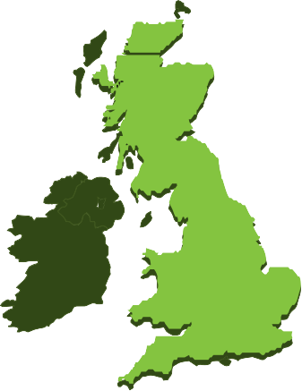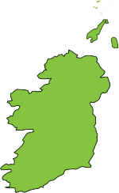

Goods and services sold to other countries are called **EXPORTS.**

International trade takes place because:

* We cannot produce some goods ourselves as we do not have the necessary raw materials in this country.
* Other countries can produce some goods and services more efficiently than we can.
* We may buy some goods from other countries so that they have the British money to buy goods and services from us.

##### Suggest an example of a product that we cannot produce ourselves

**Suggest an example of a product or service that other countries can produce/provide**

**more efficiently**

Sometimes countries do not like foreign goods being brought into their country as they can produce similar goods themselves.

The Government can reduce the likelihood of foreign goods being bought in to this country by forcing the importer to pay customs duties (taxes) or **TARIFFS.**

##### Producing Goods and Services

**Why is international trade important to business?**

Below are some of the reasons why international trade is important to Britain and its businesses. Rank the reasons why international trade is important to BUSINESS in the order 1 to 9, 1 being the most important and 9 the least.

**It provides foreign currency.**

**It provides a variety of raw materials.**

**It provides a market.**

**It shows possibilities in technology.**

**It provides cheap raw materials.**

**It allows British people to holiday abroad.**

**It allows foreigners to holiday in this country.**

**It provides a range of consumer goods.**

**It provides producer goods to be bought from abroad.**

**Producing Goods and Services**

**Problems with international trade**

Despite the benefits, there are a number of problems faced by businesses involved in international trade,

these include:

##### Different languages

There are issues related to translations between languages, that may include:

* Problems in understanding consumer needs; foreign customers may not fully appreciate what British firms have to offer and British firms will not understand what is available abroad.
* Difficulties in communication - speaking on the telephone or writing by letter, text or email.
* The need for translation of instruction books leads to high costs for the producer and misunderstandings by the customer.

##### Distance to transport

This may not be such an issue for trade with Western Europe as distances within the UK may be just as great,

but with the newly emerging markets in Brazil, Russia, India and China this is an increasing problem.

##### Cost and difficulty of transport

Costs will tend to rise, particularly when speed of delivery is important and air transport is needed. However, durable goods can be transported by less expensive sea transport. Sometimes special packaging or refrigeration may be needed.

##### Customs, traditions and religion

Exporters must be aware of the needs of local communities both in terms of the finished products and in the

materials used. Some countries may ban the import of certain goods.

##### Changing currencies

Different countries use different currencies and changing money incurs costs.

Changes in the value of currency may also affect how much businesses are paid and how much they pay

when trading abroad. Regular changes in exchange rates can lead to great uncertainty.

##### Arranging payments

Payments have to be made remotely. International banking systems will reduce the likelihood of problems but it

may be difficult to chase up bad debts due to differences in legal and political systems around the world.

##### Producing Goods and Services

**Different technical specifications for products**

Different countries have different rules about the sale of goods. Exporters have to conform with these rules and this adds to costs. Examples include:

* In France they use a two pin electrical plug whilst in the UK we mainly use a three pin plug.
* Electrical voltages vary around the world. Trying to sell goods with the wrong voltage means that electrical goods might not work.
* Differences in television and DVD systems in different countries may cause problems.

##### Different laws

Driving provides the best example of differences in countries’ laws; in the UK we drive on the left, while in

most of the rest of the world drivers travel on the right. Driving on the opposite side of the road adds to the costs of motor manufactures in Britain and producers abroad wanting to sell to British markets. Laws may also cover packaging, labelling, ingredients and so on.

##### Producing Goods and Services

**Past Paper Examination Question - 2004**

**Suggest how British vehicle producers might gain from trading in international markets and outline the problems they might experience.**

**(8)**

**Producing Goods and Services**

**Past Paper Examination Question - 2011**

**Jo Downs Handmade Glass Ltd sells some of its goods abroad.**

**Should Jo Downs Handmade Glass Ltd try to sell more of its goods abroad? Justify your answer. (8)**

**Producing Goods and Services**

**Multinationals**

Multinationals are businesses that have their headquarters in one country but OPERATE in many countries,

this means that they may have offices and factories around the world.

###### Many firms will buy and sell goods around the world but this does not make them Multinationals,

***they are just trading in other countries.***

Multinationals operate in a world market and can overcome some of the disadvantages of businesses that just trade abroad. Advantages for Multinationals may include:

* Multinationals are well-known around the world.
* It is easier to compete in foreign markets as multinationals are in effect local businesses being managed by local people.
* Multinationals can take advantage of economies of scale, due to their size.
* Multinationals may benefit from lower production costs. For example, labour costs may be lower in foreign

countries than in the UK.

* To take advantage of exchange rate movements. Setting up as a multinational means that there are few concerns caused by changes in the value of money if the business is selling locally or buying materials locally. Indeed there may be advantages gained when selling to other countries - even the home country.
* Taxes on businesses may be lower in other countries.
* Grants may be available in other countries to encourage multinationals to set up, this means that capital costs may be lower.
* Multinationals can overcome trade restrictions that limit imports, as they already produce in the particular country.
* Transport costs may be reduced as goods and materials do not have to be moved as far. For example,
* Coca Cola sends the syrup used to make their drinks to factories around the world, where water and gas are

added locally to produce the final product.

##### Name 5 large businesses you know that may be Multinationals



Your suggestions above should show that their name helps to promote the business. This leads to

enormous incomes and therefore profits and greater dividends for the owners.

##### Producing Goods and Services

**Suggest an economy of scale from which multinationals might benefit.**

**Suggest a production cost, other than labour, which might also be cheaper abroad.**

**Disadvantages of multinationals**

Disadvantages for multinationals might include:

* Multinationals are very big businesses, this makes them very difficult to manage over long distances. There may be communication problems, not just in terms of languages but, due to technology issues, physical distance and time zone differences. All these factors lead to higher costs.
* Laws in other countries will not be the same as in their home country. Different legal systems will cause

problems as will issues related to consumer rights, labour laws, planning, the environment and so on.

* Political systems may cause problems. In some countries there may be the threat of the business not being approved by the government, and in extreme cases the government may take over the business with no compensation. Political unrest may also cause problems.

##### Producing Goods and Services

**Past Paper Examination Question - 2003**

**Which *two* of the following are most likely to be multinational businesses?**

**Tick *two* boxes only.**

**(2)**

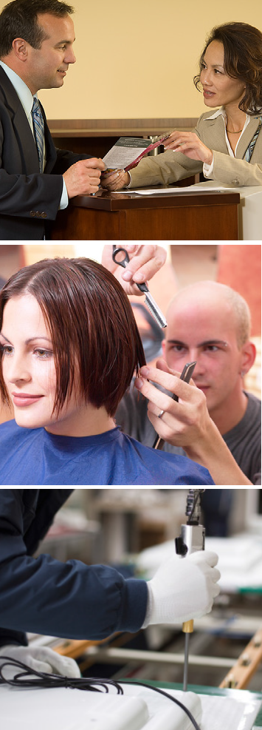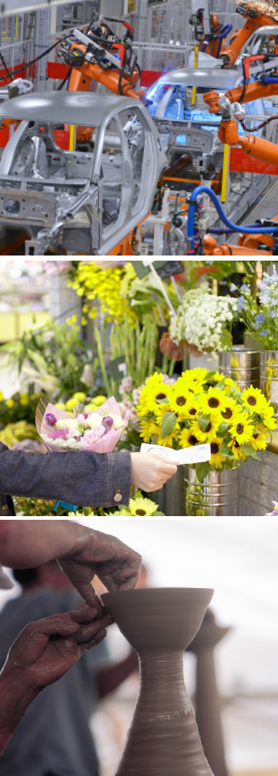

**Building societies**

**Companies making cars**

**Hairdressers Flower shops**

**Television set**

**manufacturers Potteries**

**Producing Goods and Services**

**Past Paper Examination Question - 2010**

**Associated British Foods plc is a British company operating in the food and retail sectors. It has annual sales of over £8 billion and it employs over 96,000 workers in 44 countries.**

**(a)**

**What is the name given to a business which operates in many countries? (1)**

**(b) Suggest and explain *two* benefits which Associated British Foods plc might gain from**

**operating in so many countries. (4)**

**(i)**

**(ii)**

**(c)**

**Outline one disadvantage Associated British Foods plc may experience from operating in so many countries.**

**(3)**

**Producing Goods and Services**

**Foreign firms in Britain**

As well as British firms setting up abroad many foreign firms want to have offices and factories in Britain. These businesses benefit local areas, but there are also disadvantages.

Below are a jumble of advantages and disadvantages of foreign firms setting up in Britain. Write the advantage or disadvantage in the correct column of the table on the next page.

Local businesses gain from the increased income of workers and increased spending by foreign firms.

Taxpayers’ money used to attract firms.

New production techniques / skills introduced e.g. Just in Time.

Opportunities to learn and develop skills.

More jobs available in area.

Higher paid / skilled jobs go to workers from the business’ own country to begin with.

Factories which are easy to set up may be just as easy to close down when the foreign firm sees advantages in other countries or products.

Opportunities for greater incomes for workers with extra skills and/or promotion.

**Producing Goods and Services**

|  |  |
| --- | --- |
| **Disadvantages** | **Advantages** |
|  |  |
|  |  |
|  |  |
|  |  |
|  |  |
|  |  |
|  |  |
|  |  |

**Producing Goods and Services**

**European Union**

The European Union (EU) developed out of the European Economic Community, that was set up by six countries

in 1957 with the Treaty of Rome. The EU has since grown, so that by 2013 it had 28 members. The United Kingdom joined the EU in 1973.

##### Growth of the number of members of European Union

**2007 27**

**2004 25**

**1995 17**

**1986 12**

**1981 10**

##### 1973 9

**1957 6**

Today the EU has a combined population, and therefore market, of over 500 million people or 7.3% of the world population.

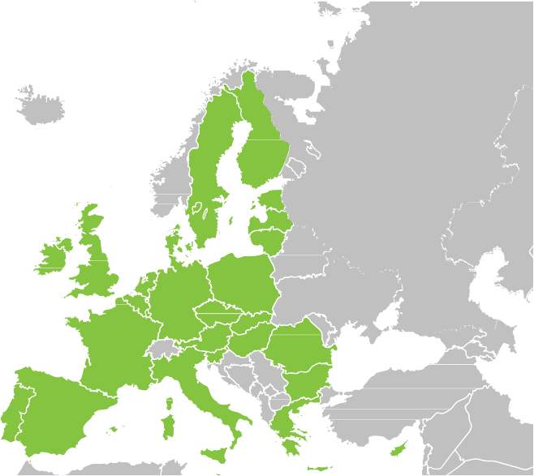

In 2011, EU countries produced 20% of the wealth

created in the world.

##### Producing Goods and Services

The European Union is a common market or Single Market, this means that:

* There are no customs duties to be paid when goods move from one member to another.
* There are no border posts, so goods pass easily between member countries.
* There is easy movement of workers from one European country to another.
* Investments also move easily across European borders.

Britain and British firms may gain or lose from this Single Market.

Members follow common policies, there are rules set out to ensure that no country or business gains an unfair

advantage from the common market. Examples of common policies include:

##### A Common Agricultural Policy

A Common Agricultural Policy to set out the quality of food we eat and the quantity which is available. It pays money to farmers to encourage them to grow the right kinds of crops and to make sure that Europeans do not go hungry: this payment is called a subsidy.

Sometimes the payment of subsidies to farmers have led to too much food being produced, this has meant

that food has had to be kept in expensive storage or it has had to be thrown away.

These days the common agricultural policy also covers care for the rural environment.

##### A Fisheries policy

In order to preserve fish stocks a limit is placed on the quantity of fish each country is permitted to catch. Fishing stock limits have had adverse effects; a large number of boat owners have lost their business and, as a result, employees have lost their jobs.

##### Competition policies

Competition Policies exist to encourage competition between businesses and reduce unfair business practices.

##### Regional policies

Regional policies provide financial support to deprived areas of member countries, this support helps in the development of infrastructure and social facilities in less affluent areas.

##### Producing Goods and Services

**Past Paper Examination Question - 2006 and 2008 - Adapted**

**Which *three* of the following have happened as a result of the United Kingdom’s membership of the European Union?**

**Tick *three* boxes only. (3)**

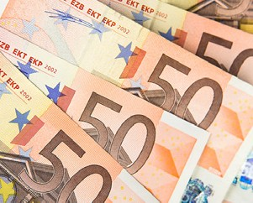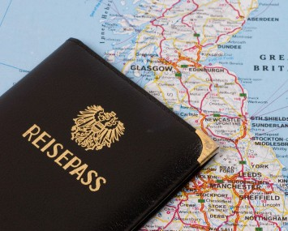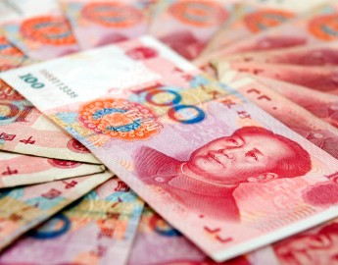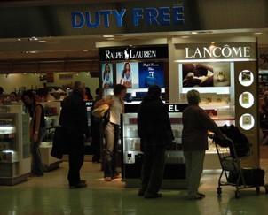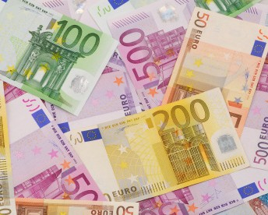

|  |  |  |
| --- | --- | --- |
| **Less trade between British business and European Union countries** |  |  |
| **Workers from other European Union countries find it easier to find work in the United Kingdom** |  |  |
| **More trade with China which is not in the European Union** |  |  |
| **No customs duties paid when moving goods between European Union countries** |  |  |
| **More trade with other European Union countries** |  |  |

##### Ifor Williams Trailers Ltd is selling more trailers in European Union countries.

**List *two* benefits gained by Ifor Williams Trailers Ltd as a result of the United Kingdom’s**

**membership of the European Union?**

**(i)**

**(2)**

**(ii)**

**Producing Goods and Services**

**The Single Currency**

Seventeen of the member countries of the European Union belong to a single currency, the Euro.

The benefits of a single currency are:

* A single currency saves the time and expense of changing one currency into another when trading with

other Euro countries.

* A single currency leads to price transparency so that people know what they are paying for goods, wherever

they buy them in the Euro zone. Think about the problems of trying to work out how much you are paying

for goods when travelling abroad.

The United Kingdom does not belong to the single currency because many people think that it takes away many of the rights the British government has to rule the country, in terms of taxes, interest rates and government spending.

##### Suggest and explain one possible effect that adopting the single European currency could have on British vehicle manufacturers.