Factors affecting PED

Limited change in demand Medium change in demand Big change in demand

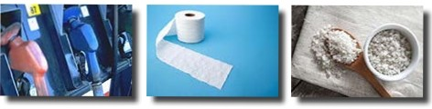'-1

