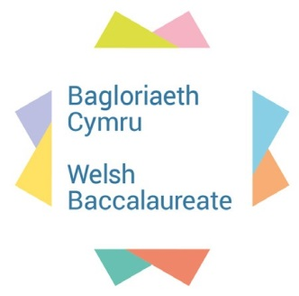

National (Post 16) Skills Induction Resource

Skills Induction preface
The National post-16 Welsh Baccalaureate is based on the essentialness of developing the skills of young people in Wales, to increase their employability options. Therefore, skills development along with knowledge acquisition is essential. The National post-16 Welsh Baccalaureate must attempt to equip learners with relevant theory in conjunction with opportunities for experiential learning. It is only with experiential learning that young people will be able to develop their skills through a process of planning, doing and reflecting. It is also vital to ensure that each learner leaves their level 2 learning programme with a minimum competency at level 2 in all 7 skills.
Unit | Skill Focus | Description of activity | Time to be allocated | Use of IT
1 | Introduction to the 7 skills | Introducing the ‘The Ruin’ | 1 hour
2 | Critical Thinking and Problem Solving | Coming up with a use for the building | 1 hour (could be extended)
3 | Literacy | Creating advertising for it | 1 hour | If available
4 | Digital Literacy | Filming an advert | 1 hour | Yes
5 | Creativity and Innovation | Designing a floor plan and creating a mock-up of a room | 1 hour (could be extended) | If available
6 | Numeracy | Decorating the building and calculating costs | 1 hour | Yes
7 | Personal Effectiveness | Deciding on staffing and job roles | 1 hour
8 | Planning and Organisation | Planning a function/event in the building | 1 hour
9 | Mini Challenge 1 | Shotgun Pitch | 1 hour | Yes
10 | Mini Challenge 2 | Managing the debt | 2 hours
Section 1.4 of the National post-16 Welsh Baccalaureate specification details all of the expected components of each skill. Activities have been produced that focus on one or more of these specific components. Mini challenges have been developed to allow learners to demonstrate a mixture of skills in one activity.

Acknowledgements

With thanks to the following for their valuable contributions to this resource:
Ruth Jones St David's College
Moya Seaman Llandrillo Menai Group

Sponsored by Welsh Government

Unit 1:  Introduction  Activity 1 Introduction to the 7 skills | Length of Activity:  1 hour
Activity Objectives:
To introduce learners to the 7 skills

Introduction to Session:  This is a team based introduction where learners will take part in a quiz. |  | Resources:  - Paper and pens  - Stickers  - 1.1a Learner Worksheet  - 1.1b PowerPoint
Activity:  - Learners should be divided into teams of 7 and a Learner Worksheet (1.1a) should be distributed to each learner.  - Tasks begin with a word-search (1.1a) where each team needs to compete in order to identify the 7 skills in the grid.  - Next, learners need to rate themselves against each of the skills.  - The learner who has the highest score for Personal Effectiveness becomes Team Captain. (If this does not apply, this role should be negotiated in the group).  - The Team Captain decides which member of their group will take questions based on each skill. This can also be negotiated and learners' ratings of their skills should be taken into account. They write their decisions on stickers that should state the learner’s name and their allocated skill.  - Now use the PowerPoint Slides. Round 1 – all learners who have been allocated ‘Literacy’ come to a table at the front of the classroom and are shown the slides 2-3.They are given 3 minutes to write their answers on a piece of paper and then must hand their answers in to the deliverer.  - Round 2 – all learners who have been allocated ‘Numeracy’ come to a table at the front of the classroom and are shown slides 4-5. They are given 3 minutes to write their answers on a piece of paper and then must hand their answers in to the deliverer.  - Round 3 – all learners who have been allocated ‘Planning and Organising’ come to a table at the front of the classroom and are shown slides 6-7. They are given 3 minutes to write their answers on a piece of paper and then must hand their answers in to the deliverer.  - Round 4 – all learners who have been allocated ‘Creativity and Innovation’ come to a table at the front of the classroom and are shown slides 8-9. They are given 3 minutes to write their answers on a piece of paper and then must hand their answers in to the deliverer.  - Round 5 – all learners who have been allocated ‘Digital Literacy’ come to a table at the front of the classroom and are shown slides 10-11. They are given 3 minutes to write their answers on a piece of paper and then must hand their answers in to the deliverer.  - Round 6 – all learners who have been allocated ‘Critical Thinking & Problem Solving’ come to a table at the front of the classroom and are shown slides 12-13. They are given 3 minutes to write their answers on a piece of paper and then must hand their answers in to the deliverer.  - The deliverer hands out the papers to be marked to each team (making sure a team does not get their own answers). The team with the highest score wins. |  | Learning Outcomes:  Learners are aware of the 7 skills and their confidence levels in applying these skills.
Plenary:
Ask learners to reflect on how confident they felt in responding to the quiz questions. Which areas are they most confident in? Which areas are they least confident in?

Skills: All 7 skills

1.1a Learner Worksheet
Task 1
As a team, find the 7 skills hidden in this worksheet. The first team to identify the full 7 skills and write them below wins:
I | N | N | O | V | A | T | I | O | N
L | I | T | E | R | A | C | Y | P | P
E | A | S | C | X | F | G | H | L | I
F | C | V | R | W | E | R | T | I | K
F | S | T | E | D | F | B | N | T | M
E | S | H | A | D | D | G | H | E | O
C | R | I | T | I | C | A | L | R | R
T | A | N | I | G | D | N | M | A | G
I | Y | K | V | I | Y | D | U | C | A
V | N | I | I | T | J | N | M | Y | N
E | W | N | T | A | P | L | C | L | I
N | Q | G | Y | L | E | A | H | T | S
E | E | W | Y | U | R | N | U | L | A
S | R | T | T | E | S | D | P | T | T
S | T | F | M | E | O | E | W | L | I
X | E | U | B | R | N | D | E | K | O
D | N | W | N | T | A | T | R | J | N
C | D | E | M | W | L | M | T | Y | Y
B | S | R | N | T | E | G | Y | R | H
G | C | E | Y | L | J | H | U | F | E
T | Z | T | B | U | K | J | I | D | R
R | S | O | L | V | I | N | G | E | E
E | R | G | R | E | L | I | I | R | D
P | V | H | E | A | L | K | O | T | T
P | L | A | N | N | I | N | G | V | Y

Skill 1:

Skill 2:

Skill 3:

Skill 4:

Skill 5:

Skill 6:

Skill 7:

Task 2
Again, for each of the skills above, rate yourself out of 10 regarding how confident you are with applying them. 1 is not confident at all. 10 is totally confident.

Unit 2:  Critical Thinking and Problem Solving  Activity 2 | Length of Activity:  1 hour  (could be extended)
Activity Objectives:
To introduce learners to techniques of coming up with ideas, and coming up with alternative uses.

Introduction to Session:  Learners will be provided with the ‘The Ruin’ brochure and asked to come up with a use for ‘The Ruin’ in groups of no more than 4. They will then need to pitch their idea to the rest of the group. |  | Resources:  - Paper and pens  - 2.1a Sales brochure for ‘The Ruin’  - 2.1b PowerPoint
Activity:  - Learners should be divided into teams of 4 and ‘The Ruin’ sales brochure should be distributed to each group.  - Work through the PowerPoint.  - Provide a set amount of time for each group to respond to the brief, depending on time available.  - Each team to pitch their idea. |  | Learning Outcomes:  Learners are able to think critically and engage in problem solving.  Learners are able to effectively pitch ideas.
Plenary:
Ask learners to reflect on how confident they felt in responding to the brief. Which team had the best idea? Why was it the best idea?

Skills:

Critical Thinking and Problem Solving

Communication

Lucky Estate Agency
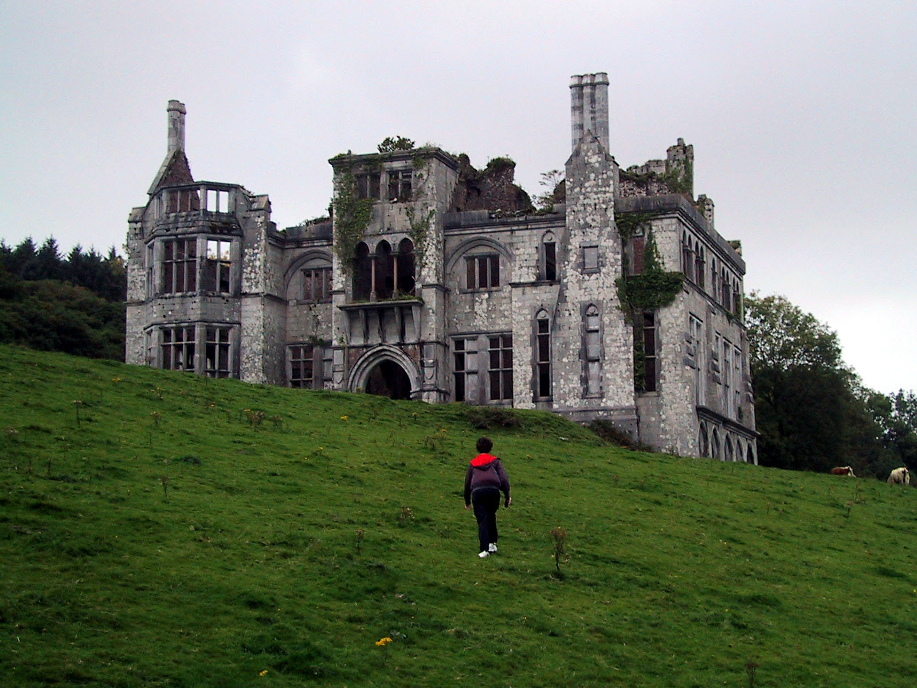
(2.1a)
SOLD

SUMMARY
A generous detached double fronted eleven bedroom residence of character, occupying a prestigious position set within mature large well established gardens and grounds, approached by a private sweeping entrance drive. What more could you want?
DESCRIPTION
The Ruin is a large and imposing mansion sitting in lovely grounds. The house dates back to around the 1880s when it was built for a wealthy local mine owning family and was later reputed to be the birth place of Sir Harry Llewellyn of Foxhunter fame.
Consequently the house has spacious reception rooms with fine period features such as large bay windows, sprung floors, ornate coving and plasterwork, and marble character fire places. The former servants' quarters remains in the basement and give the house enormous flexibility. Outside are not so well maintained formal gardens, approached by a sweeping entrance drive, with stone pillars and leading to a range of open garages and car port areas.
The Property
This imposing residence of character, built circa 1880, boasts magnificent period features throughout the accommodation, with high ceilings and original window shutters providing a wonderful ambiance of originality and splendour, most prominent within the Edwardian and Victorian era. However, it has now fallen into disrepair and needs extensive refurbishment.

Accommodation:
The property comprises a charming entrance reception hall with an imposing returning staircase (26'9 x 7'7), an elegant drawing room with large bay window and a handsome marble fireplace, a generous sitting room (18'1 x 17'10 with a further large splayed bay window and an ornate marble fireplace, a spacious dining room (17'5 x 15'4) with polished floor boards and a carved wooded fireplace, a separate breakfast room (17'5 x 13'90 with a tiled floor and a fireplace with mantel, and a fitted kitchen with a range of units. Some imagination is needed to see the property’s true potential.
Accommodation:
The first floor comprises six double sized bedrooms, many with original period fireplaces and two with wide splayed bays. There is also a charming character bathroom with separate WC and a further seventh single bedroom with its own en-suite shower room. The second floor comprises four further rooms, ideally bedrooms, each with windows with elevated outlooks across the surrounding area. A unique residence, set within large and lovely gardens, approached by a private sweeping entrance drive, and located at the end of small cul de sac, well away from busy passing traffic.
Entrance Reception Hall 26' 9" x 7' 7" Min. (8.15m x 2.31m Min.)
Parquet floor, staircase to first floor, staircase to basement cellar.
Drawing Room 18' 3" x 17' 1" min (5.56m x 5.21m min.)
A wide splayed bay window to from with outlook across the large and lovely frontage gardens. It has marble fireplace with a pair of recessed alcoves on either side.
Sitting Room 18' 5" x 17' 1" min (5.61m x 5.21m min.)
Plus a wide splayed bay window with outlooks across the large frontage gardens. Ornate marble fireplace.
Dining Room 17' 4" x 15' 10" (5.28m x 4.83m)
Polished floor boards, carved wooden fireplace, windows to rear and side aspect.
Breakfast Room 21' 2" max x 17' 5" ( 6.45m max x 5.31m )
With a tiled floor, fireplace with mantle above, cupboards to side, alcove with cupboards and display shelves and opening through to:
Kitchen 13' 1" x 9' 10" (3.99m x 3.00m)
Side Hall
Access to rear, internal door to entrance hall.
First Floor Landing
Master Bedroom One 20' 3" max x 17' 2" (6.17m max x 5.23m)
Bedroom Two 17' 11" x 13' 10" max (5.46m x 4.22m max.)
Bedroom Three
Bedroom Four 13' 7" x 10' 2" (4.14m x 3.10m)
Bedroom Five 11' 5" x 9' 11" (3.48m x 3.02m)
Bedroom Six 17' x 8' 4" (5.18m x 2.54m)
Bathroom 13' 11" x 9' 9" (4.24m x 2.97m)
Separate W.C.
Bedroom Seven 12' 10" x 8' 7" (3.91m x 2.62m)
En suite Shower Room 9' 8" x 5' 7" (2.95m x 1.70m)
Second Floor Landing
Bed Eight 10' 6" x 18' (3.20m x 5.49m)
Bed Nine 26' 6" max x 10' 4" (8.08m max x 3.15m)
Bed Ten 20' 4" max x 10' 11" ( 6.20m max x 3.33m )
Bed Eleven 20' 3" x 10' 10" ( 6.17m x 3.30m )

Activity 3:  Literacy - Creating an Advert | Length of Activity:  1 hour
Session Objectives:
- To identify different types of language used in advertising
- To understand the style of writing used
- To create an advert for ‘The Ruin’
Introduction to Session:  This session is intended to develop learners’ literacy skills through activities linked to advertising ‘The Ruin’ | Resources:  3.1a PowerPoint  3.1b Learner Worksheet  Magazines/ newspapers/ literature that contain adverts
Activity:  - Begin by working through the PowerPoint.  - As a group, discuss the chocolate adverts and their various features.  - Complete Task 1 of the Worksheet as guided in the PowerPoint.  - Create an advert (Task 2).  - Share adverts as a group and peer assess. | Learning Outcomes:  - Become more familiar with adverts and the language used within them.  - Creation of an advert (in chosen format) to market ‘The Ruin’

Plenary:

Learners should share their advert with the rest of the group. Learners should discuss their adverts with each other in terms of how effective they are.

Skills:

Literacy
Creativity

3.1b Learner Worksheet
Task 1: Adverts
- Who is this following advert aimed at?
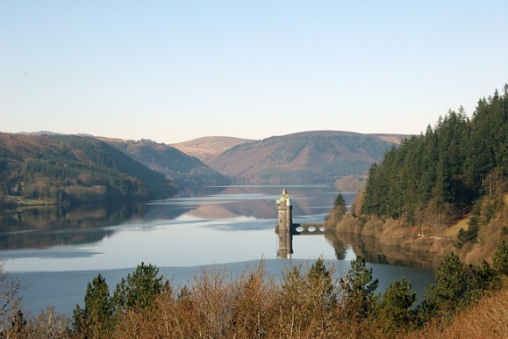
- How are they trying to persuade you to buy their product
This is Wales

Who?
How?

Other thoughts?

Who?

How?

Other thoughts?

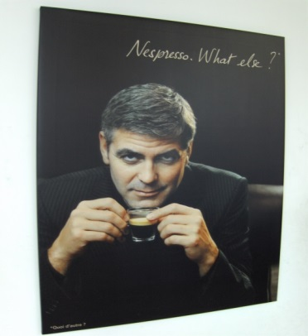
Who?

How?

Other thoughts?

Find adverts from the texts your tutor has shared with you, and note the features below (you can describe the advert, or attach it to the back of your worksheet).

Advert A:
What is it advertising?
Who?
How?

Other thoughts?

Advert B:
What is it advertising?
Who?
How?

Other thoughts?

Task 2
Create an advert to market what ‘The Ruin’ is and what it is used for.
- Consider your audience
- Think about the images you might use
- Think about the words and phrases you can use
You can create your advert by hand or using ICT.
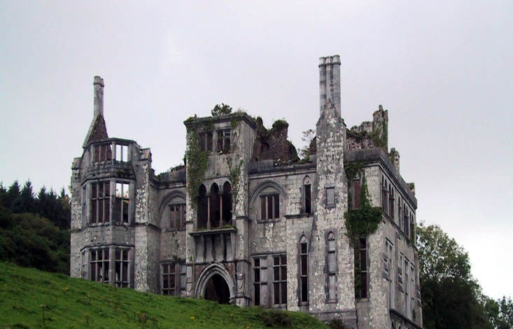

Activity 4:  Digital Literacy - Filming an Advert | Length of Activity:  1 hour
Session Objectives:
- To develop knowledge and understanding of different Digital Literacy tools that can be used to create a ‘live action advert’.
- To use chosen tool to create an advert for ‘The Ruin’.
Introduction to Session:  This session is intended to develop learners’ digital literacy skills by filming an advert to market ‘The Ruin’. | Resources:  4.1a PowerPoint  4.1b Learner Worksheet  Access to the internet in order view YouTube clips  Access to a mixture of equipment (e.g. video camera, smart phones, tablets) – this will be as appropriate to the setting, whilst ensuring that learners’ ability to complete the task is not limited. Learners could be encouraged to use their own devices.
Activity:  - Begin by working through the PowerPoint.  - Learners to complete Task 1 (Part 1); tutors to check that plans are realistic within the given timescale.  - Learners to complete Task 1 (Part 2) as the planning ahead of Task 2.  - Learners film their advert and then share with others in the class.  - Learners share views on which adverts worked well and why. | Learning Outcomes:  - More familiar with different tools that can support the creation of adverts/videos/recordings  - Creation of a digitally developed advert to market ‘The Ruin’

Plenary:

Learners should share their advert with the rest of the group. Learners should discuss their adverts with each other in terms of how effective they are.

Skills:

Digital Literacy
Creativity and Innovation

4.1b Learner Worksheet
Task 1 (Part 1)
How are we going to create the advert? What equipment do we need? Do we need an app to support this? Do we have easy access to what we need?

Task 1 (Part 2)
Our Storyboard

Team roles (who is doing what)

Unit 5:  Creativity and Innovation  Activity 5 | Length of Activity:  1 hour  (could be extended)
Activity Objectives:
To introduce learners to the meaning of colour and to apply creative skills

Introduction to Session:  Learners will be required to design a room in ‘The Ruin’ and create a mood board. |  | Resources:  - Paper and pens  - Fabric/wallpaper/colour and any other elements to be used in a mood board  - A colour printer could be used to obtain the elements for a mood board  - Paint  - 5.1a Power Point
Activity:  - Work through the PowerPoint.  - Provide a set amount of time to design the room and mood board.  - Learners to explain their design and mood board to other classmates. This could be done through organising a gallery viewing or similar where learners can display their work. |  | Learning Outcomes:  Learners are able to think creatively.  Learners are able to express creative ideas.
Plenary:
Ask learners to reflect on how confident they felt in responding to the brief. How difficult was it to design a room and create a mood board? What did they enjoy?

Skills:

Creativity and Innovation

Activity 6:  Numeracy – decorating ‘The Ruin’ and calculating the costs | Length of Activity:  1 hour
Session Objectives:
- To use scale drawings to calculate area and perimeter
- To work out costs for materials
Introduction to Session:  This session is intended to develop learners’ numeracy skills through series of activities related to costing and decorating ‘The Ruin’ | Resources:  6.1a PowerPoint  6.1b Worksheet (extension task as required – Worksheets 6.1c & 6.1d)  Access to the internet to search prices (extension task)
Activity:  - Begin by working through the PowerPoint.  - Learners will complete the task in format best suited to their numeracy ability. The tutor can split learners into groups based on skill levels and give the task out in sections as appropriate.  - The extension task is for the more able learners who may finish more quickly than others. | Learning Outcomes:  - More familiar with scale, area and perimeter.  - Able to cost materials based on area and perimeter calculations.

Plenary:

Learners should work together to cost up the total expense for the section of the building. Learners should discuss such a large scale job (e.g. are there other costs they need to consider, can any savings be made -buying in bulk, how can they ensure the best deal?)

Skills:

Numeracy
Problem Solving
Planning

6.1b Learner Worksheet
Task - use the free space for your workings out
Dado Rail
Room | Amount needed | Cost
Dining Room
Lounge
Sitting Room
Toilets
Store Cupboard
Hall
TOTAL

Skirting Boards
Room | Amount needed | Cost
Dining Room
Lounge
Sitting Room
Toilets
Store Cupboard
Hall
TOTAL

Paint
Room | Amount needed | Cost
Dining Room
Lounge
Sitting Room
Toilets
Store Cupboard
Hall
TOTAL

Total Costings
Item | Amount needed | Cost
Dado Rail
Skirting Board
Paint
TOTAL

6.1c Learner Worksheet
Extension Task - use the free space for your workings out
Carpet calculations
Room | Amount needed | Cost
Lounge
Sitting Room
TOTAL

Patio Costings

 |  |  |  |  |  |  |  |  |  | 21 m
 | Patio |  |  | Sitting Room |  |  |  |  |  | Store cupboard
 |  |  |  |  |  |  |  |  |  |  |  |  |  |  |  | Lounge
 |  |  | Toilets
 |  |  |  |  |  |  |  |  | Hall
 |  |  |  |  |  |  |  |  |  |  |  |  |  |  |  |  |  |  |  |  |  | 14 m
 |  |  |  |  |  |  |  |  | Dining Room
Scale = 1m² (1m x 1m)
Unit 7:  Personal Effectiveness  Activity 7 | Length of Activity:  1 hour
Activity Objectives:
To introduce learners to understanding potential careers/jobs that may be appealing to them.

Introduction to Session:  Learners will be asked to create a job description relating to their ideal job at ‘The Ruin’ |  | Resources:  - Paper and pens  - 7.1a Learner Work Sheet
Activity:  - Learners should be asked to consider what their ideal job would be at ‘The Ruin’ based on their selected idea in Activity 2.  - They should be given a Learner Work Sheet and create a job description for their ideal job.  - They should also decide on the terms and conditions including pay, working hours and holidays.  - Learners should then form the same teams in Activity 2, and each team should look at the job descriptions and decide whether each learner should be ‘hired’. They should consider whether the role is required and if the terms and conditions are fair and achievable. |  | Learning Outcomes:  Learners are able to create a job description.
Plenary:
Ask learners to reflect on which roles were fair and reasonable and which were not. Why had learners chosen particular jobs? What makes an ideal job?

Skills:

Personal Effectiveness

7.1a Learner Worksheet
Task 1
A job description must have the following information:
- Heading information. This should include job title, pay reporting relationship (by position, not individual), hours or shifts, and the likelihood of overtime or weekend work.
- Summary of the job. List the general responsibilities and descriptions of key tasks and their purpose and relationships with others.
- Qualifications. State the education, experience, training, and technical skills necessary for entry into this job.
- Special demands. This should include any extraordinary conditions applicable to the job (for example, heavy lifting, exposure to temperature extremes, prolonged standing, or travel).
- Job duties and responsibilities. List what must be performed.

Complete the following job description for your chosen role at ‘The Ruin’:
Job description for:

Key information (pay, hours worked etc.)

Summary of the job

Qualifications

Special demands

Job duties and responsibilities

Activity 8:  Planning and Organising – planning an event or function in the building | Length of Activity:  1 hour
Session Objectives:
- To understand how to write aims and objectives
- To state components of an action plan
- To create an action plan
Introduction to Session:  This session is intended to develop learners’ planning and organising skills through activities linked to arranging an event or function at ‘The Ruin’ | Resources:  8.1a PowerPoint  8.1b Learner Worksheet
Activity:  - Begin by working through the PowerPoint.  - Learners complete their own personal Aims and Objectives for Task 1.  - Learners complete Aims and Objectives for their chosen event and allocate roles including justification for choosing people for each role.  - Learners complete an Action Plan.  - Learners review each other’s plans and peer critique them. | Learning Outcomes:  - Learners will produce a set of personal Aims and Objectives.  - Learners will produce aims, Objectives and an Action Plan for the given task.  - An opportunity to practice planning and organising skills.

Plenary:

Learners should share their action plan with the rest of the group. The learners from other groups should give feedback on the effectiveness of these plans. Learners within the same group should discuss what went well and what could have been improved (with regard to working as a team).

Skills:

Planning and Organising
Problem Solving
Creativity and Innovation

8.1b Learner Worksheet

Task 1: Aims and Objectives
Where do you see yourself in 3 years' time? How are you going to achieve this?
My Aim:

My Objectives:

Task 2
What is the aim of the event?

What are the objectives?

What role is each member of the group going to take on?
Name | Role | Why you chose this person | How this helps meet the objectives

Task 3
Action Plan

Activity 9:  Mini Challenge 1 – Shotgun Pitch | Length of Activity:  1 hour
Session Objectives:
- To create a pitch to ‘sell’ the planned event idea to Governors
- To work to a tight timescale
- To win the pitch battle
Introduction to Session:  This session is intended to bring together skills that learners have developed in previous activities to complete a mini challenge | Resources:  9.1a PowerPoint  9.1b Learner Score Card  Access to ICT to create pitch
Activity:  - Begin by working through the PowerPoint.  - Learners work in groups to develop their pitch.  - Learners will present their pitch and will score each other as per the score card.  - Learners can review each other’s pitches once scores have been shared.  - Learners can score as a team or individually. | Learning Outcomes:  - Learners will produce a pitch to promote their chosen event.  - Learners will score each pitch and a winner will be identified as a result.

Plenary:

Learners can share their points scoring decisions and can discuss why points were awarded as they were.

Skills:

Planning Creativity and Innovation Literacy
Digital Literacy Personal Effectiveness

9.1b Learner Worksheet
Mini Challenge Score Card
 | Group 1 | Group 2 | Group 3 | Group 4 | Group 5
Pitch Length
Contribution
Name of Building
Idea for Event
Generate Income
Creativity and Innovation
TOTAL SCORE

Scoring
Pitch length = 5 point
- Over 2 minutes = 0 points
- Less than 1 minute 30 seconds = 2 points

Contribution = 5 points
- 5 points for (roughly) equal contribution by all members of the group
- 3 points for partial contribution by some members of the group
- 1 point if some members did not contribute

Name of the building
Score from 1 – 5 points based on how original you think this is.

Idea for Event
Score from 1 – 5 points based on how original you think this is.

Generate income
Score from 1 – 5 points based on how likely the idea is to make money
(Consider the costs to run such an event, likelihood of people attending and so on).

Creativity and Innovation
Score from 1 – 5 points based on how creative you think the idea is overall and including the digital presentation.

Mini Challenge 2 | Length of Activity:  2 hours
Activity Objectives:
To encourage learners to come up with an idea, apply skills of numeracy and communicate in a persuasive and convincing manner.

Introduction to Session:  The Ruin is running into huge debt. Although the previous mini challenge involved selecting an idea for its future, while architects, banks and builders are being consulted, the running costs are resulting in thousands of pounds worth of debt.  This activity involves learners thinking of a short term money making scheme in order to address these accumulating debts. |  | Resources:  - Paper and pens  - Presentation materials or tools  - Mini Challenge 2 PowerPoint 10.1a
Activity:  - Learners should be divided into teams.  - Work through Mini Challenge 2 PowerPoint.  - Allow 40 minutes (or more) for learners to respond to the problem.  - Each team presents their idea in whatever format they chose. Possible timings may be up to 5 minutes for the presentation of the idea.  - The others teams will then be able to ask a challenging question. Possible timings may be up to 5 minutes for questioning.  - The teacher or facilitator decides on the team that best responded to questioning and the team that had the most convincing idea. |  | Learning Outcomes:  Learners are able to successfully apply their numeracy skills to solve a problem  Learners are able to ‘think on their feet’  Learners are able to respond to a brief within a set period of time  Learners are able to convey their ideas in an effective manner
Plenary:
Ask learners to reflect on how easy they found it to respond to questioning. What could they have done to be better prepared if they were asked to do this again. When important people like the Prime Minister delivers a talk and takes questions and answers, do they think they practice beforehand?
Skills:
Numeracy Communication Problem Solving Creativity

